

CAPSTONE PROJECT REPORT
Report 3 – Software Requirement Specification

– Ho Chi Minh, September 2026 –
Table of Contents
I. Project Report 3
1. Status Report 3
2. Team Involvements 3
3. Issues/Suggestions 3
II. Software Requirement Specification 4
1. Overall Description 4
1.1 Product Overview 4
1.2 Business Rules 5
2. User Requirements 6
2.1 System Actors 6
2.2 Use Cases 6
3. Functional Requirements 8
3.1 System Functional Overview 8
3.2 <<Feature Name 1>> 10
3.3 <<Feature Name 2>> 10
4. Non-Functional Requirements 11
4.1 External Interfaces 11
4.2 Quality Attributes 12
5. Other Requirements 14
5.1 Appendix1 - Messages List 14
5.2 Appendix2 - … 14
5.3 … 14

I. Record of Changes
Date | A*  M, D | In charge | Change Description
27/09/2026 | A | Nguyễn Thành Trung | 1.Product Overview  2.1 Actors  4.2 Quality Attributes
09/10/2026 | A | Võ Trường Phú | 2.2 Use Cases
13/10/2026 | A | Võ Trường Phú | 5.3 Application Messages List
17/10/2026 | M | Tôn Thành Vinh | 5.1 Business Rules
26/10/2026 | M | Tộn Thành Vinh | 5.1 Business Rules
27/10/2026 | M | Nguyễn Thành Trung | 3.2 Authentication & Account Management  3.3 Event Management  3.4 Registration & Payment  3.5 Race-Day Check-in  3.6 Race Results & Rankings  3.7 Upload Race Photos  3.8 User and Platform Administration
28/10/2026 | M | Trần Huy Hoàng | 1. Context diagram
*A - Added M - Modified D - Deleted

II. Software Requirement Specification

1. Product Overview
RaceDay is a user-friendly web and mobile platform designed to simplify running event management. It serves as a hub that connects event coordinators, participants, on-site staff, and photographers all in one place. This platform enables core functionalities such as online event registration, automatic BIB assignment, QR-code check-in, tracking race results. These features work together to enhance the experience for runners while also making life easier for event coordinators. The primary users of this platform include event organizers overseeing all aspects of the race, participants eager to find upcoming running events and their personal race shots, staff handling check-ins and emergency support, and photographers who upload and sort through race galleries. The main goal of RaceDay is to streamline event workflows and make it a breeze to find event photos using automated registration, real-time tracking, and OCR technology for photo detection. Plus, it connects seamlessly with external services to handle payment processing, data management, and incorporate cutting-edge AI capabilities.
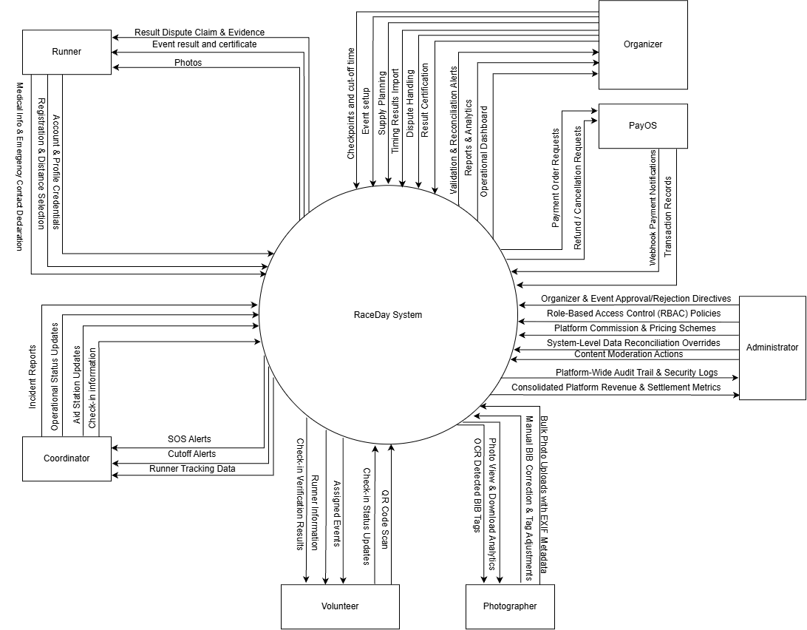

2. User Requirements

2.1 Actors
# | Actor | Description
1 | Guest | An unauthenticated specialization of User. May browse upcoming events and general public content, and create a new account. May not register for a race, complete payment, or open personal race or staff functions.
2 | User | A logged-in account that has not yet been granted an event-specific role. May manage profile and account settings, continue browsing events, submit a race registration and request organizer privileges. Event operations remain unavailable until the corresponding role is assigned or earned.
3 | Organizer | An approved event coordinator who creates and configures races, monitors registration and check-in, certifies results, handles disputes, and views participation/revenue statistics.
4 | Runner | A participant who has successfully registered for at least one event. May use the QR ticket, view personal results and leaderboards, obtain certificates, search photos by BIB, and submit result disputes.
5 | Photographer | A media contributor assigned to an event who uploads race photos in bulk, reviews low-confidence OCR BIB tags, and maintains the event gallery used by the BIB Photo Finder.
6 | Volunteer | On-site staff who scan QR tickets at check-in or checkpoints, handle basic on-site incidents, and mark special statuses within the limits set by the organizer.
7 | Coordinator | Operational lead who supports the organizer during the race: SOS and medical dispatch views, cut-off / broom-wagon decisions, and related race-day monitoring.
8 | Administrator | Platform administrator who approves organizers and events, manages users and permissions, moderates content, and oversees platform-level audit and statistics.

2.2 Use Cases

2.2.1 Diagram(s)
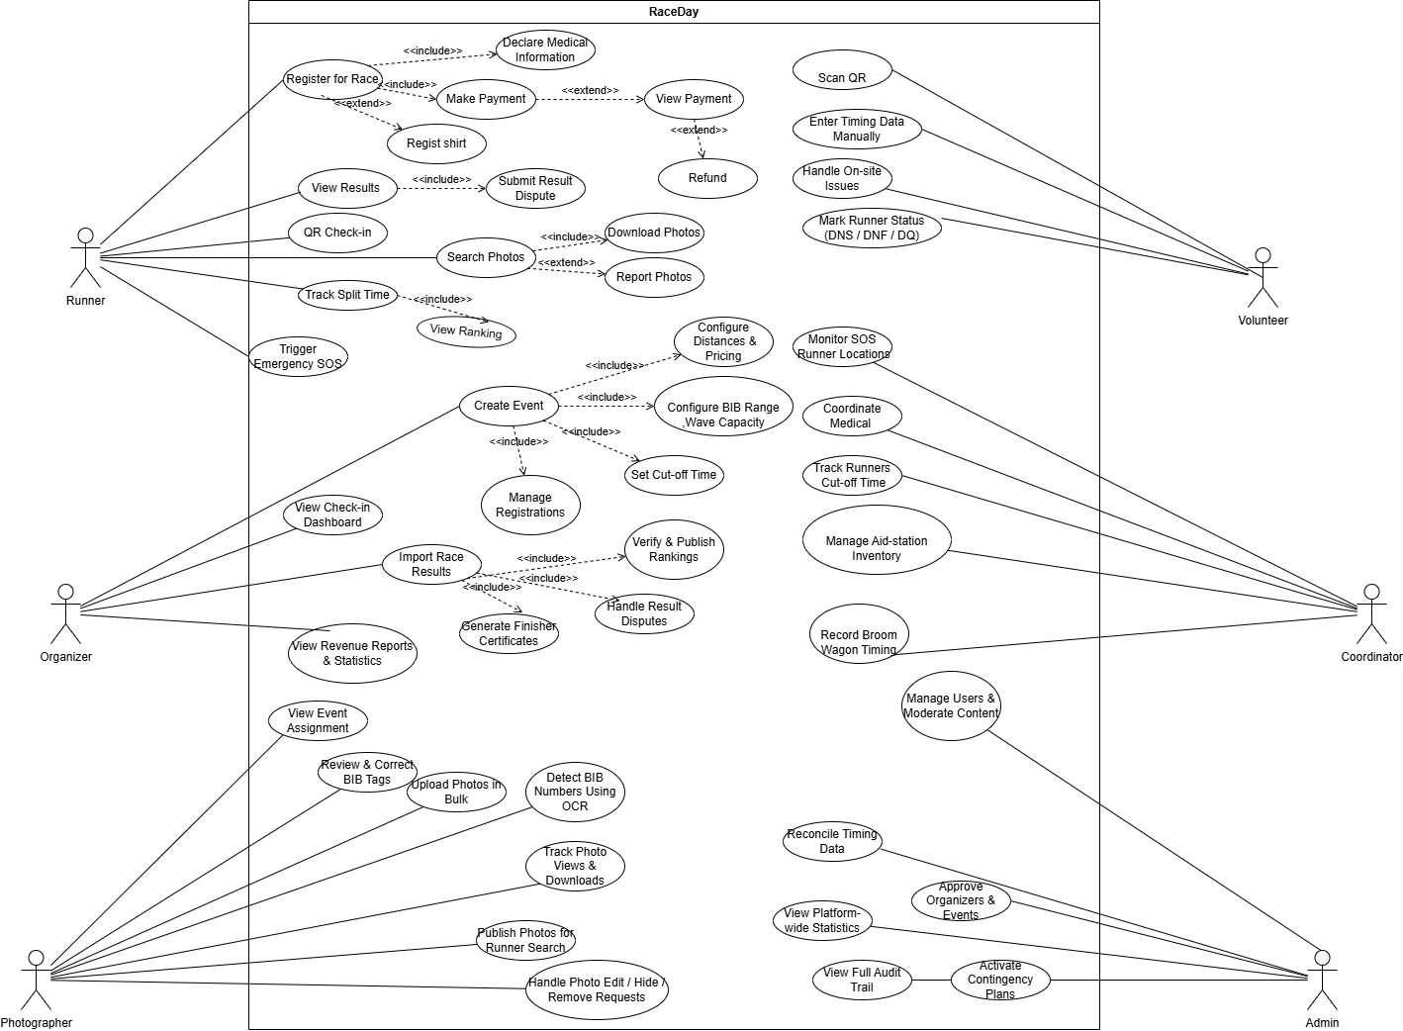

2.2.2 Descriptions
ID | Use Case | Actors | Use Case Description
01 | Register for Race | Runner | Allows runners to register for a race by providing the required personal information and selecting a race category.
02 | Provide Medical Info | Runner | Allows runners to provide medical information and emergency-related details to support safety during the event.
03 | Make Payment | Runner | Allows runners to pay the registration fee using the available payment methods.
04 | View Payment | Runner | Allows runners to view their payment details and transaction status.
05 | Request Refund | Runner | Allows runners to request a refund according to the event's refund policy.
06 | Register Shirt | Runner | Allows runners to select or register their preferred race shirt size during registration.
07 | QR Check-in | Runner | Allows runners to use their QR codes to complete the race check-in process.
08 | View Results | Runner | Allows runners to view their personal race results after the results have been published.
09 | Submit Result Dispute | Runner, Organizer | Allows runners to report incorrect race results and enables organizers to review and resolve the disputes.
10 | Search Photos | Runner | Allows runners to search for race photos associated with their BIB numbers.
11 | Download Photos | Runner | Allows runners to download photos they have found in the event gallery.
12 | Report Photos | Runner | Allows runners to report inappropriate photos or photos that require review.
13 | Track Split Time | Runner | Allows runners to view split-time information recorded at race checkpoints.
14 | View Ranking | Runner | Allows runners to view their rankings based on the published race results.
15 | Trigger Emergency SOS | Runner | Allows runners to send an emergency alert to the event operations team when assistance is needed.
16 | Create Event | Organizer | Allows organizers to create a race event and configure its basic information.
17 | Configure Distances & Pricing | Organizer | Allows organizers to define race distances, registration fees, and pricing options.
18 | Configure BIB Range, Wave Capacity | Organizer | Allows organizers to configure BIB number ranges and participant capacity for each race wave.
19 | Set Cut-off Time | Organizer | Allows organizers to define the time limit for completing a race or reaching specified checkpoints.
20 | Manage Registrations | Organizer | Allows organizers to view, manage, and update runner registration records.
21 | View Check-in Dashboard | Organizer | Allows organizers to monitor check-in progress and participant attendance during the event.
22 | Import Race Results | Organizer | Allows organizers to import race timing data or result files into the system.
23 | Verify & Publish Rankings | Organizer | Allows organizers to review race results and publish official rankings.
24 | Generate Finisher Certificates | Organizer | Allows organizers to generate finisher certificates for eligible participants.
25 | Handle Result Disputes | Organizer | Allows organizers to review runner complaints about results and update records when corrections are approved.
26 | View Revenue Reports & Statistics | Organizer | Allows organizers to view registration revenue and event-related statistics.
27 | View Event Assignment | Photographer | Allows photographers to view their assigned events and photography responsibilities.
28 | Upload Photos in Bulk | Photographer | Allows photographers to upload multiple race photos to the system.
29 | Detect BIB Numbers Using OCR | Photographer | Allows the system to analyze uploaded photos using OCR or image recognition techniques to detect visible BIB numbers.
30 | Review & Correct BIB Tags | Photographer | Allows photographers to review detected BIB numbers and manually correct inaccurate photo tags
31 | Track Photo Views & Downloads | Photographer | Allows photographers to view statistics about photo views and downloads.
32 | Publish Photos for Runner Search | Photographer | Allows photographers to publish processed photos so that runners can search for them.
33 | Handle Photo Edit / Hide / Remove Requests | Photographer | Allows photographers to review and process requests to edit, hide, or remove published photos.
34 | Scan QR | Volunteer | Allows volunteers to scan participant QR codes during check-in or at designated checkpoints.
35 | Enter Timing Data Manually | Volunteer | Allows volunteers to manually enter timing records when automated scanning or timing systems are unavailable.
36 | Handle On-site Issues | Volunteer | Allows volunteers to record and handle operational issues that occur during the race.
37 | Mark Runner Status (DNS / DNF / DQ) | Volunteer | Allows authorized volunteers to record whether a runner did not start (DNS), did not finish (DNF), or was disqualified (DQ).
38 | Monitor SOS & Runner Locations | Race-Day Operations Coordinator | Allows the operations coordinator to monitor emergency alerts and available runner-location information.
39 | Coordinate Medical | Race-Day Operations Coordinator | Allows the operations coordinator to coordinate medical personnel and ambulance responses to reported emergencies.
40 | Track Runners Against Cut-off Time | Race-Day Operations Coordinator | Allows the operations coordinator to monitor runners' progress against the configured cut-off times.
41 | Manage Aid-station Inventory | Race-Day Operations Coordinator | Allows the operations coordinator to monitor and manage supplies at race aid stations.
42 | Record Broom Wagon Timing | Race-Day Operations Coordinator | Allows the operations coordinator to record timing or progress information for the broom wagon following the last runners.
43 | Activate Contingency Plans | Race-Day Operations Coordinator | Allows authorized personnel to activate contingency procedures when unexpected situations occur during an event.
44 | Approve Organizers & Events | Administrator | Allows administrators to review and approve organizer accounts and events according to platform policies
45 | Manage Users & Moderate Content | Administrator | Allows administrators to manage user accounts and moderate content that violates platform rules.
46 | Reconcile Timing Data | Administrator | Allows administrators to review and reconcile inconsistent or conflicting race timing records.
47 | View Platform-wide Statistics | Administrator | Allows administrators to view overall platform usage and event statistics.
48 | View Full Audit Trail | Administrator | Allows administrators to review system audit records for monitoring and accountability.

3. Functional Requirements

3.1 System Functional Overview

3.1.1 Screens Flow
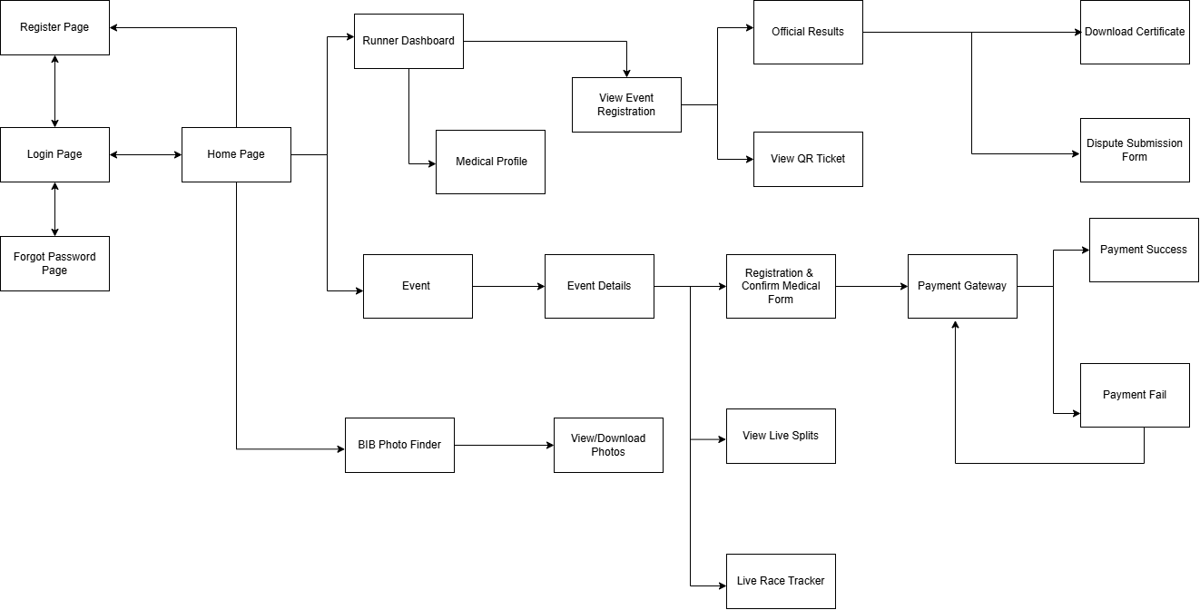
3.1.1.1 Runner Screen Flow

3.1.1.1 Runner Screen Flow
3.1.1.2 Organize Screen Flow
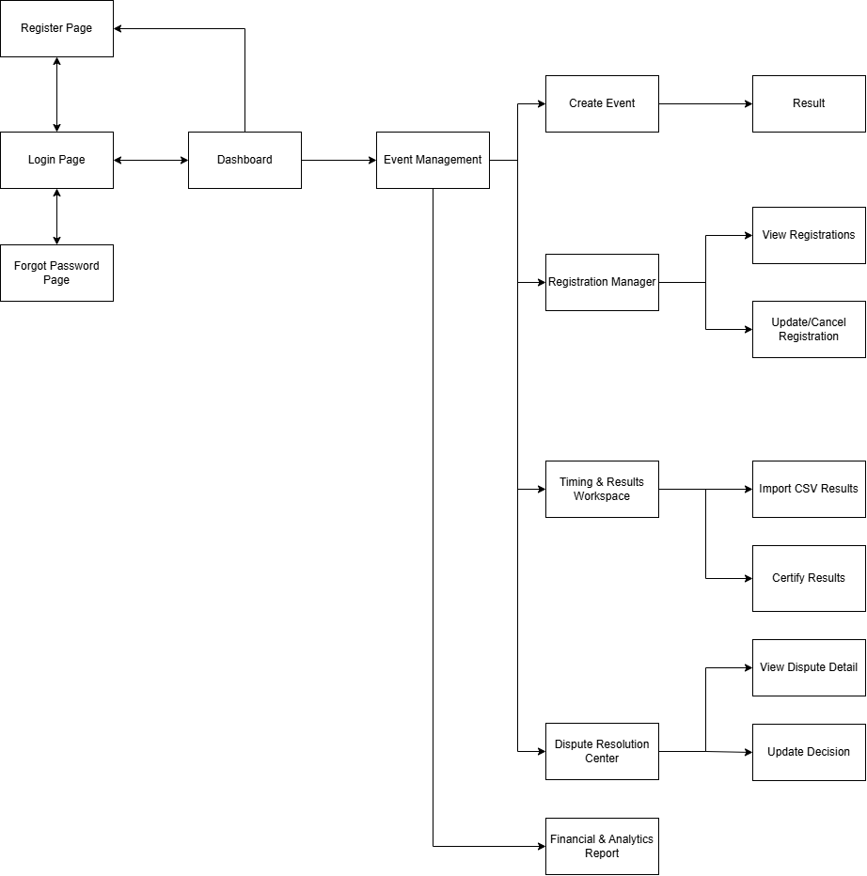
3.1.1.2 Organize Screen Flow
3.1.1.3 Photographer Screen Flow

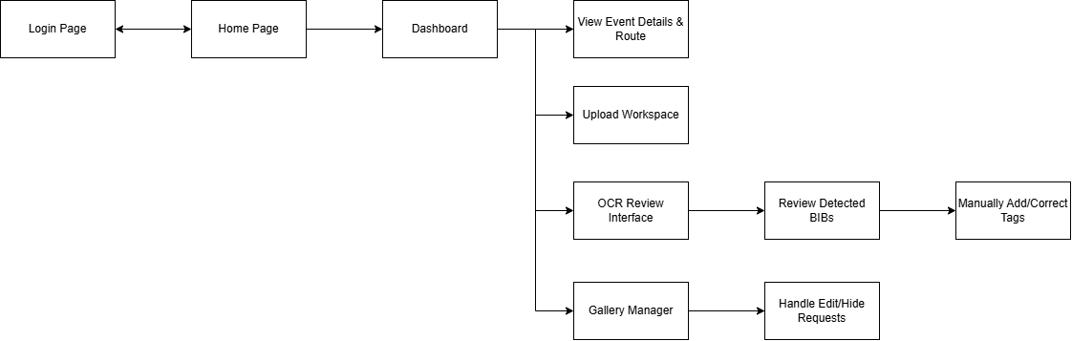
3.1.1.3Photographer Screen Flow
3.1.1.4 Volunteer Screen Flow
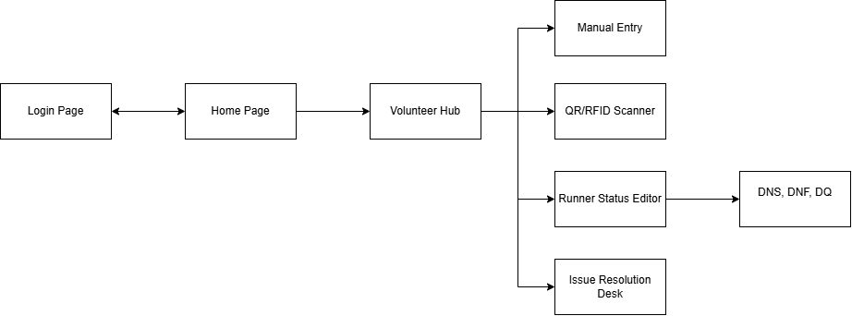
3.1.1.4 Volunteer Screen Flow
3.1.1.5 Coordinator Screen Flow
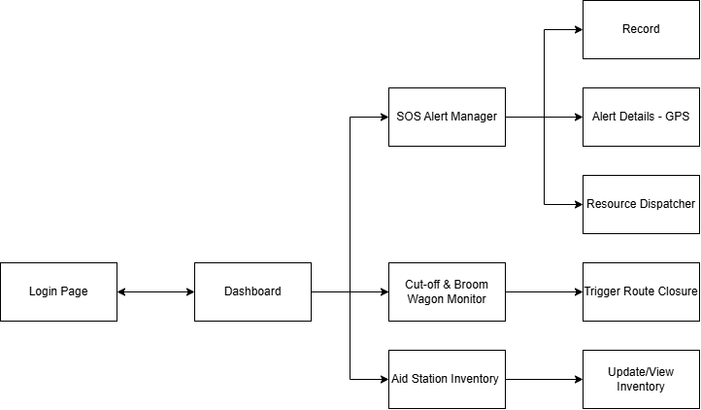
3.1.1.5 Coordinator Screen Flow
3.1.1.6 Admin Screen Flow
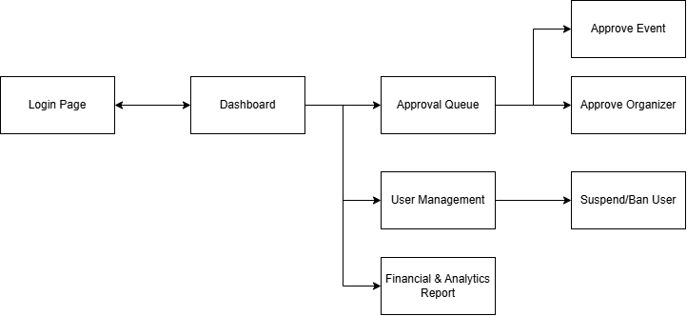
3.1.1.1 Admin Screen Flow

3.1.2 Screen Descriptions
3.1.2.1 Organizer Screen Flow
# | Feature | Screen | Description
1 | Authentication | Login | Allows organizers to sign in to RaceDay using their registered credentials.
2 | Authentication | Forgot Password | Allows organizers to request a password reset using their registered email address.
3 | Dashboard | Organizer Dashboard | Displays an overview of managed events, registrations, check-in progress, results, and financial statistics.
4 | Event Management | Event Management | Displays the list of events managed by the organizer, including their status, dates, and registration progress.
5 | Event Management | Create Event Wizard | Allows organizers to create events by entering event details, race distances, registration fees, participant capacity, schedules, and race routes.
6 | Event Management | Edit Event | Allows organizers to update event information according to event status and authorization rules
7 | Registration Management | Registration Manager | Displays participant registrations, payment status, assigned BIB numbers, and registration information.
8 | Registration Management | Registration Detail | Displays the detailed registration information of a selected participant.
9 | Registration Management | Update/Cancel Registration | Allows authorized organizers to update registration information or cancel a registration according to applicable rules.
10 | Race-Day Monitoring | Check-in Monitor | Displays check-in progress and participant attendance statistics for an event.
11 | Race-Day Monitoring | Real-time Check-in Statistics | Presents check-in counts and progress by race category, time, or check-in station.
12 | Timing & Results | Import CSV Results | Allows organizers to upload timing result files for validation and processing.
13 | Timing & Results | Raw Times Viewer | Displays imported timing records and identifies missing, duplicate, or inconsistent timing data.
14 | Timing & Results | Results Management | Allows organizers to review, correct, and calculate participant results and rankings.
15 | Timing & Results | Certify Results | Allows authorized organizers to confirm and publish official race results.
16 | Dispute Resolution | Dispute Resolution Center | Displays participant disputes related to results, rankings, or registration information.
17 | Dispute Resolution | Dispute Resolution | Displays participant disputes related to results, rankings, or registration information.
18 | Dispute Resolution | Dispute Detail | Displays the dispute description, supporting evidence, related participant data, and processing history.
19 | Dispute Resolution | Update Dispute Decision | Allows organizers to record investigation findings and update dispute decisions.
20 | Reports & Analytics | Financial Report | Displays registration revenue, payment summaries, refunds, and other available financial statistics.
21 | Reports & Analytics | Participant Statistics | Displays participant counts and statistics by event, race category, registration status, or other supported criteria.
3.1.2.2 Runner Screen Flow
# | Feature | Screen | Description
1 | Event Discovery | Home / Discovery Feed | Displays available running events and allows runners to discover events by location, date, distance, or other supported filters.
2 | Authentication | Login / Signup | Allows runners to sign in or create an account to access registration and personal features.
3 | Dashboard | Runner Dashboard | Displays the runner's registered events, upcoming races, recent results, and relevant notifications.
4 | Event Discovery | Event Details | Displays event descriptions, race categories, schedules, registration fees, capacity, and participation requirements.
5 | Registration | Registration & Medical Form | Allows runners to select a race category, enter participant information, and provide required medical and emergency contact information.
6 | Payment | Payment Gateway | Allows runners to initiate payment through the configured payment provider or sandbox integration.
7 | Payment | Payment Success | Displays successful payment confirmation and the corresponding registration status.
8 | Payment | Payment Fail | Displays payment failure information and allows runners to retry payment when permitted.
9 | Tickets | My Tickets / Wallet | Displays the runner's registrations, tickets, payment statuses, and assigned BIB numbers.
10 | Tickets | QR Ticket | Displays the registration QR code and BIB information for race-day identification and check-in.
11 | Live Race Tracking | Live Race Tracker | Displays available live race information, including recorded checkpoints, elapsed time, and split times when supported by the event's timing system.
12 | Live Race Tracking | Live Splits | Displays the runner's recorded passage times at supported checkpoints.
13 | Emergency Support | SOS Modal | Displays imported timing records and identifies missing, duplicate, or inconsistent timing data.
14 | Results | Post-Race Dashboard | Displays the runner's completed races, available results, and post-race information.
15 | Results | Official Results | Displays certified finishing times, rankings, and other published performance information.
16 | Certificates | Certificate Download | Allows runners to view or download their available race completion certificates.
17 | Dispute Resolution | Dispute Submission Form | Allows runners to submit a result or registration dispute with a description and supporting evidence.
18 | Photo Discovery | BIB Photo Finder | Allows runners to search for race photos associated with their BIB number.
19 | Photo Discovery | Photo Gallery | Displays approved and published photos associated with the runner's search results.
20 | Photo Discovery | Photo Detail / Download | Allows runners to view individual photos and download them according to the event's access and photo usage policies.
3.1.2.3 Photographer Screen Flow
# | Feature | Screen | Description
1 | Authentication | Login | Allows photographers to sign in using their registered accounts.
2 | Dashboard | Photographer Dashboard | Displays assigned events, photo upload progress, pending reviews, and photo performance statistics.
3 | Assignment Management | Assignment Inbox | Displays events and photography assignments assigned to the photographer.
4 | Assignment Management | Event Details & Route | Displays the event schedule, race route, assigned shooting locations, and relevant checkpoints.
5 | Photo Management | Upload Workspace | Allows photographers to select an event and prepare photos for upload.
6 | Photo Management | Bulk Upload Photos | Supports uploading multiple photos and displays upload progress and processing status.
7 | BIB Recognition | OCR Processing Status | Displays the processing status of automatic BIB detection and recognition tasks.
8 | BIB Recognition | Manual Tag Editor | Allows photographers to add, correct, or remove BIB tags when automatic recognition is incorrect or incomplete.
9 | BIB Recognition | OCR Review Interface | Displays detected BIB numbers and associated photos for photographer verification.
10 | Gallery Management | Gallery Manager | Displays uploaded photos and their review, publication, and visibility statuses
11 | Gallery Management | Publish Approved Photos | Allows authorized photographers to publish approved photos to the event gallery.
12 | Gallery Management | Photo Edit/Hide Requests | Allows photographers to review and process authorized requests to correct, hide, or remove photos.
13 | Analytics | Photo Performance Analytics | Displays available photo views, downloads, and other supported engagement statistics.
3.1.2.4 Volunteer Screen Flow
# | Feature | Screen | Description
1 | Authentication | Login | Allows volunteers to sign in and access their assigned race-day functions.
2 | Station Management | Volunteer Hub | Displays assigned events and allows volunteers to select an authorized station or checkpoint.
3 | Station Management | Station Dashboard | Displays the selected station, its operational status, and available participant processing functions.
4 | Checkpoint Processing | QR/RFID Scanner | Allows volunteers to scan participant QR tickets or RFID tags using supported devices and record the corresponding checkpoint event.
5 | Checkpoint Processing | Scan Success | Displays the scan result and relevant participant information, including duplicate or invalid scan warnings when applicable.
6 | Checkpoint Processing | Manual Entry | Allows volunteers to search for participants or enter a BIB number when scanning is unavailable.
7 | Checkpoint Processing | Submit BIB / Checkpoint Record | Allows volunteers to submit a verified participant passage record for the assigned checkpoint.
8 | Participant Status | Runner Status Editor | Displays participant race status and allows authorized status updates.
9 | Participant Status | Mark DNS / DNF / DQ | Allows authorized volunteers to record Did Not Start, Did Not Finish, or Disqualified statuses, subject to event rules and permissions.
10 | Participant Support | Issue Resolution Desk | Allows volunteers to search for participant registrations and resolve permitted check-in issues.
11 | Participant Support | Search & Reissue Ticket | Allows authorized volunteers to locate a participant and assist with ticket or BIB recovery according to organizer procedures
3.1.2.5 Operations Coordinator Screen Flow
# | Feature | Screen | Description
1 | Authentication | Login | Allows operations coordinators to sign in and access authorized race-day operational functions.
2 | Operations Monitoring | Ops Command Center | Displays an overview of race-day operations, checkpoint status, active incidents, and available location information.
3 | Emergency Management | SOS Alert Manager | Displays emergency alerts and their statuses for triage and response coordination.
4 | Emergency Management | Alert Details | Displays the alert details, reported GPS coordinates when available, participant information, and response history.
5 | Emergency Management | Resource Dispatcher | Allows coordinators to assign medical or other emergency response resources and update response statuses.
6 | Race Operations | Cut-off & Broom Wagon Monitor | Displays race cut-off times, checkpoint progress, and available information about sweep vehicles or participants requiring assistance.
7 | Race Operations | Route Closure / DNF Management | Allows authorized coordinators to record route closures, operational decisions, and participant status updates resulting from race incidents.
8 | Aid Station Management | Aid Station Inventory Map | Displays aid station locations and available inventory information.
9 | Aid Station Management | Inventory Details | Allows authorized coordinators to view and update station supply quantities and replenishment status.
10 | Incident Management | Contingency Log | Displays operational incidents, decisions, and related records.
11 | Incident Management | Record Operational Decision | Allows coordinators to record changes to race operations, including the reason, time, and responsible personnel.
3.1.2.6 Administrator Screen Flow
# | Feature | Screen | Description
1 | Authentication | Login | Allows administrators to sign in and access system administration functions.
2 | Dashboard | Admin Dashboard | Displays platform-wide statistics, pending approvals, moderation tasks, and system alerts.
3 | Approval Management | Approval Queue | Displays organizer and event applications awaiting administrative review.
4 | Approval Management | Organizer Approval | Allows administrators to review organizer information and approve or reject organizer applications.
5 | Approval Management | Event Approval | Allows administrators to review event information and approve, reject, or request corrections to submitted events.
6 | User Management | User Management | Displays user accounts, roles, account statuses, and available administrative actions.
7 | User Management | User Detail | Displays account information and relevant account activity for authorized administrative review.
8 | User Management | Suspend / Ban User | Allows authorized administrators to suspend or ban accounts in accordance with platform policies.
9 | Content Moderation | Moderation Queue | Displays photos and other supported content reported or awaiting moderation.
10 | finacial | financial | Displays financial

3.1.3 Screen Authorization
Screen | ORG | RUN | PHO | VOL | OPS | ADM
Login / Forgot Password | X | X | X | X | X | X
Organizer Dashboard | X |  |  |  |  | X
Event Management | X |  |  |  |  | X
Registration Manager | X |  | X |  |  | X
Check-in Monitor | X |  |  |  |  | X
Timing & Results Workspace | X | X |  | X | X | X
Dispute Resolution Center | X | X |  |  |  | X
Runner Dashboard |  | X
Payment & My Tickets |  | X
Live Race Tracker & Live Splits |  | X |  |  | X | X
SOS Alert Management |  | X |  |  | X | X
Certificate Download | X | X | X | X | X | X
BIB Photo Finder & Gallery | X | X | X | X | X | X
Photographer Dashboard |  |  | X
Photo Upload & OCR Review |  |  | X |  |  | X
Gallery Publication & Photo Requests | X | X | X | X | X | X
Photo Performance Analytics | X | X | X |  |  | X
Volunteer Hub & Station Dashboard |  |  |  | X |  | X
QR/RFID Scanner & Manual Entry |  |  |  | X | X | X
Runner Status Editor | X |  |  | X | X | X
Issue Resolution Desk | X |  |  | X |  | X
Ops Command Center & Live Map |  |  |  |  | X | X
Emergency Resource Dispatcher |  |  |  |  | X | X
Cut-off & Route Closure Management | X |  |  | X | X | X
Aid Station Inventory | X |  |  | X | X | X
Contingency Log | X |  |  | X | X | X
Admin Dashboard |  |  |  |  |  | X
Approval Queue & Organizer Approval |  |  |  |  |  | X
Event Approval |  |  |  |  |  | X
User Management & Account Suspension |  |  |  |  |  | X
Content Moderation |  |  | X |  |  | X
System Anomaly Radar & Resolution |  |  |  |  |  | X
Audit Trail Viewer |  |  |  |  |  | X
Platform Statistics |  |  |  |  |  | X

3.1.4 Non-Screen Functions
# | Feature | System Function | Description
1 | Authentication | Authentication & Authorization Service | Authenticates users and verifies their roles and permissions.
2 | Event Management | Event API Service | Manages event information, race distances, schedules, and event status.
3 | Registration | Registration Processing Service | Validates registration requests and manages participant registrations and BIB allocation.
4 | Payment | Payment Processing Service | Processes payment requests and updates payment status after verification.
5 | Ticket Management | QR Ticket Generation Service | Generates QR tickets associated with participant registrations.
6 | Race-Day Operations | Check-in Processing Service | Validates participant tickets and records check-in information.
7 | Race Timing | Finish Time Processing Service | Records finish times, calculates race duration, and updates participant status.
8 | Results Management | Result Calculation Service | Calculates finishing times and rankings based on valid timing records.
9 | Dispute Resolution | Dispute Processing Service | Stores disputes and manages their processing status and decisions.
10 | BIB Photo Finder | BIB Detection & OCR Service | Detects BIB numbers in uploaded photos to support photo searching.
11 | Photo Management | Photo Processing Service | Processes uploaded photos and manages their publication status.
12 | Emergency Management | OS Alert Processing Service | Records emergency alerts and available GPS coordinates for response coordination.
13 | Messaging & Integration | Background Message Dispatcher | Processes pending messages and supports communication between system modules.
14 | Notifications | Notification Service | Sends notifications about registrations, payments, results, and operational alerts.
 | Audit & Monitoring | Audit Logging Service | Records important system activities and administrative actions for auditing.

3.1.5 Conceptual Entity Relationship Diagram
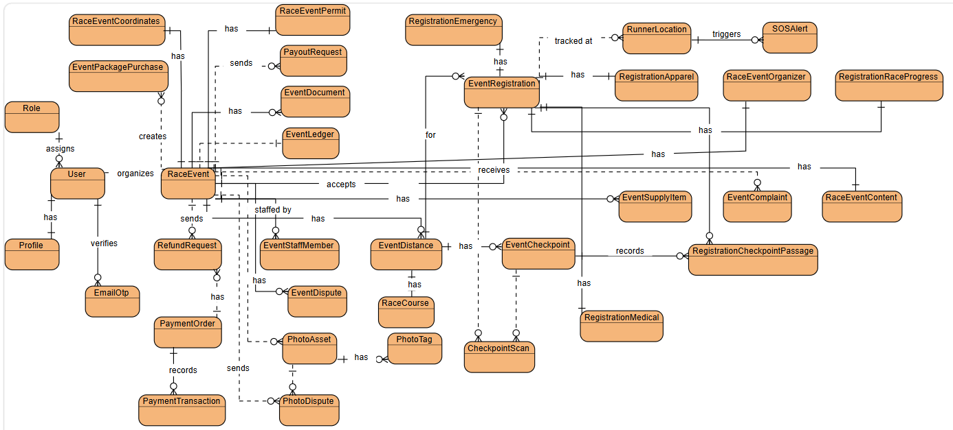
Figure 3.1.5.1 RP3-Conceptual-ERD.svg

3.1.6 Physical Entity Relationship Diagram
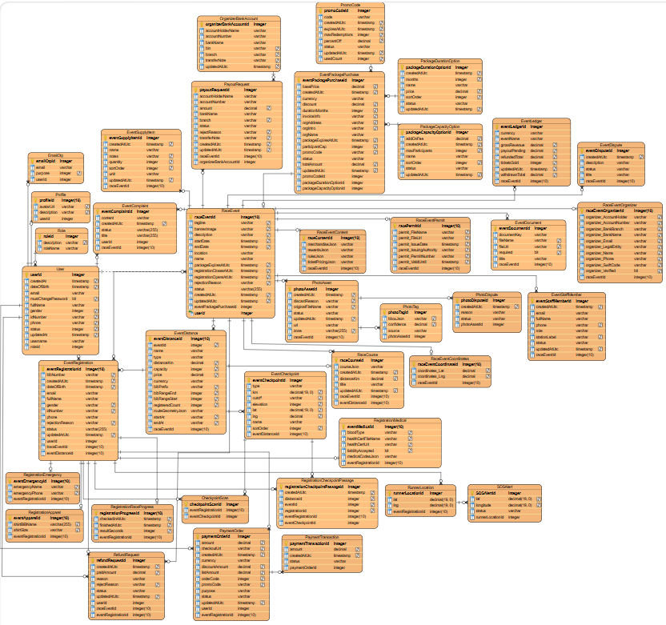

Figure 3.1.6.1 RP3-Physical-ERD.svg
Entities Description
# | Entity | Description
1 | User | Stores core account data for all system users, including credentials, contact info, status, and role assignment.
2 | Role | Defines available system roles (e.g. User, Organizer, Admin) used for authorization.
3 | Profile | Stores extended profile details for a user such as avatar, bio, and verification status.
4 | EmailOtp | Stores one-time email verification/reset codes linked to a user or email address.
5 | RaceEvent | Stores core race/event information such as name, location, dates, status, registration window, and package linkage.
6 | RaceEventContent | Stores event content payloads such as ticket pricing, merchandise, rules, and rewards (JSON).
7 | RaceEventCoordinates | Stores geographic coordinates of the event venue.
8 | RaceEventOrganizer | Stores organizer contact and bank details associated with a race event.
9 | RaceEventPermit | Stores permit/license document metadata for event approval.
10 | EventDistance | Defines race distances/categories within an event, including capacity, price, and schedule.
11 | EventCheckpoint | Stores checkpoints along a race distance (km mark, location, cutoff, type).
12 | EventDocument | Stores required/uploaded documents attached to an event.
13 | EventSupplyItem | Tracks event logistics supplies (name, quantity, unit, notes).
14 | EventStaffMember | Stores staff assigned to an event, including role, station, and contact details.
15 | EventComplaint | Stores runner/user complaints related to an event and organizer responses.
16 | EventDispute | Stores disputes raised against an event for review/resolution.
17 | EventPackagePurchase | Stores organizer package purchases used to create/host events (pricing, duration, capacity, promo).
18 | PackageDurationOption | Catalog of package duration options and base prices offered by the platform.
19 | PackageCapacityOption | Catalog of package capacity add-on options and fees.
20 | PromoCode | Stores promotional discount codes, validity, and redemption limits.
21 | EventRegistration | Stores a runner’s registration for an event distance, including personal snapshot, bib, and status.
22 | RegistrationMedical | Stores medical information for a registration (blood type, health notes/cert).
23 | RegistrationEmergency | Stores emergency contact details for a registration.
24 | RegistrationApparel | Stores apparel preferences for a registration (shirt size/type/color).
25 | RegistrationRaceProgress | Stores race progress timestamps such as check-in, start, finish, and result time.
26 | RegistrationCheckpointPassage | Records when a registered runner passes a specific checkpoint.
27 | PaymentOrder | Stores payment orders for registration or package checkout, including amount, status, and gateway refs.
28 | PaymentTransaction | Stores individual payment gateway transactions linked to a payment order.
29 | EventLedger | Tracks per-event financial summary (gross revenue, refunds, withdrawals, pending payout).
30 | PayoutRequest | Stores organizer withdrawal/payout requests and bank transfer status.
31 | RefundRequest | Stores refund requests for registrations/payments and approval outcomes.
32 | OrganizerBankAccount | Stores default bank account details for an organizer used in payouts.
33 | PhotoAsset | Stores race photo metadata (URL, zone, publish status, uploader, event).
34 | PhotoTag | Stores bib tags detected/assigned on a photo with confidence and source.
35 | PhotoDispute | Stores disputes reported against a photo for review.
36 | RaceCourse | Stores mapped course geometry for an event distance.
37 | RunnerLocation | Stores live/receive GPS locations for a registration during the race.
38 | CheckpointScan | Stores checkpoint scan events for a registration (method and timestamp).
39 | SOSAlert | Stores SOS alerts raised during race monitoring, optionally linked to a runner location.

3.2 Authentication & Account Management
This feature enables guests to create RaceDay accounts, verify email ownership via OTP, authenticate with username and password, and recover access through a password-reset flow. After authentication, access to protected functions is constrained by account status and the assigned role.

3.2.1 Registration
Function Trigger:
- From the Home Page, a Guest clicks on “Đăng ký ngay”.
- The Guest enters the required information and clicks on “Đăng ký tài khoản”.
Function Description:
Allow guests to create a new account on the RaceDay web platform to register for running events, manage their registrations, access race tickets, view race results, and search for race photos by BIB number. The account remains unverified until email confirmation is completed.
Screen Layout:

Figure 3.2.1.1 – Sign Up button on the Home Page
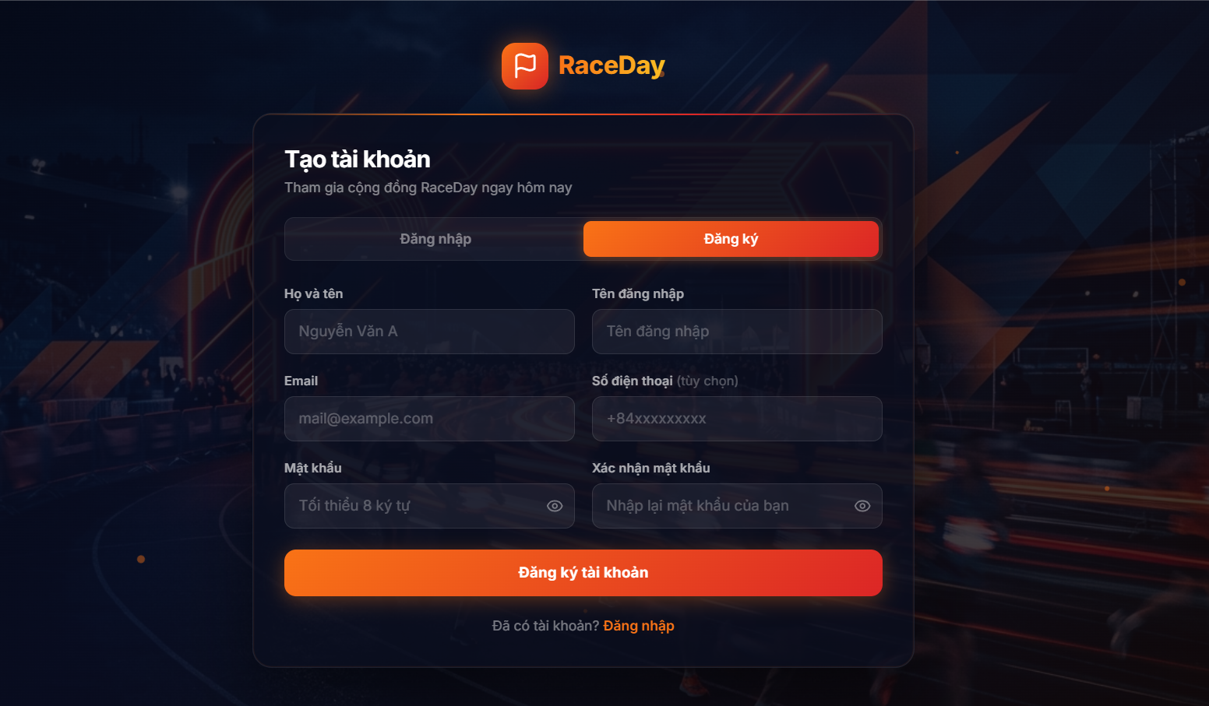
Figure 3.2.1.2 – Register Account Page
Function Details:
Fields:
- Full name
- Username
- Email
- Phone number
- Password
- Confirm password
- Create Account button
- Link to Login page
Data Processing:
- Validate the required fields and email format.
- Validate username format and uniqueness.
- If a phone number is provided, validate it against the accepted mobile format.
- Validate password length and confirm that Password matches Confirm password.
- Reject registration when the email is already associated with a verified account.
- Securely hash the password before storing it.
- Create with the system default role User and status Pending; email is marked unverified.
- Generate a 6-digit email-verification OTP, store only its hash, and send it to the registered email.
- Redirect the user to the Email Verification Page with the registered email pre-filled.
Business Rules:
- Each email address and each username must be unique among active registrations.
- Users must not assign themselves privileged roles (For example: Administrator).
- Newly registered accounts follow the system default role and Pending status until email verification succeeds.
- Password confirmation is enforced on the client; only the password value is submitted to the server.
- Protected system functions remain unavailable until the user authenticates with a verified, eligible account.

3.2.2 Email Verification
Function Trigger:
- After successful registration, the user is directed to the Email Verification Page.
- From Email Verification Page enter 6 digits OTP and click on “Xác thực Email”.
- The user may request a new OTP via “Gửi lại mã” after the client-side resend cooldown (60 seconds).
Function Description:
Verifies ownership of the email address used at registration by confirming a 6-digit OTP delivered through SMTP. After successful verification, the account becomes eligible to log in and to use runner-facing RaceDay functions (event registration, tickets, results, and BIB photo search), subject to role and status checks.
Screen Layout:

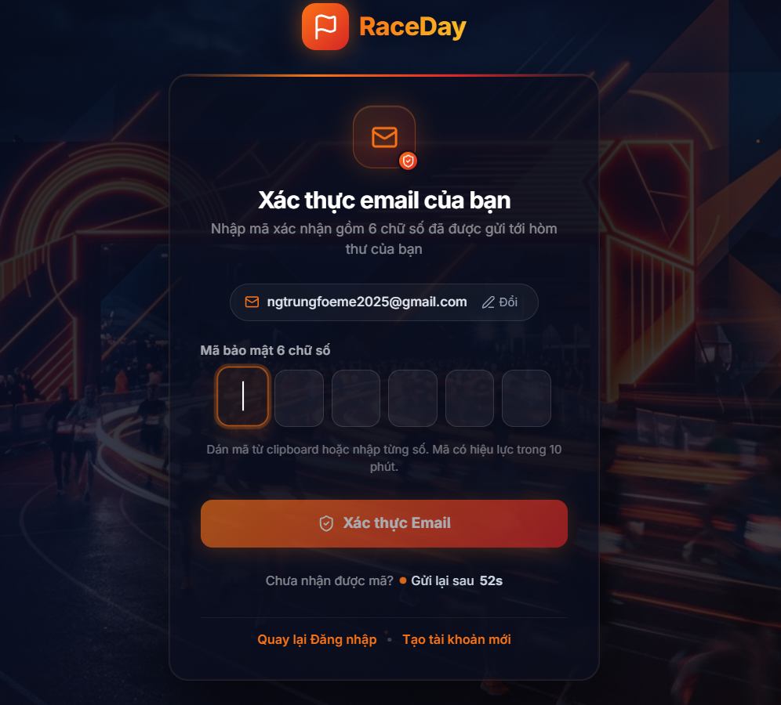
Figure 3.2.2.1 – Email Verification Page
Function Details:
Fields:
- Email display, with an option to change the email used for verification
- 6-digit OTP input
- Email Verification button
- Resend OTP control
- Link to Login page
- Link to Register page
Data Processing:
- Validate email format and that the OTP consists of exactly 6 digits.
- Locate the account associated with the email.
- Reject verification when no matching unverified account exists, or when the OTP is invalid, expired, or has exceeded the allowed number of failed attempts (maximum 5).
- On success, mark the email as verified, transition the account from Pending to Active when applicable, invalidate the consumed OTP, and redirect the user to the Login Page.
- On resend, invalidate any previous active verification OTP for that email, issue a new OTP, and send it by email.
Business Rules:
- Each user must have a unique email address.
- OTP codes are time-limited (10 minutes), stored as hashes, and invalidated after successful use or after too many failed attempts.
- Resend is rate-limited on the client (60-second cooldown) to reduce repeated submission.
- An already verified and active account may be treated as successfully verified without issuing a new OTP.
- Display a clear error when verification fails; do not expose unrelated account internals.

3.2.3 Login
Function Trigger:
- From the Home Page, a registered user clicks on “Đăng nhập”.
- On the Login Page, the user enters their username and password and clicks on “Đăng nhập”.
Function Description:
Allows a registered user to authenticate with RaceDay and obtain an access token (session) so that subsequent requests are authorized according to account status, assigned role, and permissions.
Screen Layout:
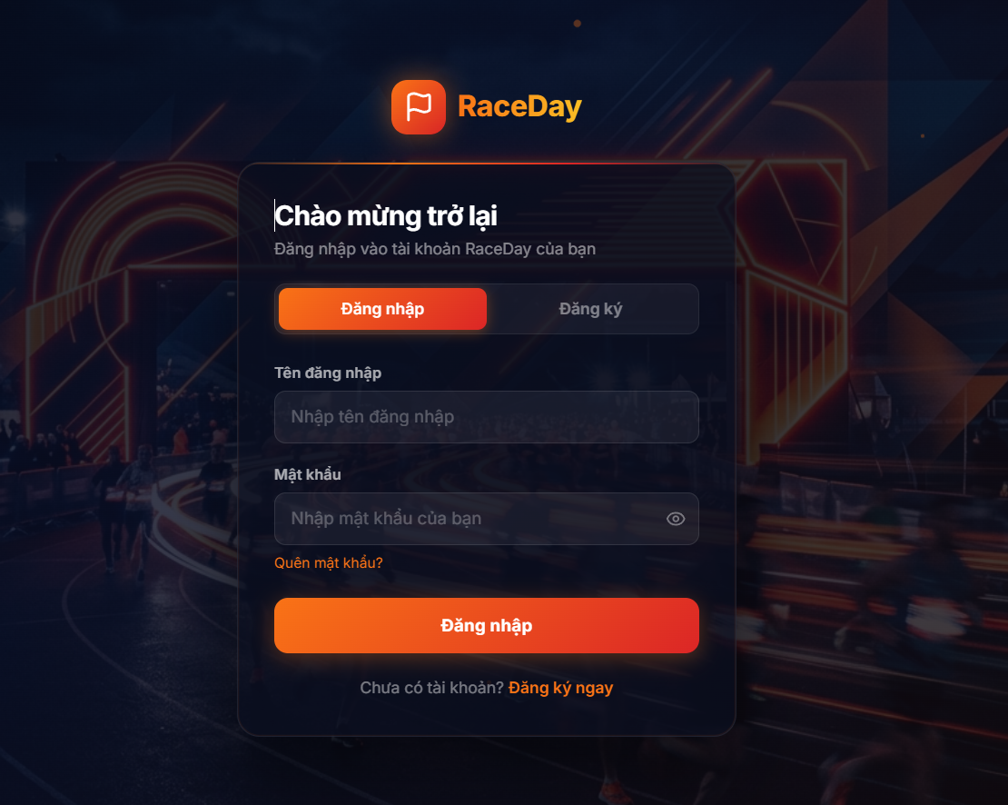
Figure 3.2.3.1 – Login Page
Function Details:
Fields:
- Username
- Password
- Link to Forgot Password
- Login button
- Link to Register page
Data Processing:
- Validate that username and password are provided.
- Resolve the account by username and verify the password against the stored password hash.
- Enforce account eligibility: reject locked accounts; reject accounts that are still Pending or whose email is not verified.
- On success, issue an authentication token (and related profile claims) and redirect the user to the Home Page, or to the safe return path supplied by the client when present.
- On failure, display a generic authentication error that does not disclose whether the username exists.
Business Rules:
- Authentication uses username and password
- Only accounts with valid credentials and an eligible status may be authenticated.
- Successful login does not by itself grant every system capability; authorization still depends on role and feature policies.
- Error messages must not reveal sensitive account details.

3.2.4 Forgot Password
Function Trigger:
- On the Login Page, a user clicks on “Quên mật khẩu?”.
- On the Forgot Password Page, the user submits the registered email to request a reset OTP.
- On the Password Recovery Page, the user enters the OTP, a new password, and password confirmation, then selects “Đặt lại mật khẩu”.
Function Description:
Allows a user to regain access by resetting the account password after proving control of the registered email through a time-limited OTP.
Screen Layout:
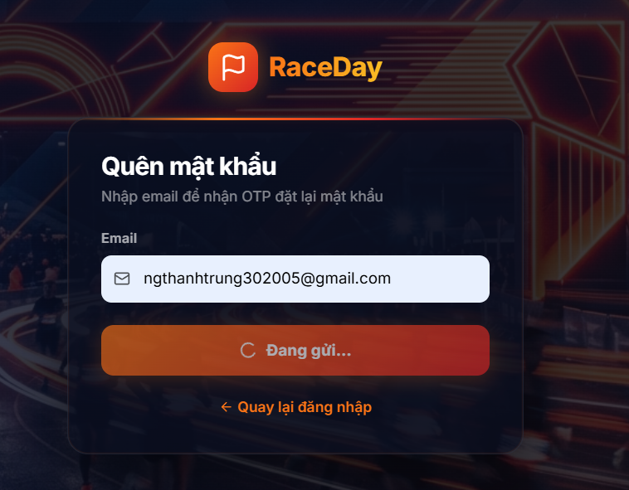
Figure 3.2.4.1 – Forgot Password link on the Login Page
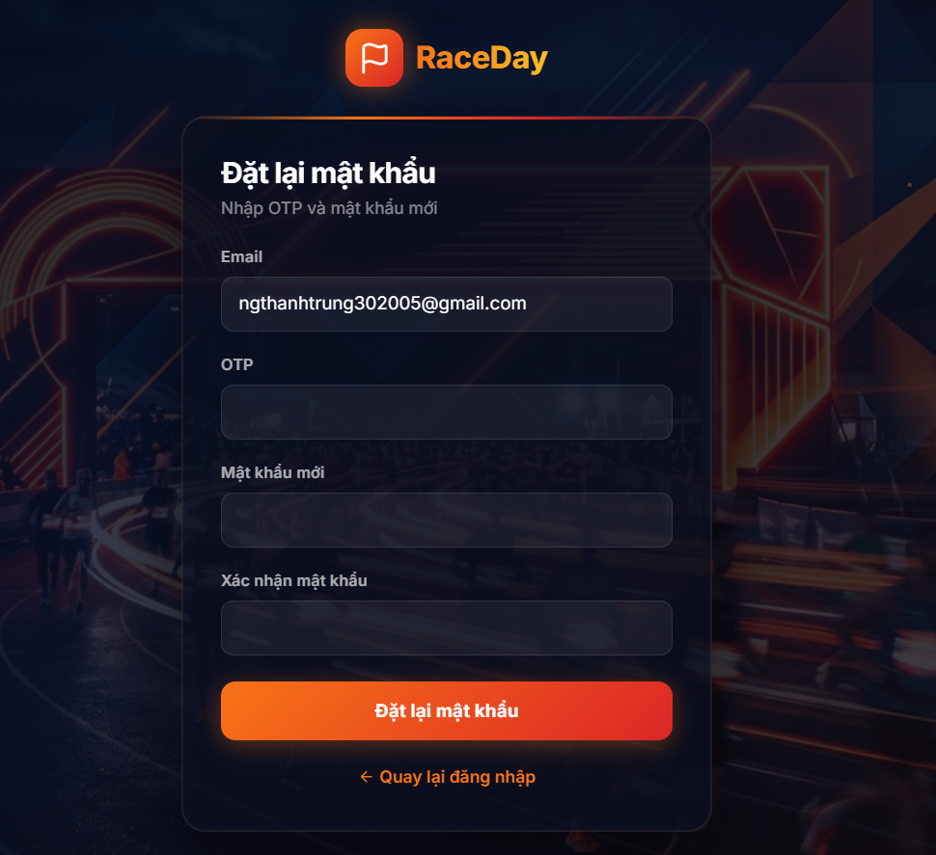
Figure 3.2.4.2 – Password Recovery Page
Function Details:
Fields (request step):
- Email
- Submit button
- Link to Login Page
Fields (reset step):
- Email
- 6-digit OTP
- New password
- Confirm password
- Reset Password button
- Link to Login page
Data Processing:
- Validate email format on the request step.
- If the email belongs to an eligible account, generate a 6-digit password-reset OTP (hash stored; validity 10 minutes) and send it by email. Locked accounts do not receive an OTP.
- Always return a neutral success response so that the interface does not disclose whether the email is registered.
- On the reset step, validate email, OTP length, password length (minimum 8 characters), and password confirmation on the client.
- Verify the OTP for the password-reset purpose; on success, replace the password hash, invalidate the OTP, and confirm completion.
- Redirect the user to the Login Page after a successful reset.
Business Rules:
- Password recovery must prove control of the registered email via OTP before the password may be changed.
- Recovery OTPs are securely hashed, time-limited, single-use after success, and invalidated after excessive failed attempts.
- The system must not disclose whether a given email address is registered.
- The new password must satisfy the system password policy (minimum length enforced by the server; confirmation enforced on the client).

3.2.5 Profile
Function Trigger:
- An authenticated user selects “Hồ sơ của tôi” from the user navigation menu.
- From the Personal Profile Page, the user may select “Chỉnh sửa hồ sơ” to open the Personal Profile Edit Page.
Function Description:
Allows an authenticated user to view personal account information, update editable profile attributes (including avatar), change the account password, and review a short list of recent event registrations linked to the account.
Screen Layout:
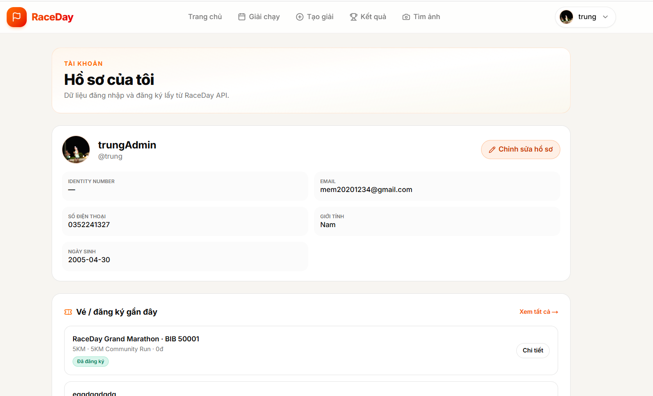
Figure 3.2.5.1 – Personal Profile Page

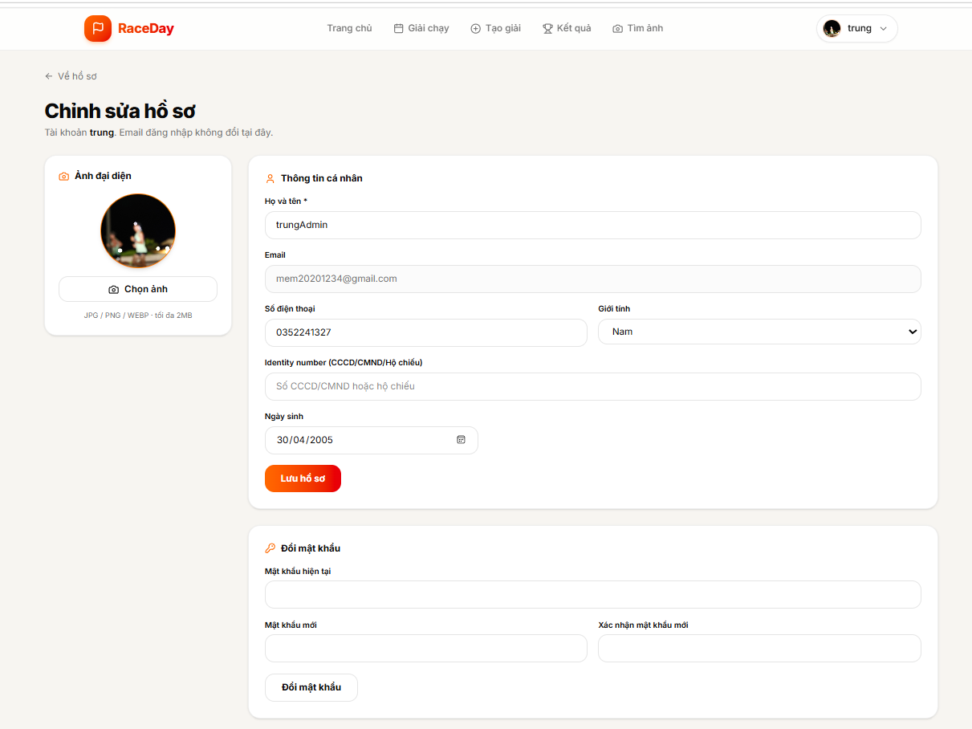
Figure 3.2.5.2 – Personal Profile Edit Page

Function Details:
Fields (view):
- Avatar
- Full name
- Username
- Email
- Phone number
- Gender
- Date of birth
- Identity number
- Edit Profile button
- Recent registrations
Fields (edit - profile):
- Profile image selection
- Full name
- Email
- Phone number
- Gender
- Identity number
- Date of birth
- Save Profile button
Fields (edit - change password):
- Current password
- New password
- Confirm new password
- Change Password button
Data Processing:
- When the user opens “Hồ sơ của tôi”, the system loads the current profile from the authenticated account and displays the Personal Profile Page, including a summary of recent registrations when available.
- When the user selects “Chỉnh sửa hồ sơ”, the system opens the Personal Profile Edit Page with the current values pre-filled. Email remains non-editable.
- For profile updates, the system validates submitted fields, optionally uploads a new avatar when a file is selected, and persists the editable profile attributes.
- For password changes, the system verifies the current password, validates the new password and client-side confirmation, then replaces the stored password hash.
- On success, the system confirms the update; on failure, it returns an appropriate validation or authorization error.
Business Rules:
- Only an authenticated user may view or update their own profile.
- Email and username are not changed through the profile edit function.
- Avatar files must be an accepted image type (JPG/JPEG, PNG, WEBP) and must not exceed 2 MB.
- Phone number, date of birth, gender, and identity number must satisfy the system validation rules when provided.
- The new password must satisfy the system password requirements (minimum length enforced by the server; confirmation enforced on the client).
- Changing the password or profile data must not alter unrelated account records (for example, event registrations remain intact).

3.2.6 Logout
Function Trigger:
An authenticated user clicks on “Logout” from the user navigation menu.
Function Description:
Allows an authenticated user to end the current authenticated session and return to a publicly accessible page.
Screen Layout:
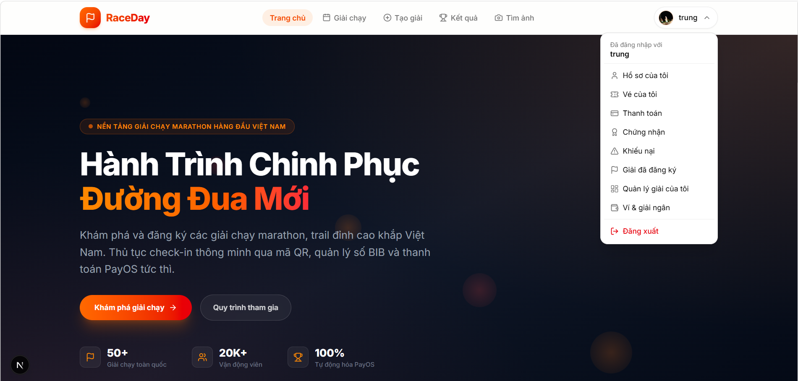
Figure 3.2.6.1 – Logout option in the user navigation menu
Function Details:
Data Processing:
- The user selects “Logout”.
- The system terminates the active session or invalidates the applicable authentication credentials.
- The client clears authentication information where applicable.
- The system redirects the user to a public page (Home Page).
Business Rules:
- After logout, previously issued session credentials must not grant access to protected functions.
- Logout must not delete the user's account or associated data.
- Public pages may remain accessible after logout.

3.3 Event Management
This feature allows Organizers to create and manage running events, configure race distances and registration settings, and submit events for administrative approval when required.

3.3.1 Create Event
Function Trigger:
- The Organizer clicks “Tạo giải mới” on the Organizer Event List screen.
Function Description:
Allow an Organizer to purchase an event package, complete the event profile, and submit the event for approval. After payment succeeds, the system creates a draft event and opens its profile for the Organizer to complete.
Screen Layout:
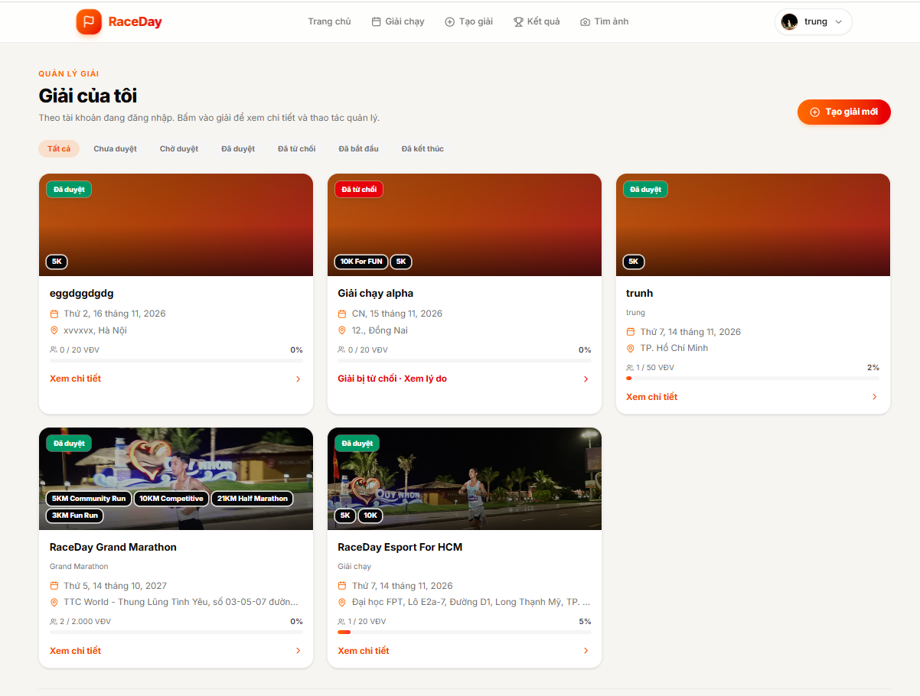
Figure 3.3.1.1 – Organizer Event List

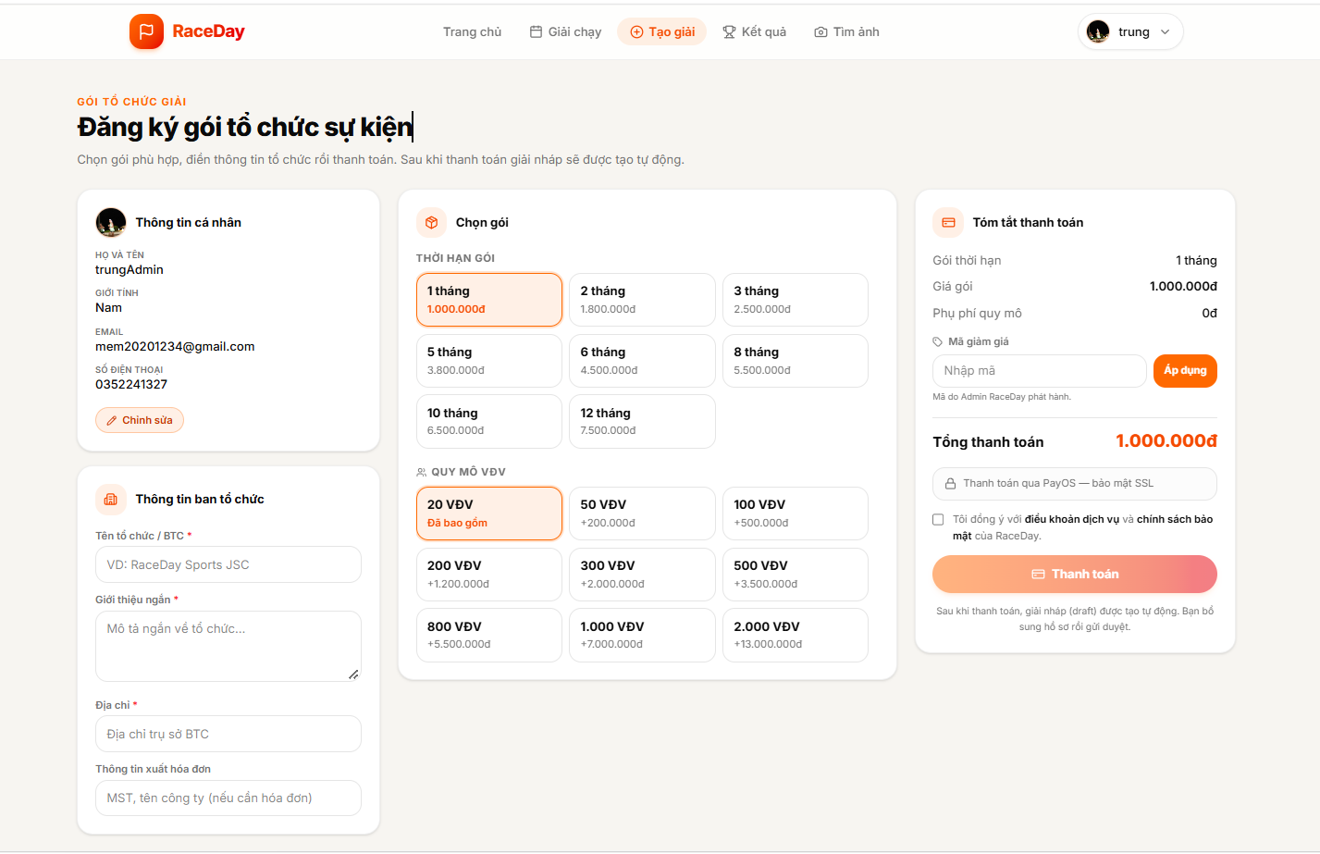
Figure 3.3.1.2 – Create Event Form
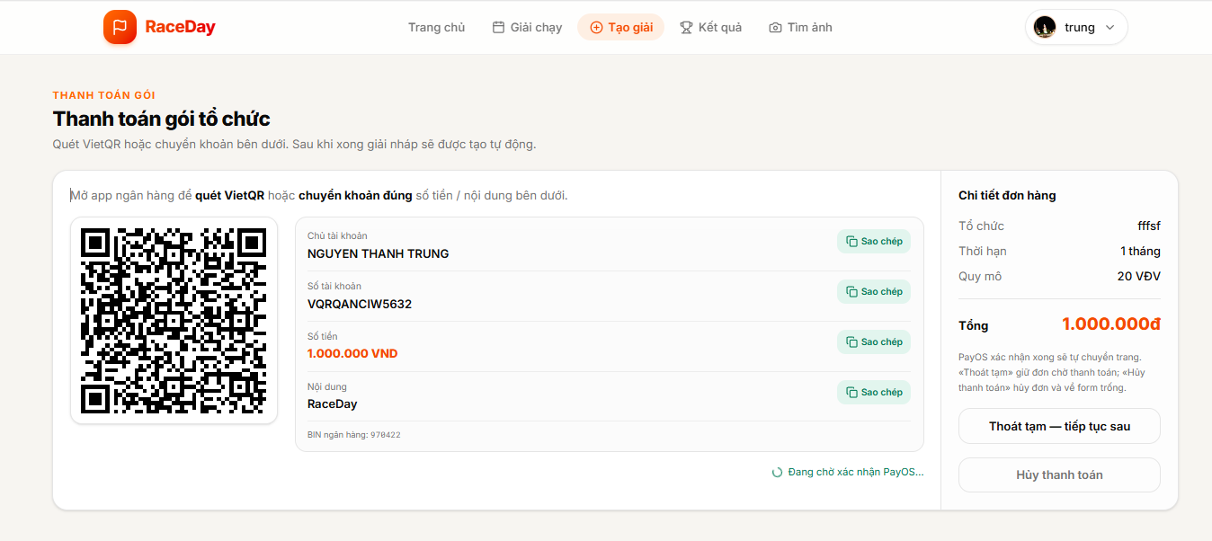
Figure 3.3.1.3 – Payment Form
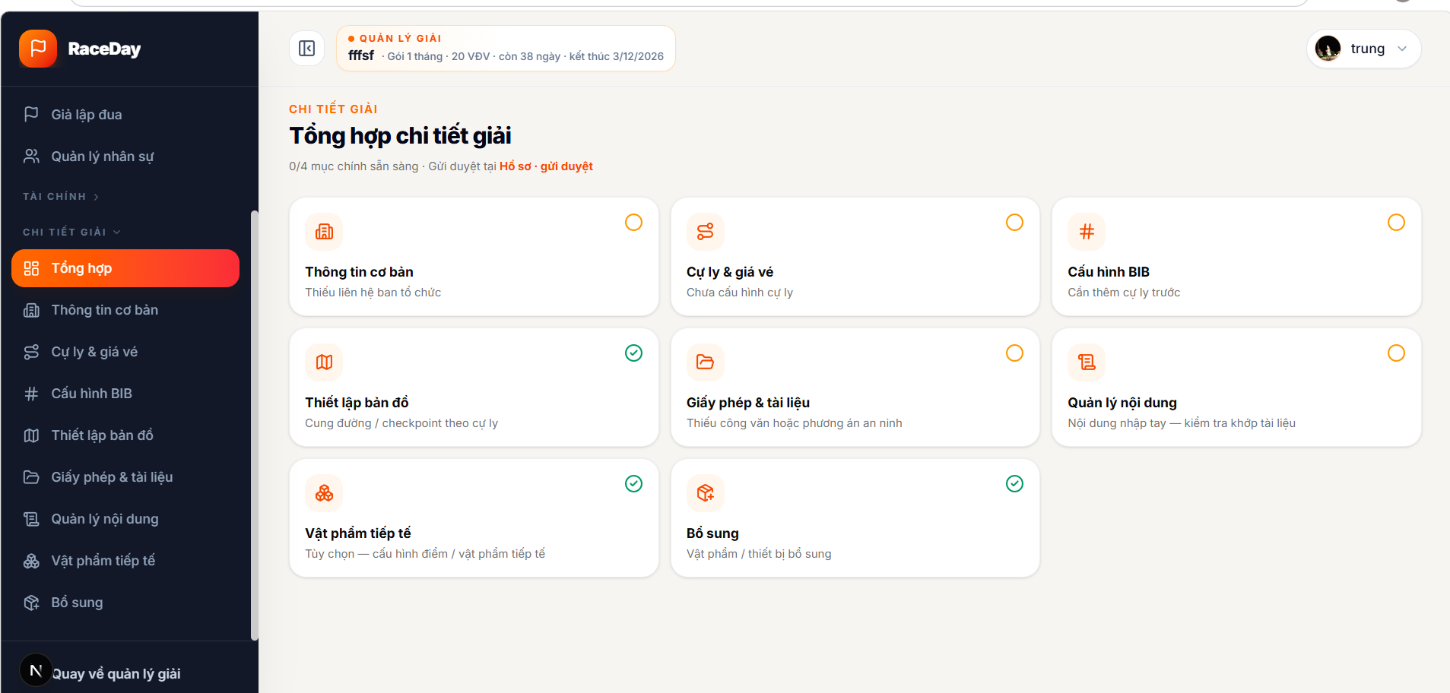
Figure 3.3.1.4 – Event details after payment

Function Details:
Fields:
Organizer Event List: The Organizer’s events, with filters for status and event cards showing the event name, location, date, banner image, distances, and current status.
Create Event / Package Form:
- Organizer name
- Organizer introduction
- Organizer address
- Invoice information, optional
- Package duration
- Participant capacity
- Promo code, optional
- Terms acceptance
Payment Form: Package details, price, promo discount, and payment through PayOS.
Event Profile after Payment:
- Event name
- Tagline, optional
- Location
- Event date and start time
- End date, optional
- Description
- Banner image, optional
- Participant capacity
- Registration opening and closing dates
- Organizer contact and beneficiary bank details
- Race distances and ticket prices
- Required event documents
- Draft-saving and approval-submission actions
Data Processing:
- Validate the required organizer details, package selection, participant capacity, and terms acceptance.
- Create a package purchase and start the payment checkout.
- Confirm the payment result.
- After successful payment, create a draft event and assign it to the Organizer’s account.
- Open the new event’s profile so the Organizer can complete the event details, distances, and documents.
- Save the event as a draft or submit it for approval.
- Show the event and its current status in the Organizer Event List.
Business Rules:
- The Organizer must be logged in to purchase a package and create an event.
- Organizer name, introduction, address, package duration, participant capacity, and terms acceptance are required to continue to payment.
- An event is created only after successful package payment, and starts in draft status.
- Only the event owner or an administrator may manage the event profile.
- Event dates, registration dates, capacity, and race distances must meet the system’s validation rules.
- An event awaiting approval cannot open registration. After approval, the Organizer must open registration separately.

3.3.2 Manage Event Basic Information
Function Trigger:
Organizer opens “Thông tin cơ bản” in the event profile.
Function Description:
View and update an event’s basic information and organizer contact details.
Screen Layout:
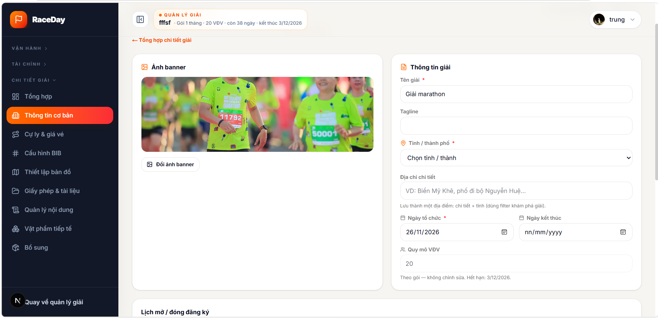
Figure 3.3.2.1
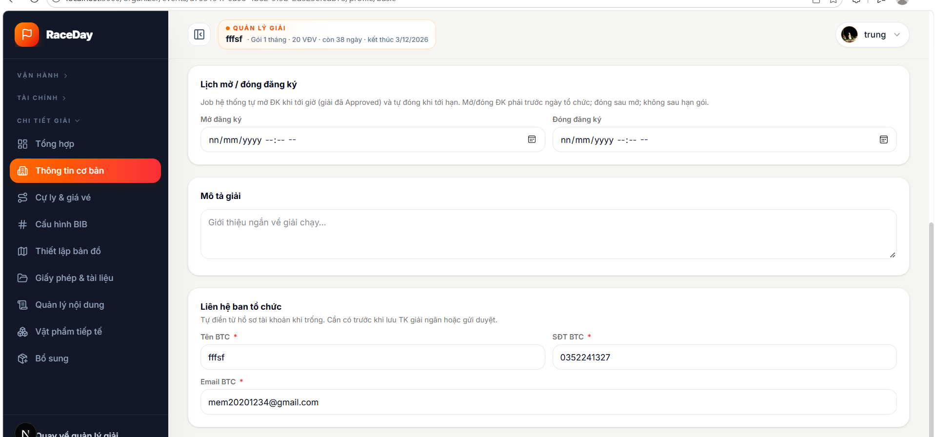
Figure 3.3.2.2
Function Details:
Displayed Information:
- Event name, tagline, location, event dates, description, banner image
- Participant capacity
- Registration opening and closing times
- Organizer name, phone, and email
- Optional payout bank account details
Data Processing:
- Retrieve events associated with the authenticated Organizer.
- Display the event list and current statuses.
- Allow the Organizer to open an event's details.
- Validate permissions before processing an update.
- Save valid changes and refresh the displayed information.
Business Rules:
- Event name, location, and event date are required.
- Registration must close after it opens and before the event date.
- Package-based participant capacity cannot be changed here.
- Approval submission is a separate step.

3.3.3 Configure Event Distances and Pricing
Function Trigger:
The Organizer opens an event’s management page and selects “Cự ly & giá vé”.
Function Description:
Allow the Organizer to add, update, and remove an event’s race distances, set capacity and start/cutoff times for each distance, and configure ticket prices.
Screen Layout:
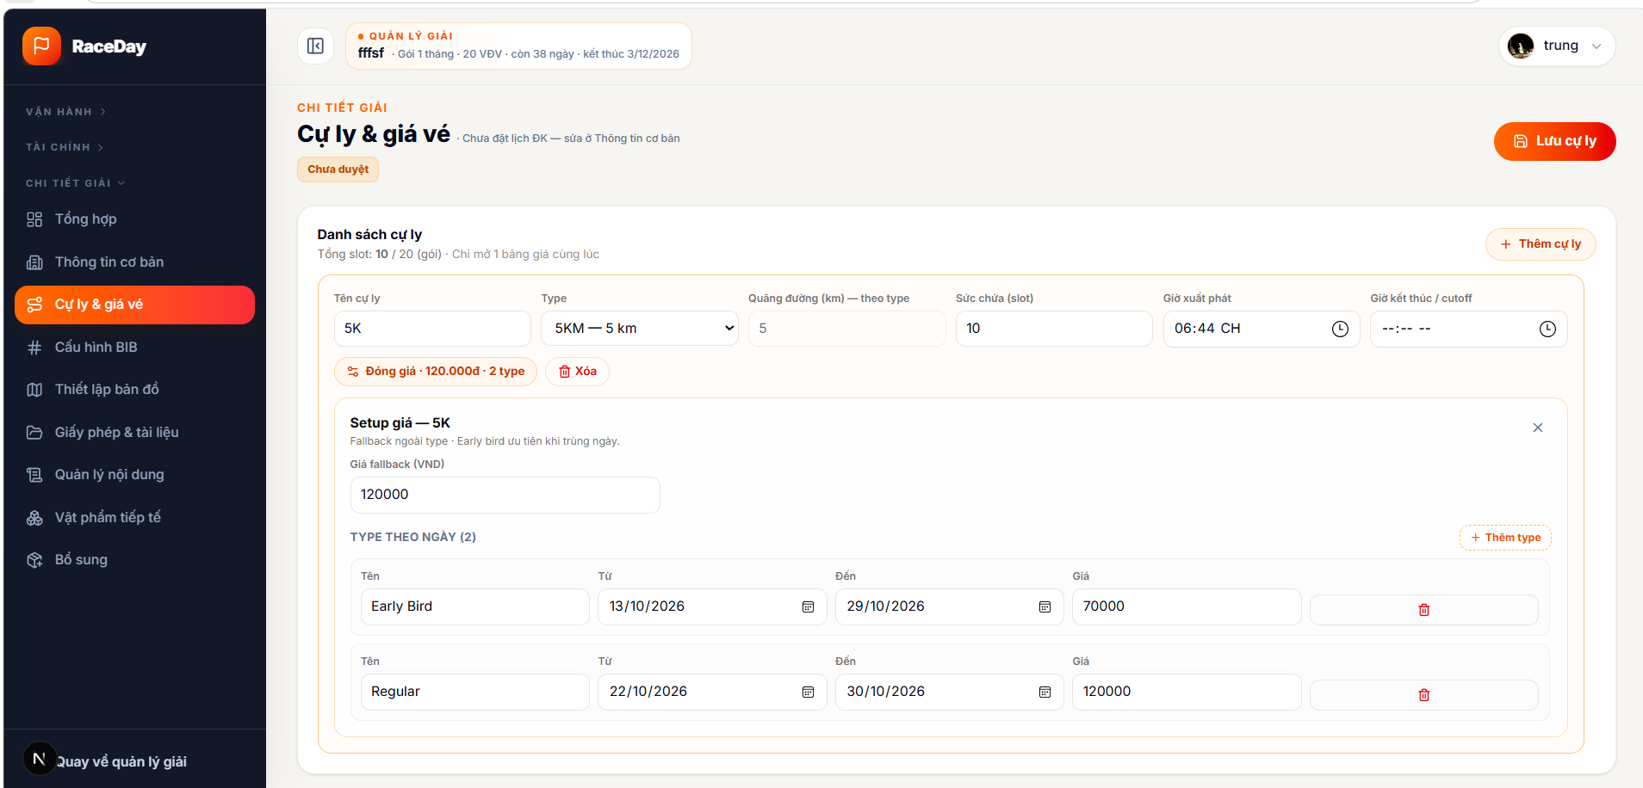
Figure 3.3.2.1 – Event Distance and Pricing Configuration Page
Function Details:
Fields:
- Distance Name
- Distance Type
- Distance (km)
- Participant Capacity
- Start Time
- Cutoff Time
- Fallback Price (VND)
- Price Type Name
- Price Type Start Date
- Price Type End Date
- Price Type Price
Data Processing:
- Load the event’s existing distances and prices.
- Validate and save the updated configuration.
- Display a success message or validation errors.
Business Rules:
- At least one distance is required.
- Distance name, length, and capacity must be valid.
- Prices must be between 0 and 100,000,000 VND.
- Total distance capacity cannot exceed the package capacity.
- Capacity cannot be lower than existing registrations or conflict with a configured BIB range.
- Distances with registrations cannot be removed.
- The registration period is managed separately in “Thông tin cơ bản”.

3.3.4 Configure Event BIB
Function Trigger:
The Organizer opens “Cấu hình BIB” for an event.
Function Description:
Configure a BIB prefix and number range for each race distance. The system uses these ranges when assigning BIB numbers to approved registrations.
Screen Layout:

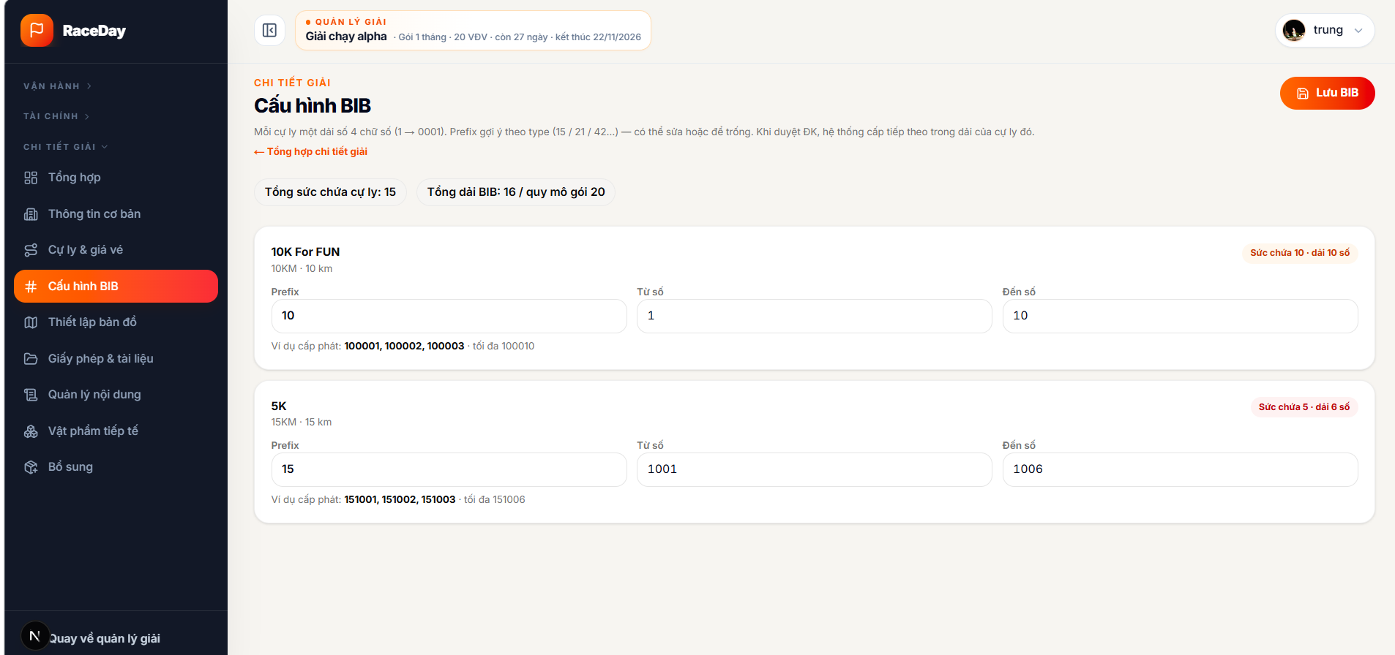
Function Details:
- Load the event’s race distances, capacities, and any existing BIB prefixes and number ranges.
- Suggest a prefix for each distance based on its type, and display a preview of the BIB numbers that the range will produce.
- Validate that every distance has a range, the numbers are within 0001–9999, each range matches its distance capacity, and ranges do not overlap.
- Submit the complete configuration to the API and save it for the event.
- Reload the saved configuration and show a success message. If validation or saving fails, show the relevant error so the Organizer can correct it.
- Use the saved range when assigning BIB numbers to registrations.
Business Rules:
- At least one distance must exist, and every distance needs a BIB range.
- BIB numbers must be from 0001 to 9999. The range size must match the distance capacity.
- Ranges cannot overlap, and total BIB slots cannot exceed the event/package capacity.
- A prefix is optional; if provided, it can contain up to 12 letters or numbers and may end with a hyphen.
- Completed, cancelled, or suspended events cannot have their BIB configuration changed.

3.3.5 Configure Event Distance Map
Function Trigger:
The Organizer opens “Thiết lập bản đồ” and selects a distance.
Function Description:
Create and save a separate race route for each distance, including its start, finish, checkpoints, and aid stations.
Screen Layout:

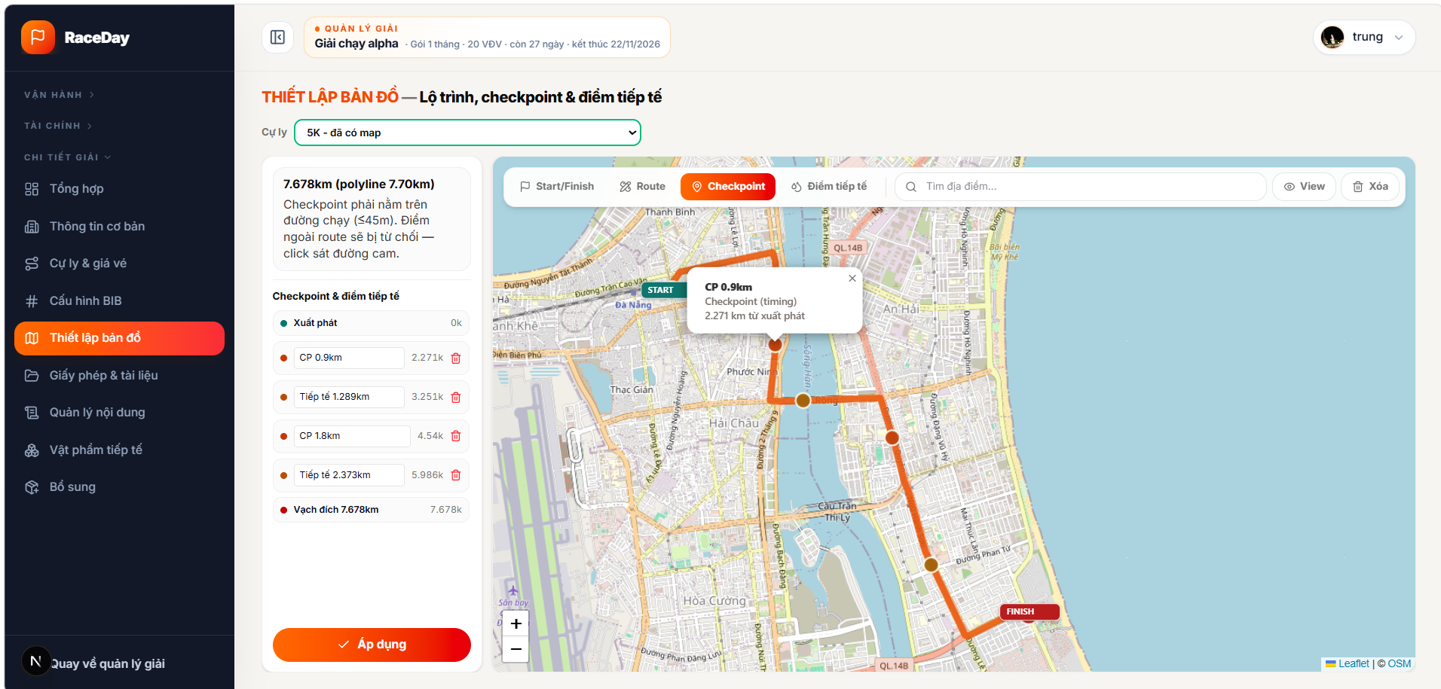

Function Details:
- Load the event’s distances and the saved map configuration for the selected distance.
- Let the Organizer search for a place, set start and finish points on the map, and adjust the route. The system requests a road route and snaps it to the map.
- Allow checkpoints and aid stations to be added along the route; their distance from the start is calculated. The Organizer can rename or remove these points.
- When the Organizer applies the changes, save the route and points for the selected distance.
- Show a success message after saving, or an error message if the route cannot be created or saved.
Business Rules:
- At least one event distance must exist before map setup.
- A route needs both a start and finish before it can be applied.
- Checkpoints and aid stations require a route and must be within 45 meters of it; they must be placed between the start and finish.
- Routes are saved separately per distance.
- Only the event Organizer or an administrator can save the course.

3.3.4 Manage Event Staffs
Function Trigger:
The Organizer opens an event’s management page and selects “Quản lý nhân sự”.
Function Description:
Invite staff to an event, assign them a role and station or duty, update their assignment, and remove them from the event.
Screen Layout:
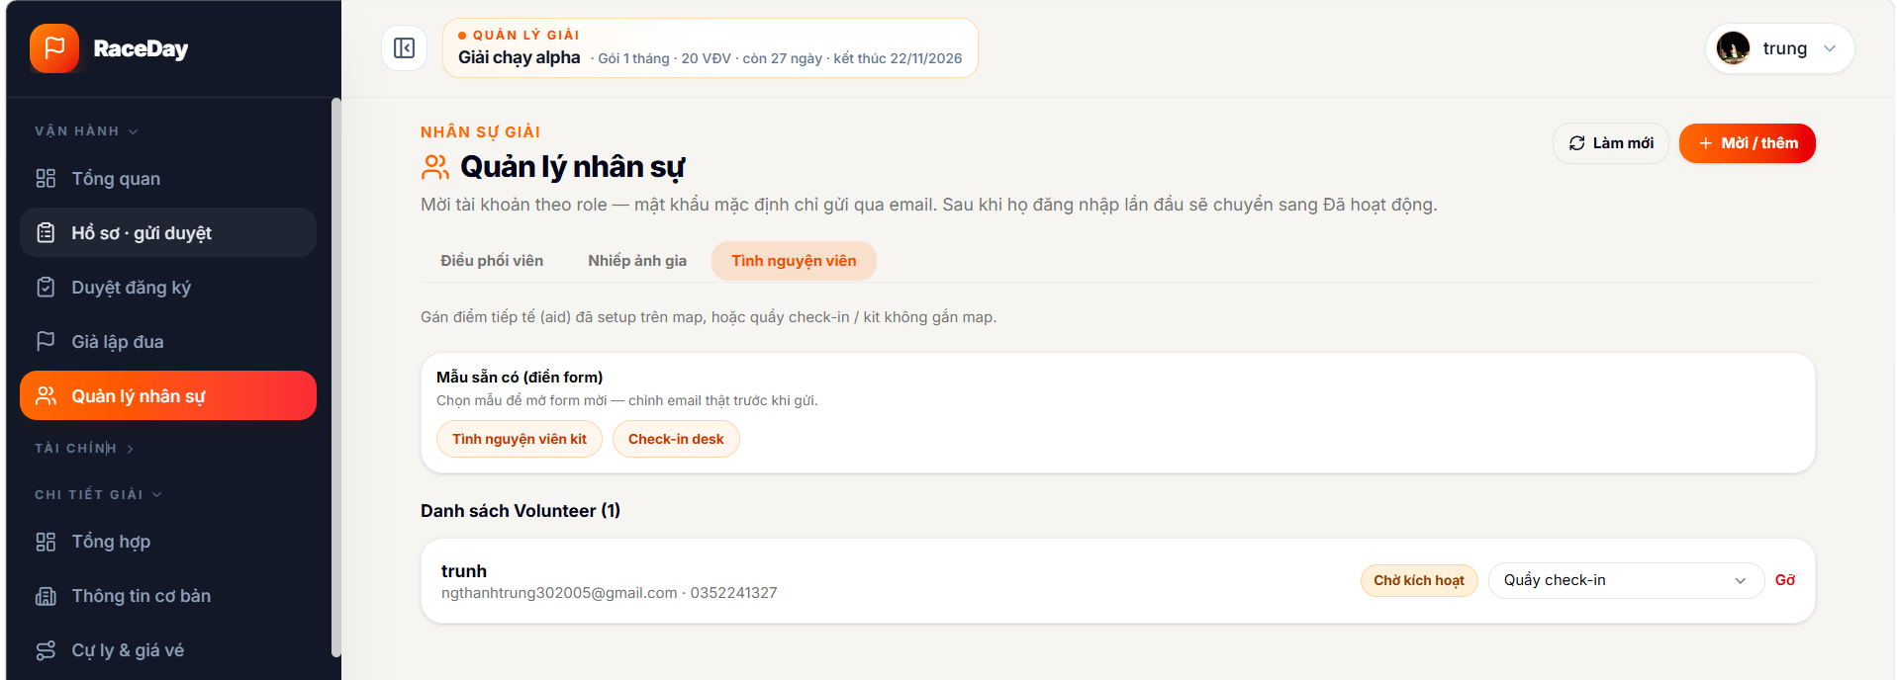

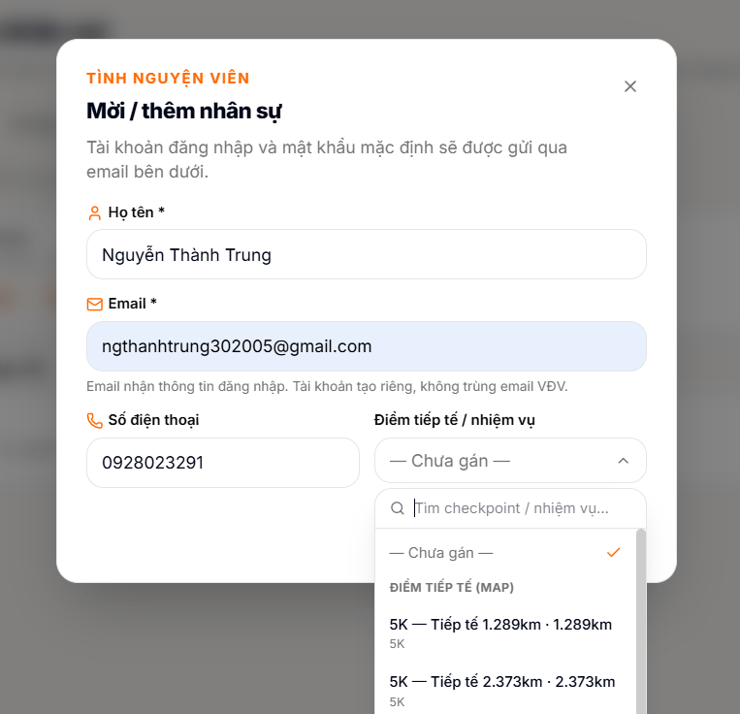
Function Details:
- Load staff members and available assignments for the selected role.
- Let the Organizer choose a role, enter staff details, and optionally select a checkpoint, aid station, or other duty. Presets can prefill the invitation form.
- Validate the required name and email, then send the invitation.
- Create the staff account and send login details by email. Show the new member as “Chờ kích hoạt” until their first login.
- Allow the Organizer to change a member’s assignment or remove them from the event. Refresh the list and show a success message or error after each action.
Business Rules:
- Only the event Organizer or an administrator can manage its staff.
- Supported roles are Coordinator, Photographer, and Volunteer.
- Name and valid email are required for an invitation; phone and assignment are optional.
- An email cannot be invited more than once to the same role while the existing assignment is active.
- Assignment options depend on the selected role and can include map checkpoints, aid stations, or duties that are not tied to a map.
- Removing a member revokes their event assignment.

3.3.4 Manage Licenses and Documents
Function Trigger:
The Organizer opens “Giấy phép & tài liệu” in the event profile.
Function Description:
Upload and save the permits and supporting documents for an event.
Screen Layout:


Figure 3.3.4.1 – Event Approval Management Page
Function Details:
- Load any documents already saved for the event.
- Let the Organizer upload a file or replace an existing one. Accepted file types shown in the UI are PDF, DOC, DOCX, and images.
- Save the uploaded file references to the event profile.
- Show a success message or an error if upload or saving fails.
Business Rules:
- The Permit Application Letter and Security, Public Order and Fire Safety Plan are required before the event can be submitted for approval. Other relevant documents are optional.
- The approval flow checks that required files exist; the UI says the admin checks that documents exist and can be opened.
- Only editable event profiles allow document uploads and saving.

3.3.4 Manage Event Content
Function Trigger:
The Organizer opens “Quản lý nội dung” in the event profile.
Function Description:
Add or update the event schedule, rules, runner guidance, penalties, and prizes, with a preview of how the content will appear on the public event page.
Screen Layout:
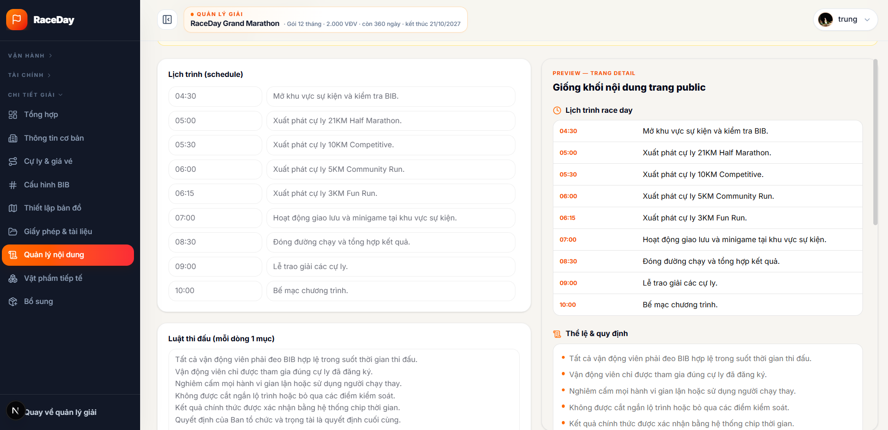

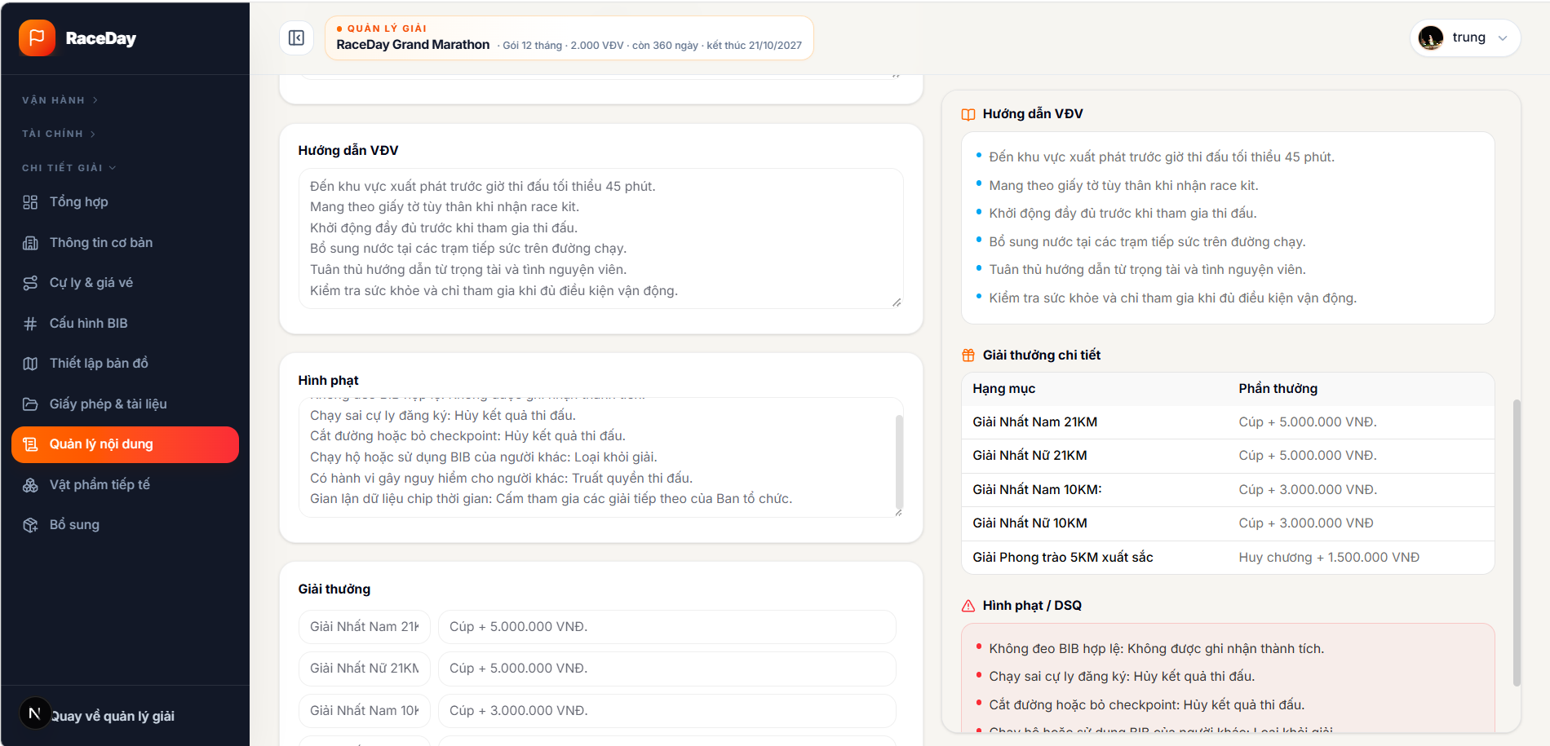
Figure 3.3.4.1 – Event Approval Management Page
Function Details:
- Load the event’s saved content into the form.
- Let the Organizer add or remove schedule rows and prize rows, and edit text sections.
- Build a live preview from the entered content.
- Save the schedule and rules with the event profile, reload the saved data, and show a success message or an error.
- If event documents include an organization plan, show a reminder to enter and verify the content manually; the system does not extract content from uploaded files.
Business Rules:
- Only editable event profiles allow changes.
- Blank schedule or prize rows are omitted when saving.
- Content entered here is separate from uploaded permits and supporting documents.
- The preview reflects the content intended for the public event detail page.

3.3.4 Manage Aid Supplies
Function Trigger:
The Organizer opens “Vật phẩm tiếp tế” in event management.
Function Description:
Maintain a planning list of supplies for the event, including item names, quantities, and packing notes.
Screen Layout:

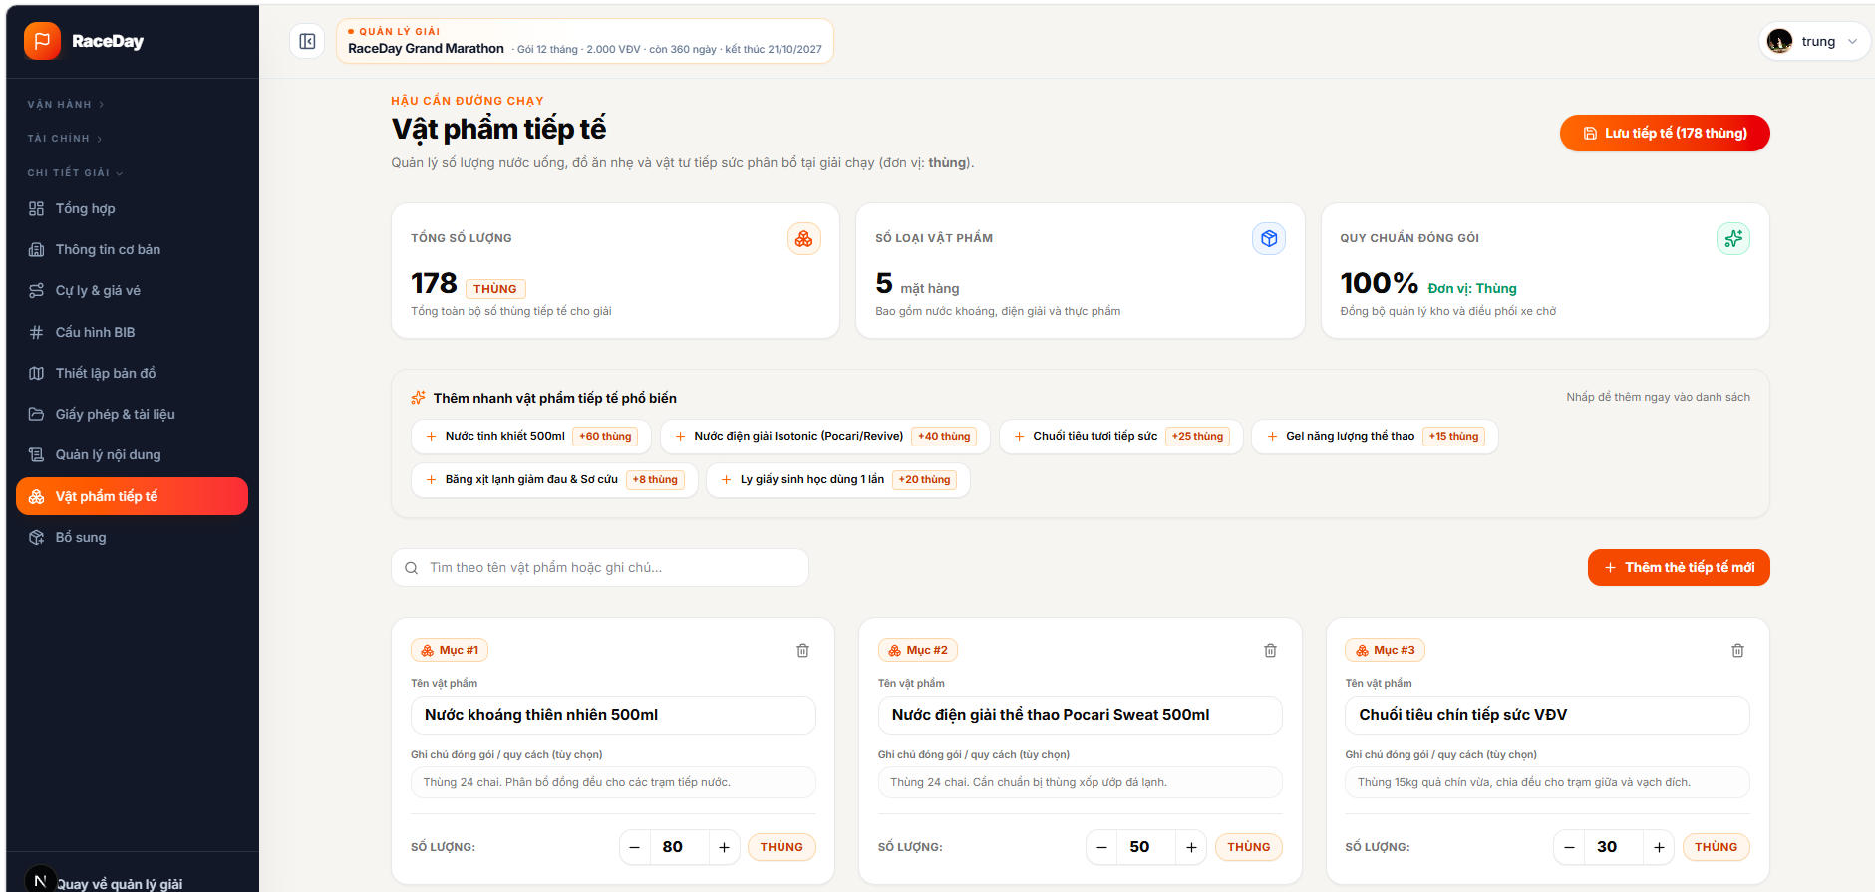
Figure 3.3.4.1 – Event Approval Management Page
Function Details:
- Load the event’s saved supply list; show the default suggested items if no saved items are returned.
- Let the Organizer search, add an item manually or from a preset, change quantities, edit notes, or remove items.
- Calculate and display the number of item types and total cartons.
- Save the full list for the event and show a success message or an error.
Business Rules:
- Each item needs a name; quantity cannot be negative.
- The UI uses “thùng” as the unit.
- A maximum of 50 items is allowed per event.
- Only the event Organizer or an administrator can manage the list.
- This list is for planning event supplies; it does not track stock usage or deliveries.

3.3.4 Manage Event Approval
Function Trigger:
The Organizer selects “Duyệt giải” under “Vận hành”.
Function Description:
Review paid runner registrations and approve or reject each application.
Screen Layout:
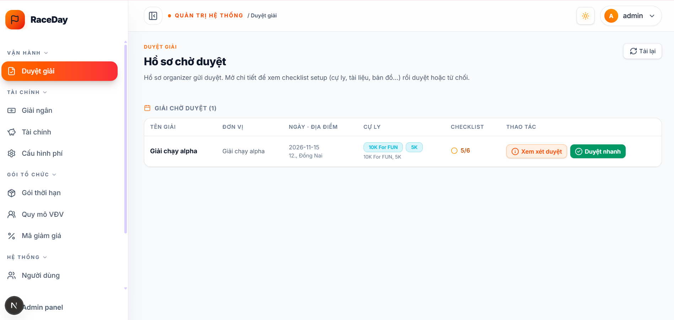
Figure 3.3.4.1 – Event Approval Management Page
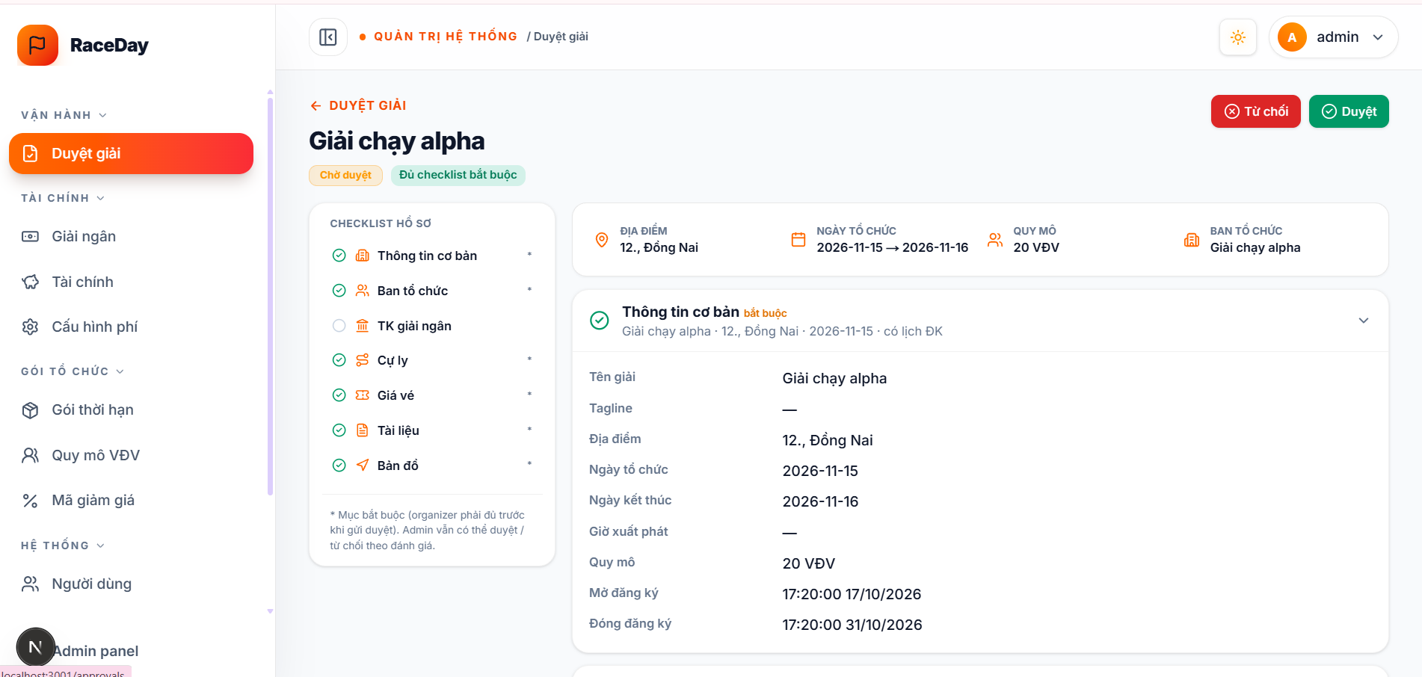
Figure 3.3.4.2 – Event Approval Management Page
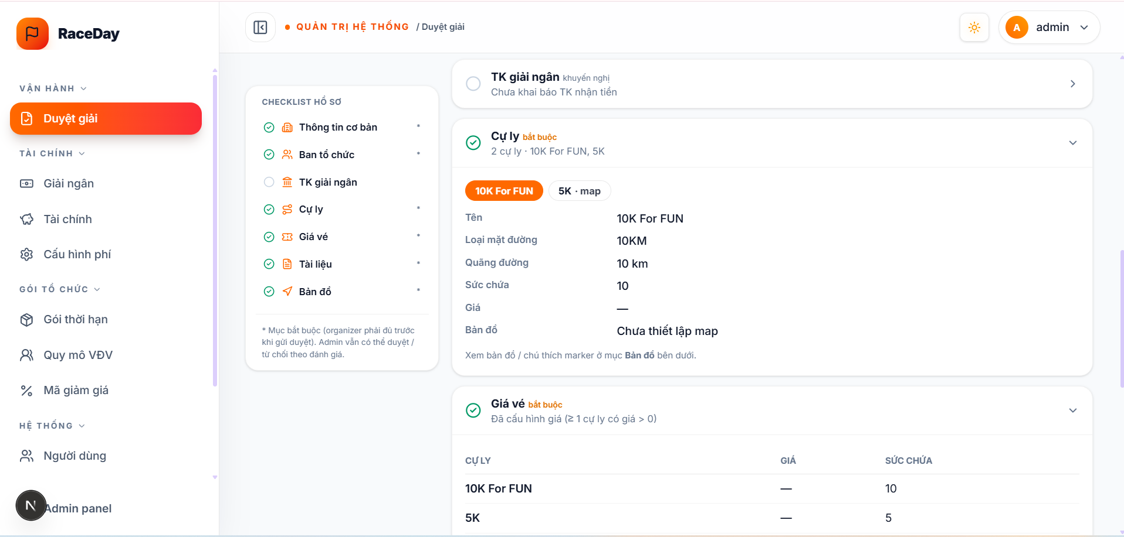
Figure 3.3.4.3 – Event Approval Management Page
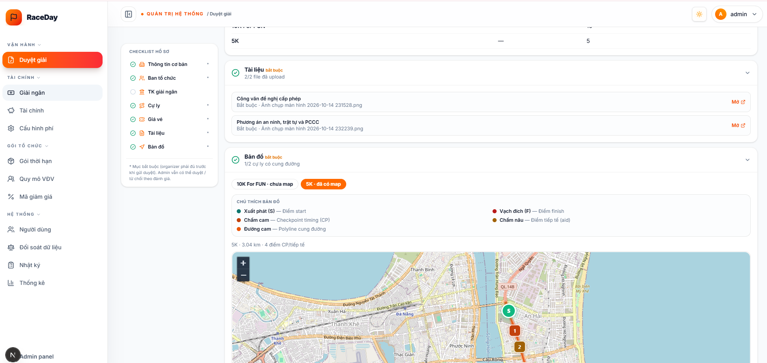
Figure 3.3.4.4 – Event Approval Management Page

Function Details:
- Load registrations for the selected event; default to applications waiting for approval.
- Let the Organizer search by runner details or BIB and filter by status, distance, or health condition.
- Open an application to review the runner’s personal, emergency contact, medical, shirt, and consent information.
- On approval, update the registration, assign the next available BIB in that distance’s configured range, and refresh the list.
- On rejection, require a reason, save the decision, and show it in the registration details.
- Display a success message or an error for the action.
Business Rules:
- Only registrations that have completed payment enter the approval queue.
- Only registrations awaiting approval can be approved or rejected.
- BIB assignment follows the configured range for the runner’s distance.
- A rejection requires a reason; the Organizer can later view it with the reviewer and review time.

3.4 Registration & Payment
This feature allows Runners to register for events, select race distances, complete payments, and receive registration confirmation and BIB assignments.

3.4.1 Register for an Event
Function Trigger:
- A Runner opens a published event page.
- The Runner selects a race distance and clicks on “Register”.
Function Description:
Allow Runners to register for a running event by selecting an available distance and providing the required participant information.
Screen Layout:
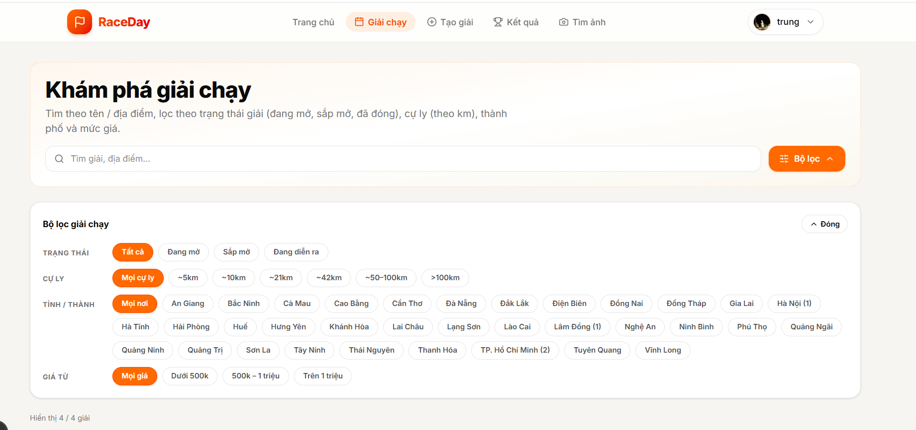
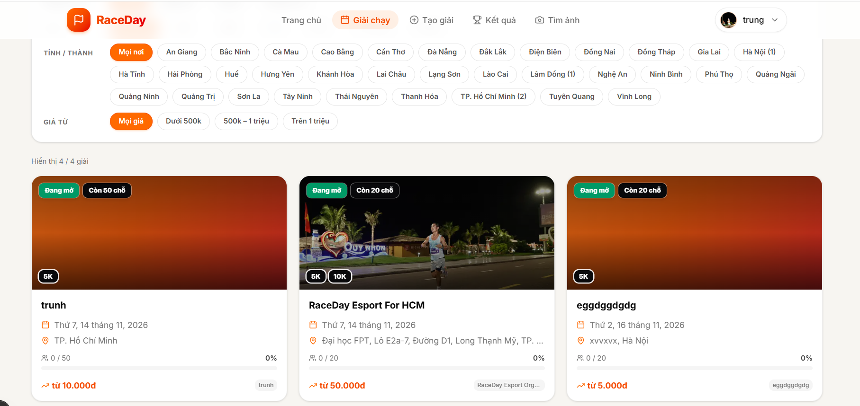

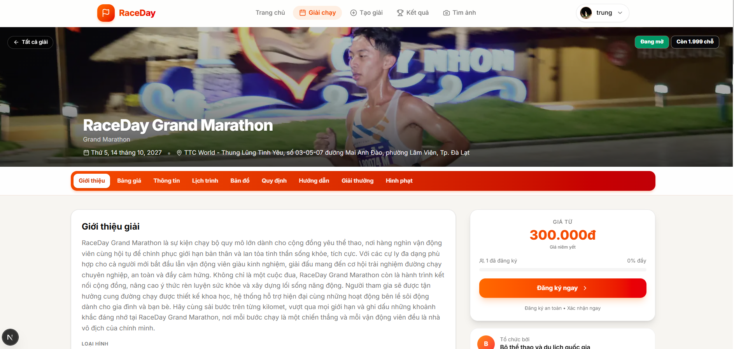
Figure 3.4.1.1 – Event Details Page
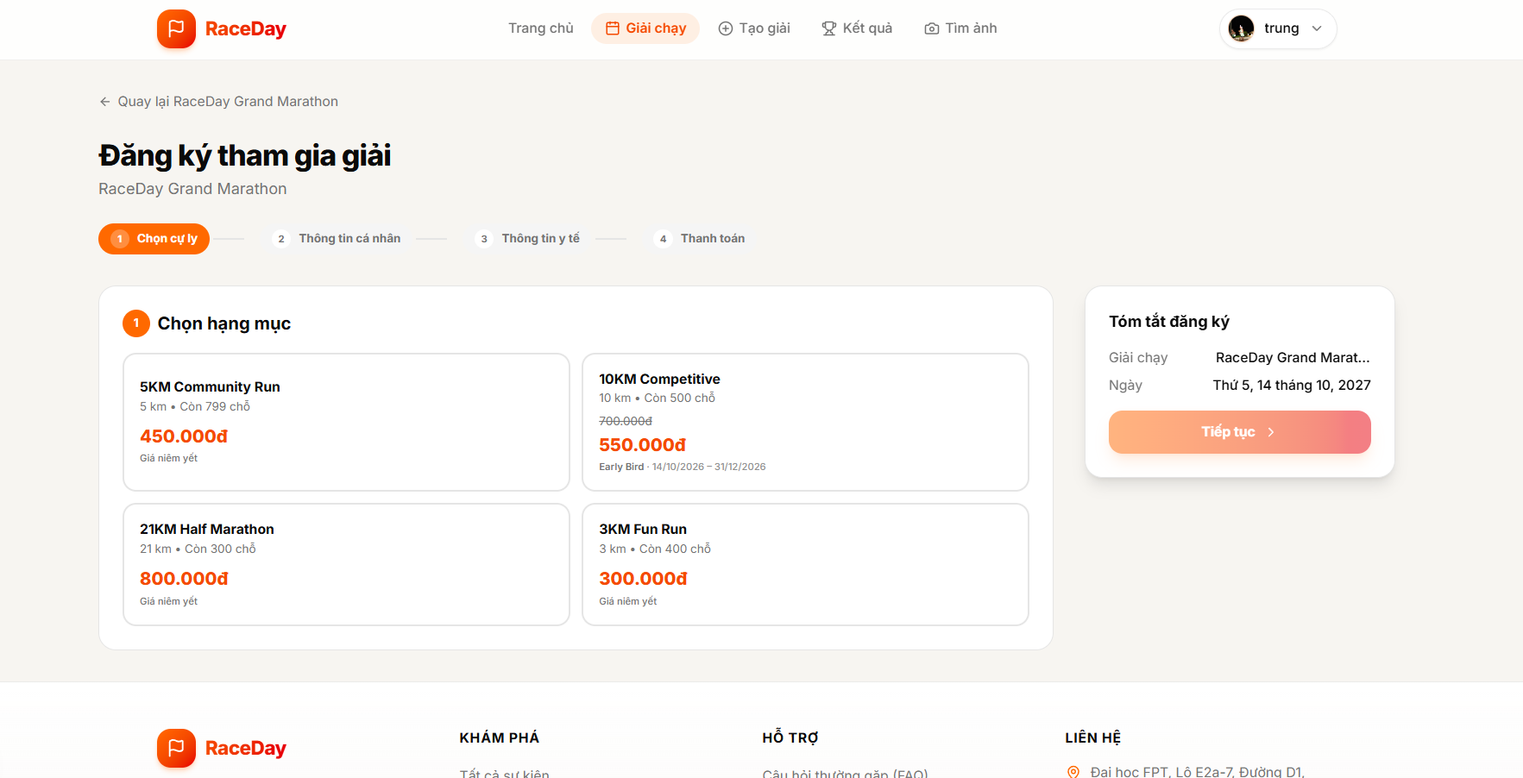
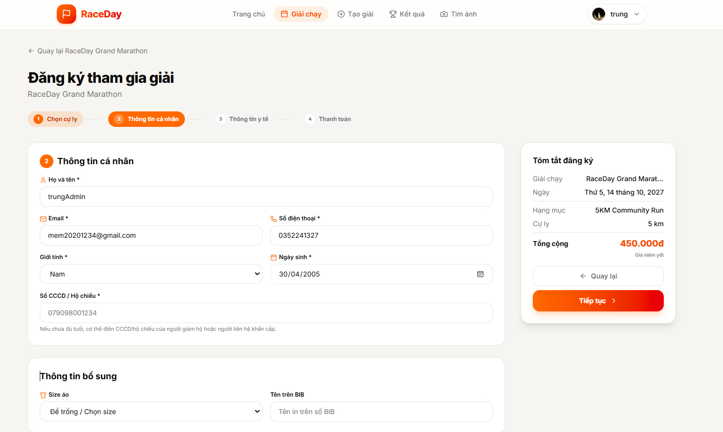
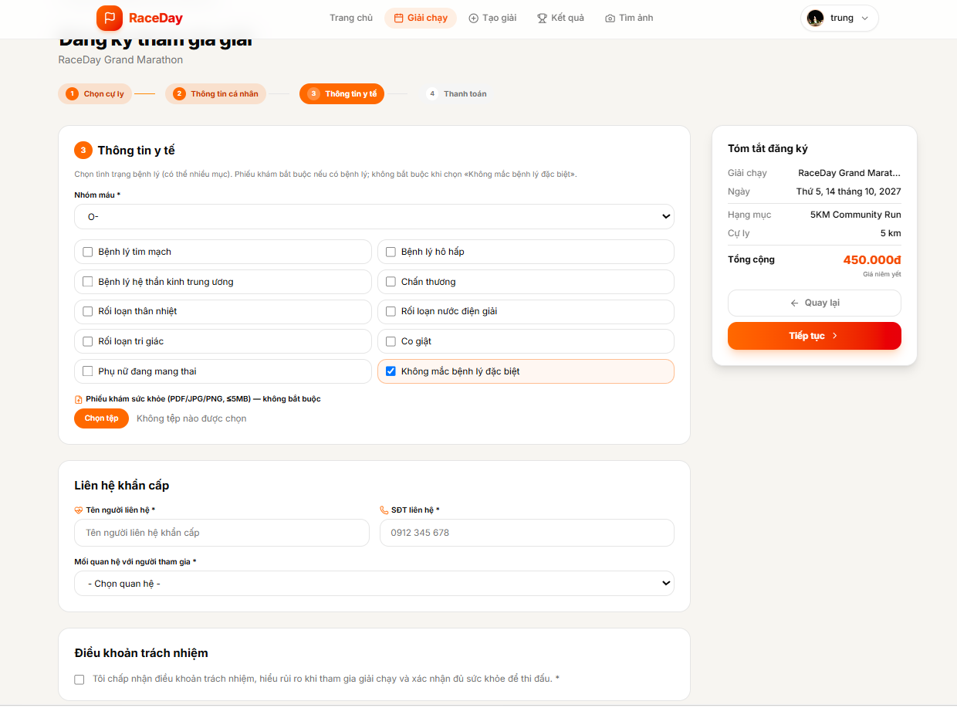
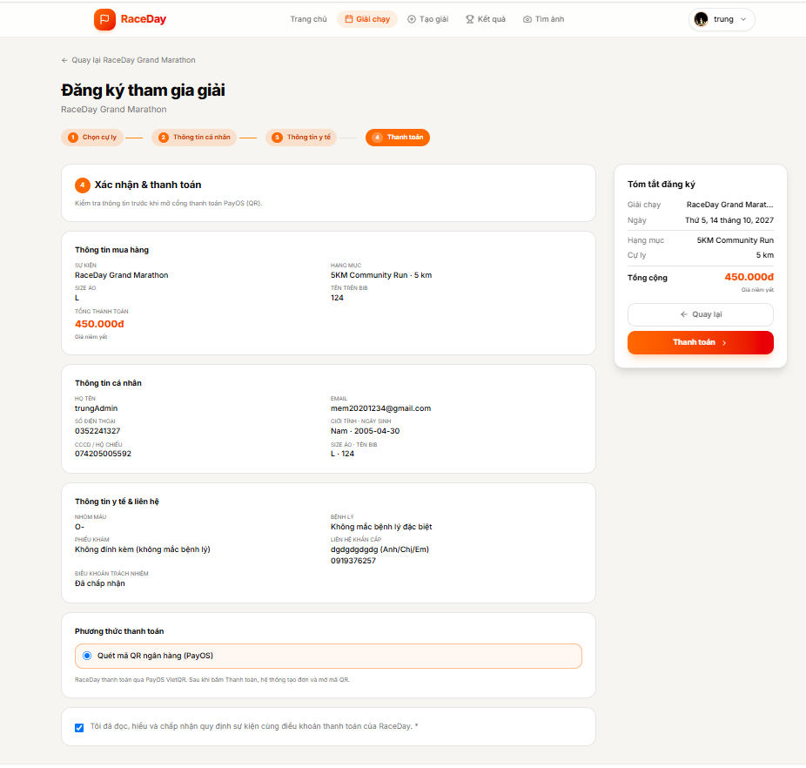

Figure 3.4.1.2 – Event Registration Form
Function Details:
Fields:
- Selected Event
- Race Distance
- Participant Information
- Registration Fee
- Submit Registration button
Data Processing:
- Verify that the event is available for registration.
- Validate the selected distance and participant information.
- Check the remaining participant capacity.
- Create a registration record with the appropriate initial status.
- Reserve a participant slot for the configured payment period, if temporary reservation is supported.
- Display the registration summary and payment instructions.
Business Rules:
- A Runner may register only for an available event and distance.
- Required participant information must be valid.
- Registration must comply with event capacity and registration deadlines.
- The system must prevent participant capacity from being exceeded.
- A registration is not confirmed as paid until payment has been successfully verified.

3.4.2 Process Payment
Function Trigger:
A Runner with a pending registration selects the payment option and initiates payment.
Function Description:
Allow Runners to pay the registration fee through the payment method configured for RaceDay.
Screen Layout:
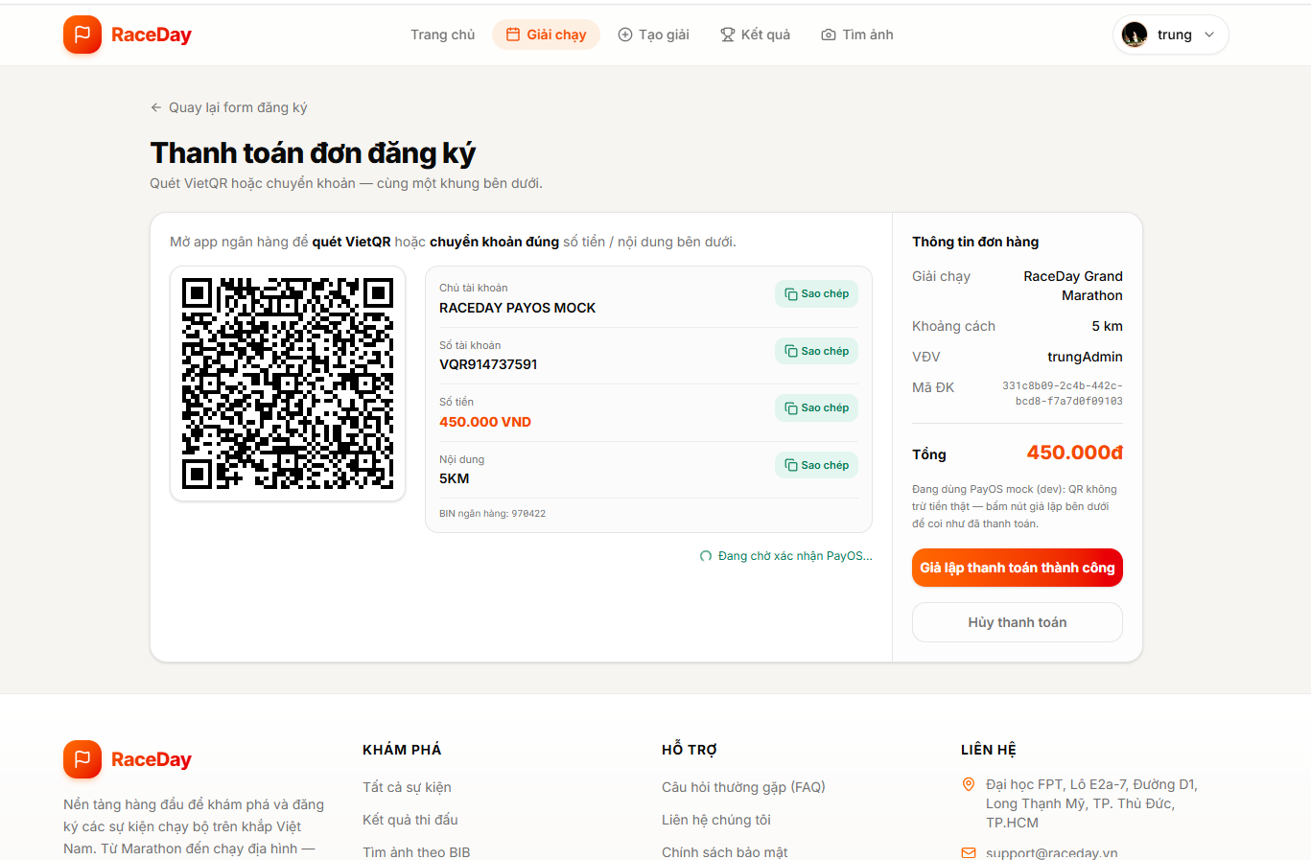
Figure 3.4.2.1 – Registration Summary and Payment Page
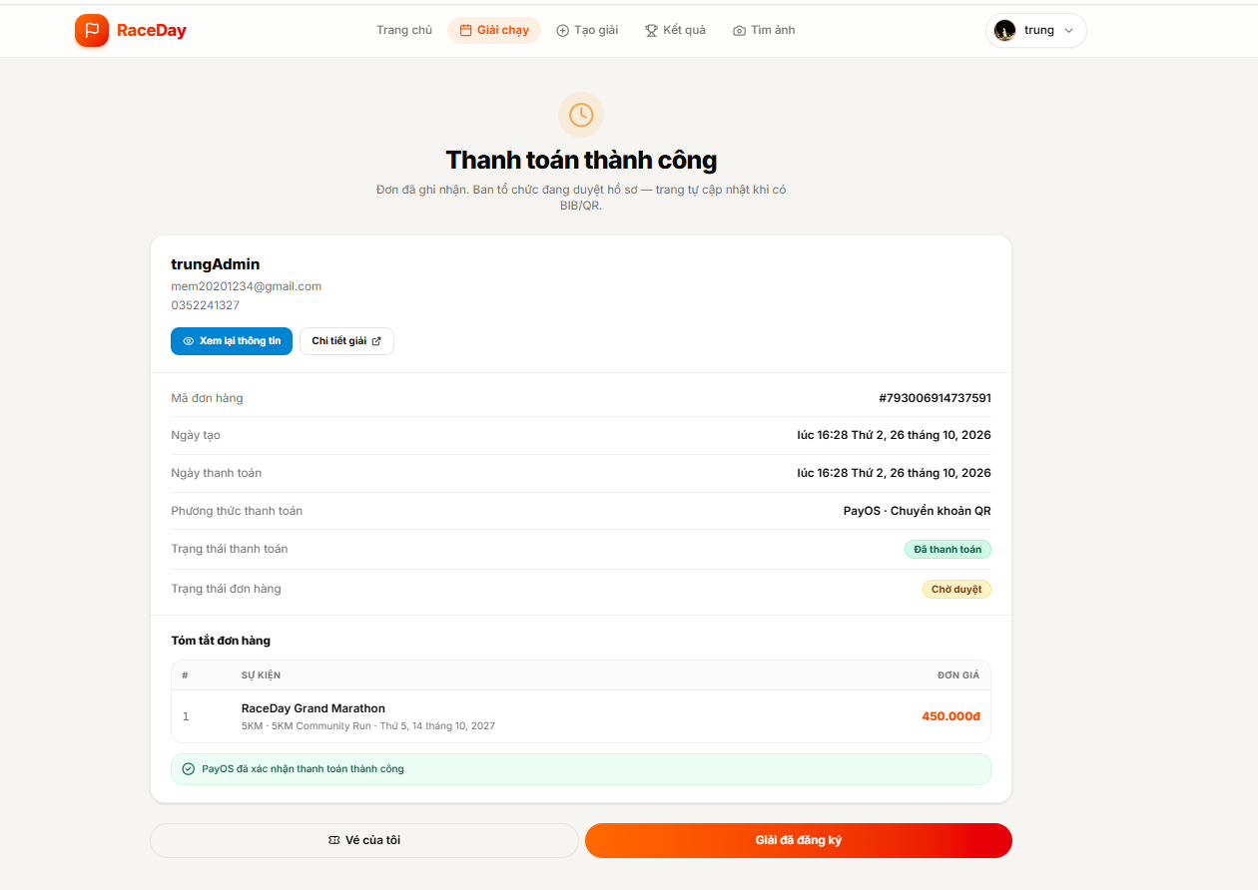
Function Details:
Displayed Information:
- Event Name
- Selected Distance
- Registration Fee
- Payment Status
- Proceed to Payment button
Data Processing:
- Retrieve the registration and its payment amount.
- Verify that the registration is eligible for payment.
- Create or retrieve the corresponding payment transaction.
- Initiate payment through the configured payment provider.
- Display the payment result or current payment status.
- Process the final payment result through the payment verification workflow.
Business Rules:
- The payment amount must match the registration fee.
- Payment status must be maintained separately from registration status.
- A browser redirect alone must not be treated as proof of successful payment.
- Duplicate payment requests must be handled safely.

3.4.3 Verify Runner Registrations

Function Trigger:
The payment verification service receives a payment callback or another trusted payment result from the configured payment provider.
Function Description:
Verify payment results, update the registration status, and assign a unique BIB number to an eligible registration after successful payment.
Screen Layout:
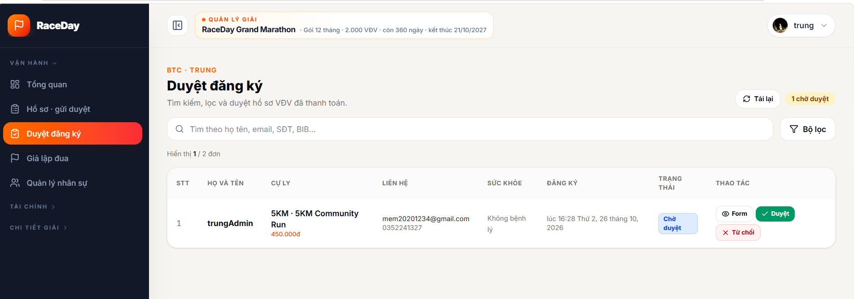

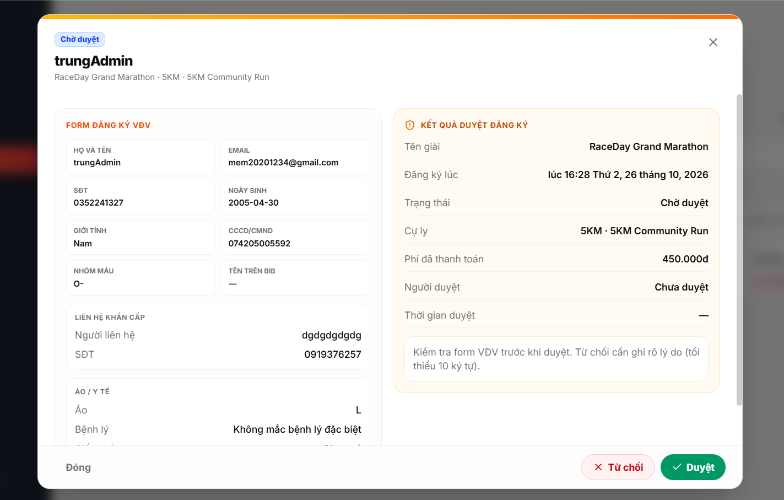
Processing Flow:
Payment Provider → Payment Verification → Registration Confirmation → BIB Assignment → QR Ticket Generation
Function Details:
- Receive the payment result.
- Validate the callback or payment reference using the configured verification mechanism.
- Verify the payment status, transaction reference, and expected amount.
- If the payment is valid and successful, update the payment status.
- Confirm the registration.
- Assign an available BIB number according to the event's BIB allocation rules.
- Generate or activate the registration's QR ticket.
- Return the appropriate result and notify the Runner when supported.
- Reject invalid or unsuccessful payment results without confirming the registration.
Business Rules:
- Only verified successful payments may result in paid registration confirmation.
- The payment amount must match the expected amount.
- A registration must not receive multiple active BIB assignments.
- BIB numbers must be unique within the applicable event allocation scope.
- Repeated callbacks must not duplicate registration confirmation or BIB assignment.
- Payment and registration states must remain consistent.

3.4.4 View Registration and Ticket
Function Trigger:
An authenticated Runner opens the “My Registrations” or “My Tickets” page.
Function Description:
Allow Runners to view their registration details, payment status, assigned BIB number, and QR ticket when available.
Screen Layout:

Figure 3.4.4.1 – My Registrations Page
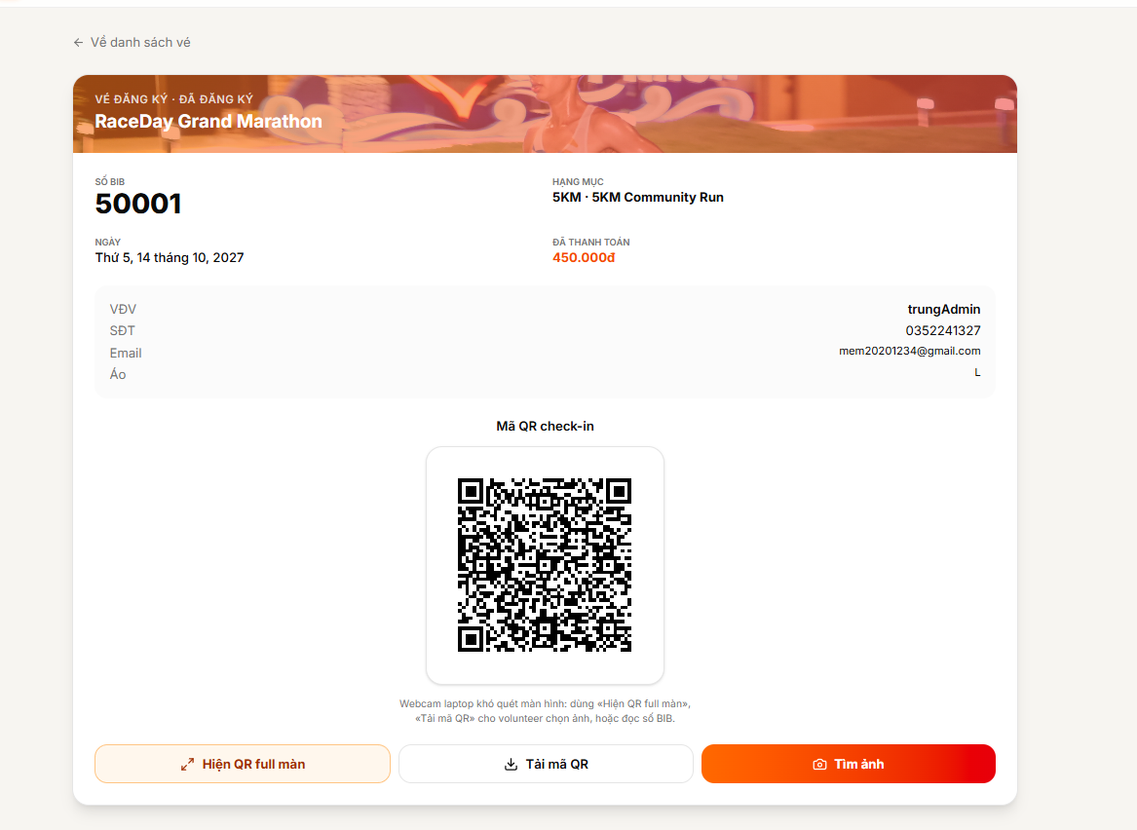
Figure 3.4.4.2 – Registration Details and QR Ticket
Function Details:
- Retrieve registrations belonging to the authenticated Runner.
- Display event information, selected distance, and registration status.
- Display payment status and BIB number when available.
- Display the QR ticket for an eligible registration.
- Show appropriate information if the registration is pending, cancelled, or otherwise ineligible for a ticket.
Business Rules:
- Runners may view only their own registrations unless additional permissions apply.
- A ticket must be associated with the correct registration.
- A BIB number must be displayed only when assigned.
- The QR ticket must not expose unnecessary sensitive information.

3.5 Race-Day Check-in
This feature supports participant check-in and race-kit collection by allowing authorized staff to verify registration information using QR tickets or manual lookup.

3.5.1 Scan QR Ticket
Function Trigger:
An authorized staff member opens the check-in interface and scans a Runner's QR ticket.
Function Description:
Verify a Runner's registration and record the check-in result for the relevant event.
Screen Layout:
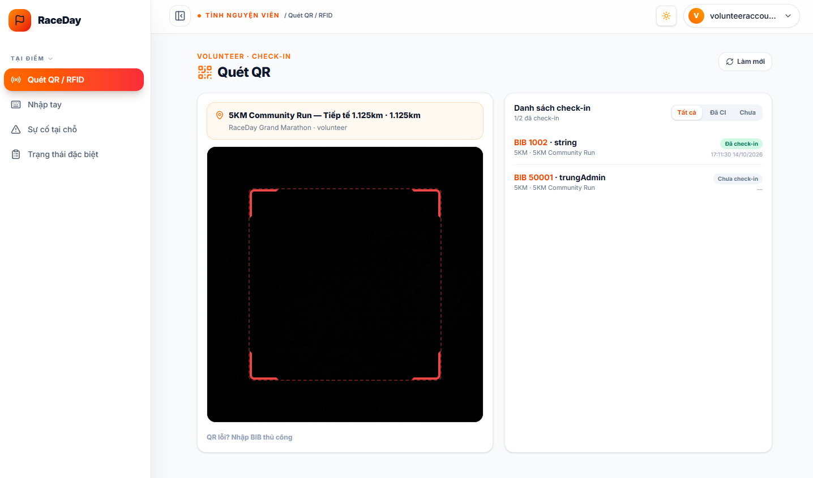
Figure 3.5.1.1 – Staff Check-in Page
Function Details:
Fields and Controls:
- QR Scanner
- Event Selection, if applicable
- Check-in Result
- Runner Information
- Check-in Status
Data Processing:
- Scan or read the QR ticket.
- Retrieve the associated registration.
- Verify the registration, event, and applicable check-in conditions.
- Check whether the Runner has already checked in.
- Record the check-in time and staff information when validation succeeds.
- Display the result to the staff member.
Business Rules:
- Only authorized staff may perform check-in operations.
- The QR ticket must correspond to a valid registration for the selected event.
- Duplicate check-in attempts must not create duplicate check-in records.
- Invalid, cancelled, or otherwise ineligible registrations must be rejected according to the event rules.

3.5.2 Manual Runner Lookup
Function Trigger:
An authorized staff member selects manual lookup when a QR ticket cannot be scanned or is unavailable.
Function Description:
Allow staff to search for a participant using supported identifiers, such as a BIB number or registration information, and process check-in when the registration is valid.
Screen Layout:
Figure 3.5.2.1 – Manual Runner Lookup Page
Function Details:
Fields:
- Search Field
- Search Button
- Runner Information
- Registration Status
- Check-in Action
Data Processing:
- Enter the supported participant identifier.
- Search for the corresponding registration.
- Display matching registration information.
- Verify eligibility and current check-in status.
- Record check-in when authorized and eligible.
- Display a success or error message.
Business Rules:
- Manual lookup is restricted to authorized staff.
- The system must not check in a participant whose registration is invalid or ineligible.
- Duplicate check-in must be prevented.
- Participant information must be limited to what staff need for their assigned duties.

3.5.3 Record Race Finish
Function Trigger:
An authorized Organizer or active event staff member submits a finish record using a supported participant identifier, such as a BIB number or QR payload.
Function Description:
Record a Runner's finish time, calculate the elapsed race time using the applicable start time, and update the registration's finish status.
Screen Layout:
This function may be accessed through a staff timing interface. If timing is handled only through an API, use the processing flow instead of a screen screenshot.
Function Details:
- Receive the participant identifier and finish request.
- Locate the corresponding registration.
- Verify the user's permission to record finish times for the event.
- Retrieve the applicable start time, prioritizing the configured distance start time and using the event start time as a fallback when required.
- Record the finish timestamp.
- Calculate the elapsed time from the applicable start time to the finish time.
- Update the registration's result information and status to Finished.
- Return the processing result.
Business Rules:
- Only authorized Organizers, active event staff, or Administrators with the required permissions may record finish times.
- The participant must belong to the relevant event and distance.
- Finish time must be valid in relation to the applicable start time.
- Repeated requests must not unintentionally overwrite an existing finish record.
- The system must apply the configured timing rules consistently.

3.6 Race Results & Rankings
This feature allows authorized users to review race results, calculate rankings, publish results, and provide result-related information to Runners.

3.6.1 Import or Manage Race Results
Function Trigger:
An Organizer opens the event's Results Management page.
Function Description:
Allow Organizers to review finish records and manage race result data using the timing information available to the system.
Function Details:
Displayed Information:
- Runner Name or Participant Identifier
- BIB Number
- Race Distance
- Finish Time
- Result Status
- Available Actions
Data Processing:
- Retrieve result records associated with the selected event.
- Display finish times and result statuses.
- Allow authorized users to review the records.
- If CSV import is supported, validate the file structure and participant identifiers.
- Check for invalid or duplicate records.
- Save valid result changes and report any errors.
Business Rules:
- Only authorized users may manage race results.
- Imported records must correspond to valid event participants.
- Invalid records must be rejected or flagged for correction.
- Result changes must follow the event's result management rules.

3.6.2 Review and Publish Results
Function Trigger:
An Organizer opens the calculated results and selects the review or publish action.
Function Description:
Allow Organizers to review calculated results, correct permitted errors, and publish approved results for Runners to view.
Screen Layout:

Function Details:
- Retrieve the calculated result list.
- Display the result records for review.
- Allow authorized corrections where permitted.
- Validate any changes.
- Save the reviewed results.
- Publish the results when the required conditions are met.
- Make published results available on the event page.
Business Rules:
- Only authorized Organizers or Administrators may publish results.
- Unreviewed results must not be presented as final when review is required.
- Changes to published results must follow the applicable correction rules.
- The system must distinguish unpublished and published result states.

3.6.3 View Race Results
Function Trigger:
A Runner opens the results section of an event page.
Function Description:
Allow Runners to view published race results and rankings for the relevant event and distance.
Screen Layout:
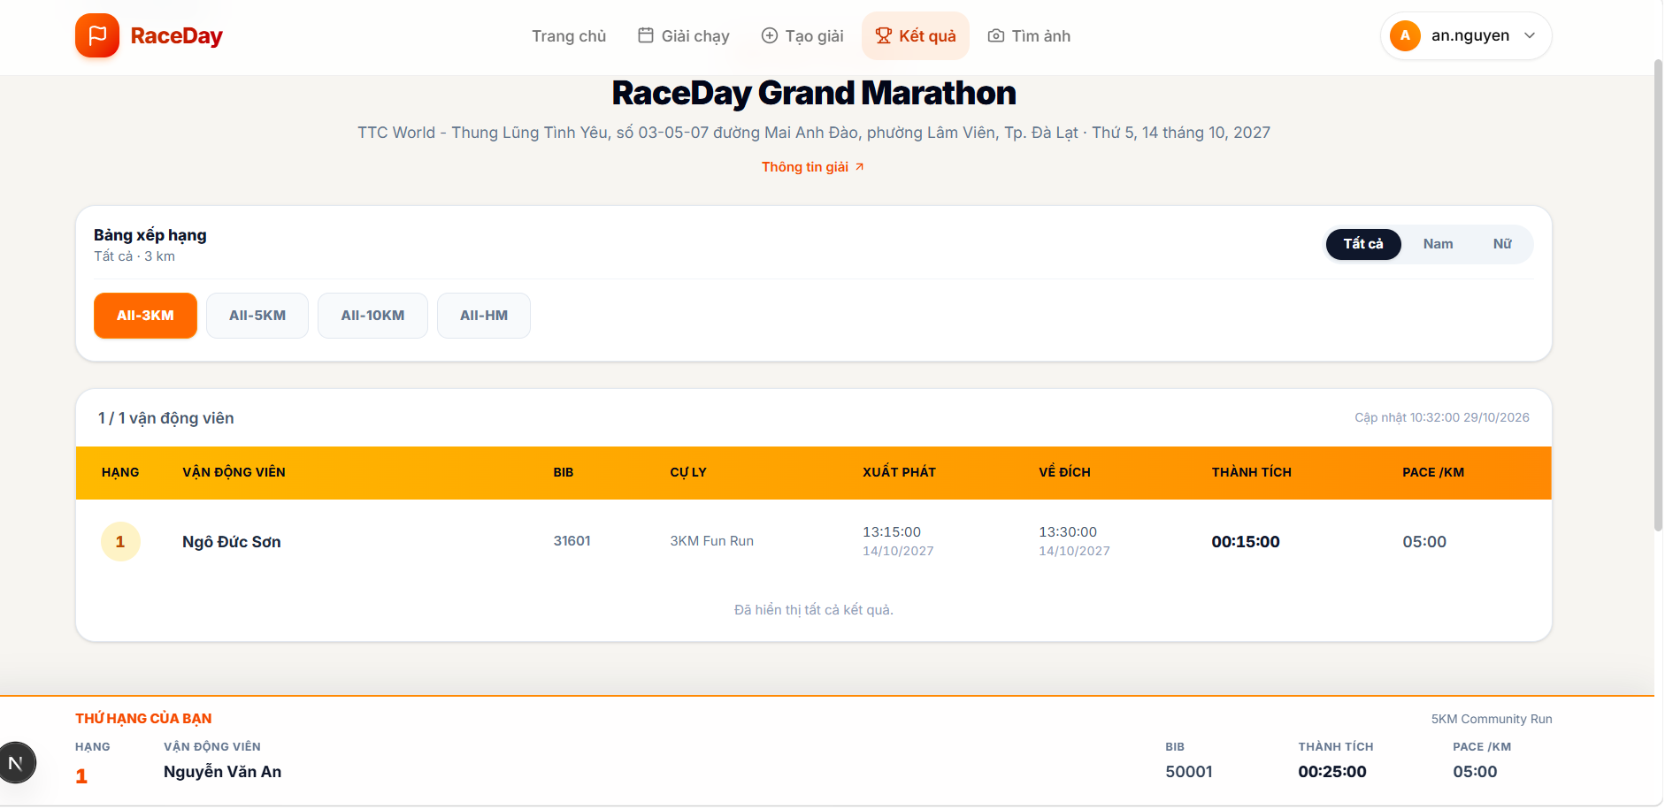
Figure 3.6.3.1 – Public Race Results Page
Function Details:
- Retrieve published results for the selected event.
- Display the available participant rankings and finish times.
- Allow users to select a supported distance or category.
- Display the relevant results.
- Show an appropriate message when results have not yet been published.
Business Rules:
- Public users may view results marked as published.
- Unpublished or restricted result data must not be exposed.
- Displayed rankings must match the published result records.

3.6.4 View and download Race Certificate
Function Trigger:
A Runner opens the results section of an event page.
Function Description:
Allow Runners to view published race results and rankings for the relevant event and distance.
Screen Layout:
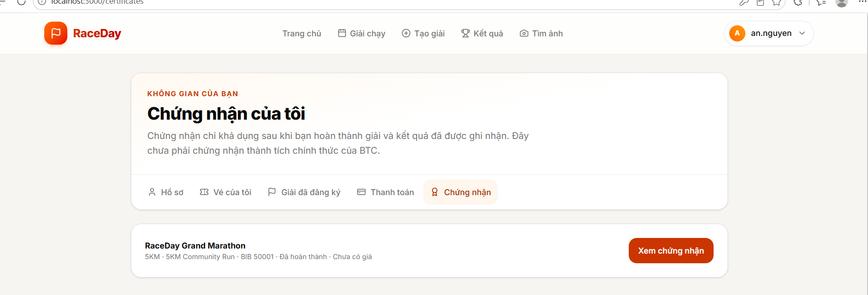
Figure 3.6.4.1 – Certificate List Page
Figure 3.6.4.2 – Certificate Detail Page

Function Details:
- Retrieve published results for the selected event.
- Display the available participant rankings and finish times.
- Allow users to select a supported distance or category.
- Display the relevant results.
- Show an appropriate message when results have not yet been published.
Business Rules:
- Public users may view results marked as published.
- Unpublished or restricted result data must not be exposed.
- Displayed rankings must match the published result records.

3.7 BIB Photo Finder
This feature allows authorized Photographers to upload race photos for an assigned event, run BIB-number detection, review or correct tags, and publish eligible photos. Authenticated Runners can then search published photos by event and BIB number, download them, and submit a dispute when a photo is incorrect.

3.7.1 Upload Race Photos
Function Trigger:
An authorized Photographer opens the Photographer panel and selects “Tải ảnh lên”.
Function Description:
Allow Photographers to bulk-upload race photos for the event (and assignment) granted by the Organizer. Accepted photos are stored as pending items and are not publicly searchable until later publication.
Screen Layout:
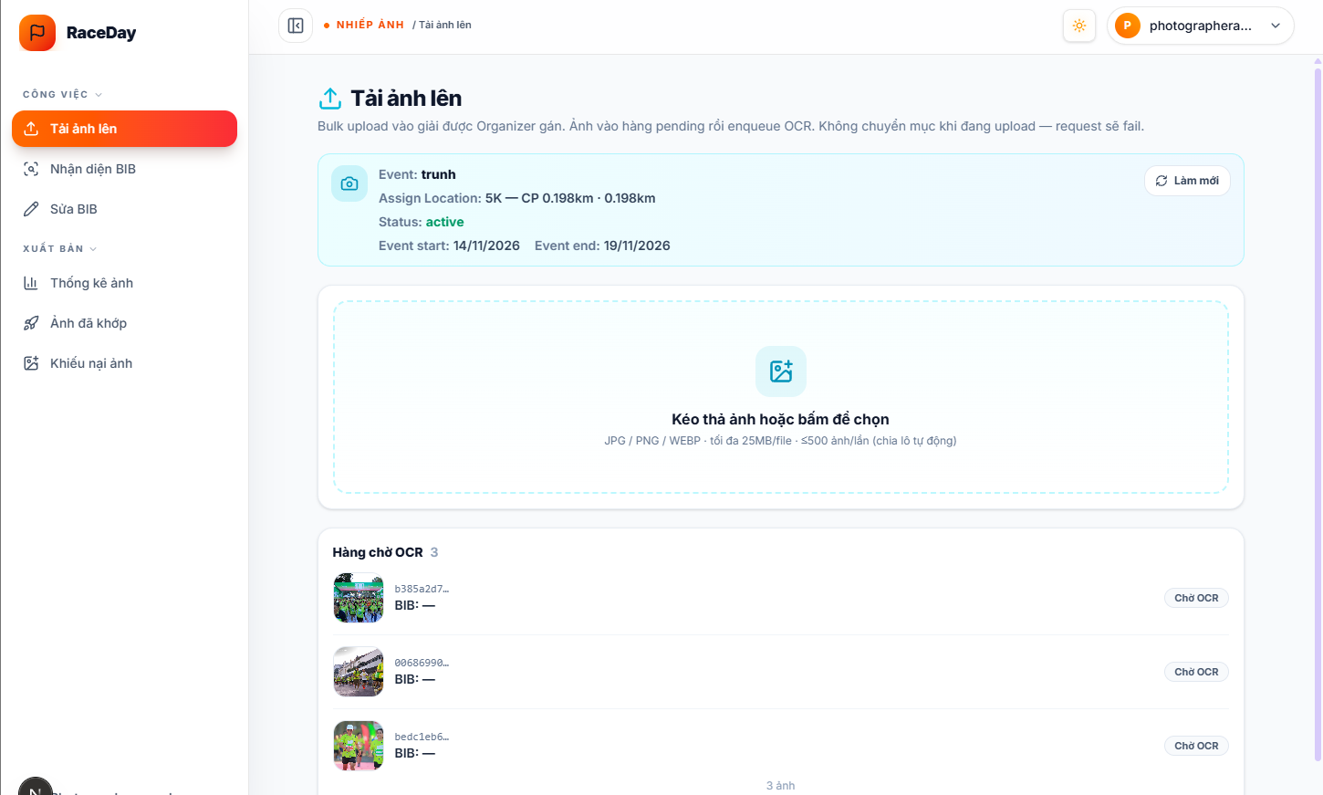
Figure 3.7.1.1 – Upload Race Photos Page
Function Details:
Fields:
- Assigned event context (event name, location/checkpoint assignment, status, event dates)
- Refresh button
- Photo File Selection
- Upload progress indicator
- OCR waiting list (thumbnail, identifier, BIB placeholder, and status)
Data Processing:
- Verify that the current user is an active Photographer for the assigned event.
- Validate each selected file against supported types and size limits; reject oversized or unsupported files.
- Upload accepted files in batches; store the photo assets and associate them with the assigned event.
- Deduplicate by content hash where a matching non-discarded photo already exists for the event.
- Create each accepted photo with status Pending and unpublished.
- Display upload results and the pending queue; do not start OCR automatically.
Business Rules:
- Photographers may upload photos only to events they are authorized to access.
- Supported types: JPG / PNG / WEBP; maximum 25 MB per file; at most 500 photos per upload request (the client may split large selections into smaller batches).
- Failed or rejected files must be reported to the user.
- Uploaded photos must not appear in the Runner photo search until they are matched/corrected and explicitly published.
- Navigating away during an active upload may cancel the in-progress request on the client.

3.7.2 Detect BIB Numbers
Function Trigger:
An authorized Photographer opens “Nhận diện BIB” and selects “Chạy OCR” for the pending photos of the assigned event.
Function Description:
Submit pending (and failed) photos to the configured OCR service, detect candidate BIB numbers, match them against the event roster, and classify each photo as matched, needs review, or discarded according to confidence and roster rules.
Screen Layout:
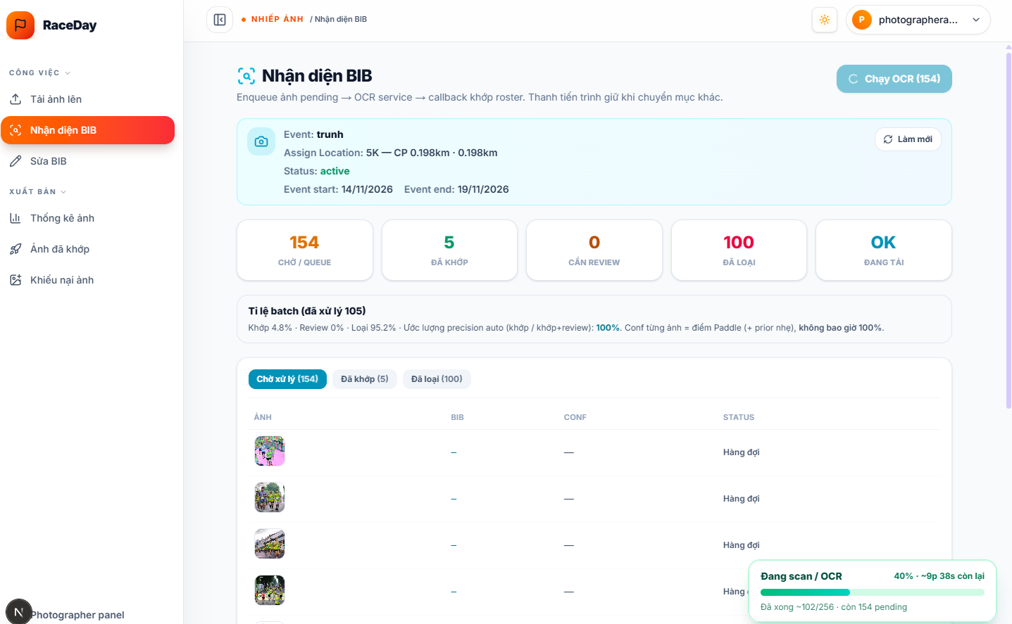
Figure 3.7.2.1 – BIB Detection / OCR Page

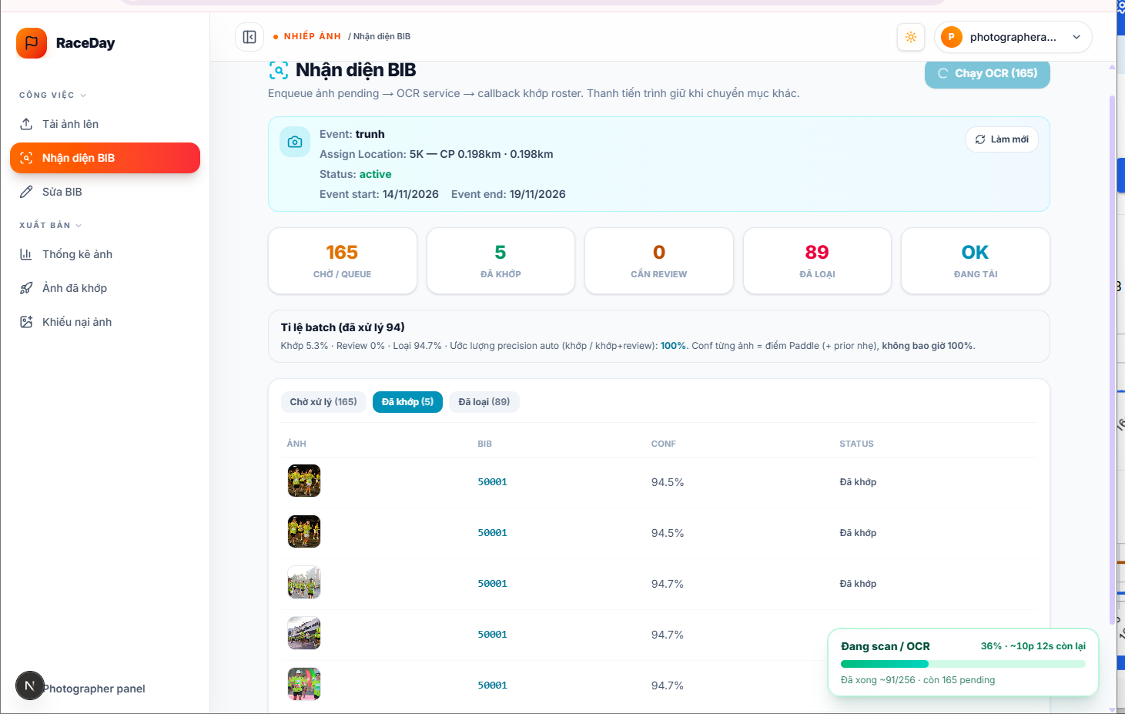
Figure 3.7.2.2– BIB Detection / OCR Page
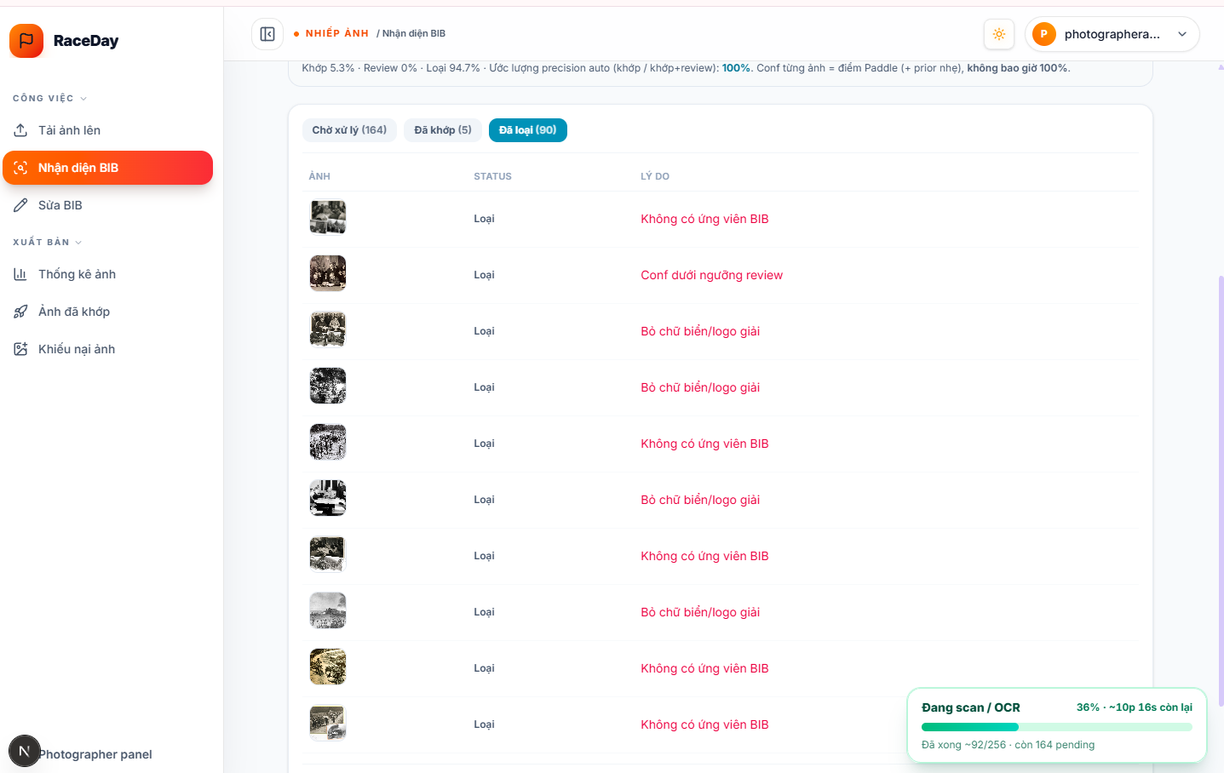
Figure 3.7.2.3 – BIB Detection / OCR Page
Function Details:
Fields:
- Assigned event context
- Run OCR button
- Summary counters: waiting/queue, matched, needs review, discarded, loading status
- Batch rate summary (matched / review / discarded)
- Result tabs
- Table columns: photo thumbnail, BIB, confidence, status; discarded tab also shows reason
- Persistent OCR progress indicator
Data Processing:
- Retrieve photos awaiting processing for the assigned event (pending or failed).
- Enqueue selected photos for OCR (mark as queued / processing).
- Submit each photo to the OCR service together with the event roster snapshot when available.
- Receive detection results (candidate BIBs, confidence, and related signals).
- Persist suggested BIB tags on the photo record.
- Classify the photo as matched, needs review, or discarded according to configured confidence and roster-matching rules; store discard reasons when applicable.
- Make counters and tabbed results available to the Photographer; keep progress visible across panel navigation.
Business Rules:
- OCR does not start automatically on upload; the Photographer must enqueue processing.
- OCR outputs are suggestions and are not assumed correct in every case.
- Only roster-compatible BIB values are retained for matching where a confirmed roster exists.
- Photos below the auto-match threshold, or otherwise uncertain, must be marked for review or discarded per system rules.
- Failed processing must be visible (failed / discarded reason) and may be re-enqueued where supported.
- Detected tags must remain associated with the correct photo record.

3.7.3 Review and Correct BIB Tags
Function Trigger:
An authorized Photographer opens “Sửa BIB” after OCR (or after a Runner dispute has been approved into the review queue.
An authorized Photographer opens a queue item or “Chi tiết”
Function Description:
Allow Photographers to review photos that need manual attention, confirm or correct the BIB tag, or reject (discard) the photo when it is not usable.
Screen Layout:
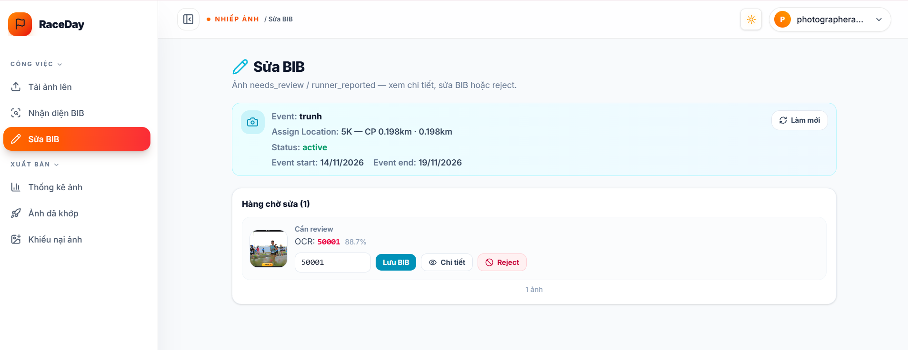
Figure 3.7.3.1 – Photo Review and BIB Tag Correction Page
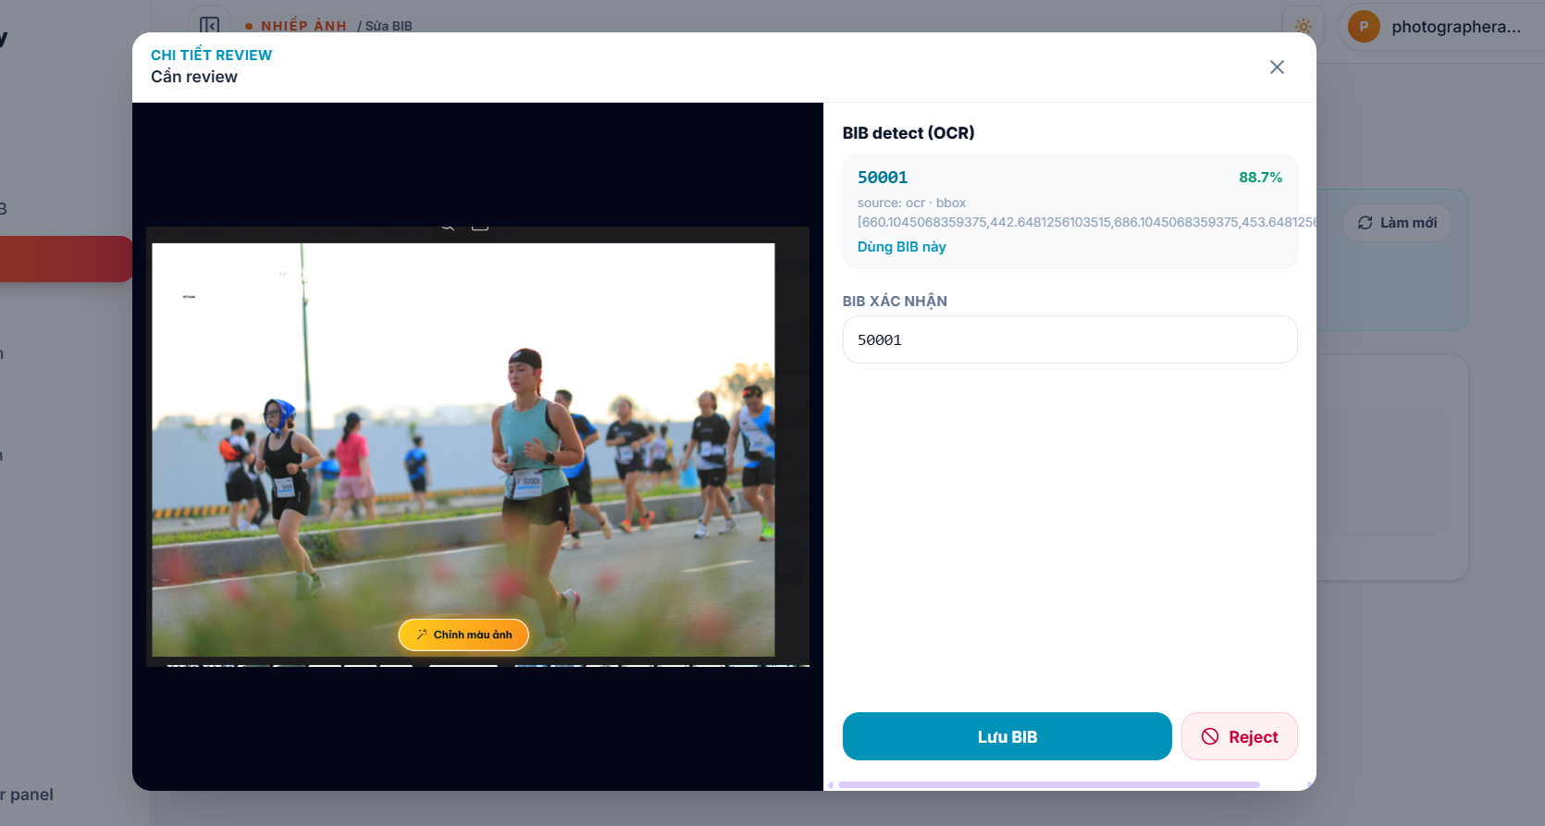
Figure 3.7.3.2 – Review Detail Dialog
Function Details:
Fields:
- Review queue
- Photo thumbnail and status
- Suggested OCR BIB and confidence
- Confirmed BIB input
- Save BIB button
- Detail BIB button
- Reject BIB button
- Detail view: full image, OCR tag list
Data Processing:
- Retrieve photos requiring review and their suggested BIB tags.
- Display each photo with current tag and confidence information.
- Allow the Photographer to confirm, replace, or reject the tag/photo.
- Validate the submitted BIB (including roster membership when a roster is available).
- On save, store the manual BIB tag and mark the photo as manually corrected.
- On reject, discard the photo, clear tags, and record the rejection reason.
- Refresh the review queue and status display.
Business Rules:
- Only authorized Photographers may edit or reject photo tags for their assigned event.
- A tag must remain associated with the correct photo record.
- Manual correction replaces the previous suggestion and marks the photo as manually corrected.
- Rejected photos are discarded and are not eligible for publication or Runner search.
- Changes must be saved before the photo can proceed to publication.

3.7.4 Publish Photo Gallery
Function Trigger:
An authorized Photographer opens “Xuất bản ảnh” after photos have been matched or manually corrected.
An authorized Photographer selects “Publish đã chọn” or “Publish tất cả”.
Function Description:
Allow Photographers to make eligible race photos available to Runners. Matched or manually corrected photos remain hidden from public BIB search until they are published.
Screen Layout:
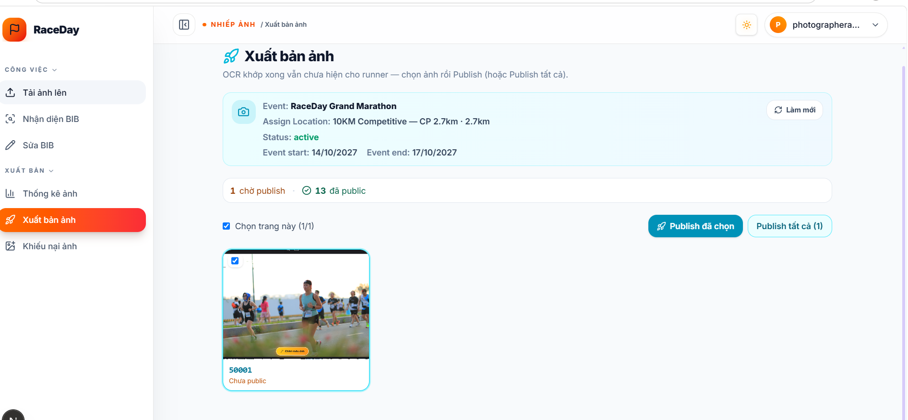
Figure 3.7.4.1 – Photo Gallery Management Page
Function Details:
Fields:
- Assigned event context
- Counters: waiting to publish / already public
- Photo selection checkboxes
- Publish selected Image button
- Publish all Image button
- Photo grid: thumbnail, primary BIB, publication state
Data Processing:
- Retrieve matched / manually corrected photos that are not yet published (ready list) and the published count.
- Validate that the Photographer is authorized for the event.
- Accept a selected subset or a publish-all request for ready photos.
- Mark accepted photos as published (publication timestamp recorded; processing status unchanged).
- Make published photos searchable through the Runner BIB Photo Finder.
- Display the publication result to the Photographer.
Business Rules:
- Only authorized Photographers may publish photos for their assigned event.
- Only matched or manually corrected photos may be published.
- Unpublished photos must not appear in Runner search results.
- Published photo tags must reflect the saved photo metadata at the time of publication.
- Unpublish is not provided in the current implemented scope.

3.7.5 Search Photos by BIB
Function Trigger:
An authenticated Runner opens “Tìm ảnh”.
An authenticated Runner selects an event, enters a BIB number, and selects “Tìm”.
Function Description:
Allow Runners to find published race photos associated with a given event and BIB number, view photo details, and download the image file.
Screen Layout:
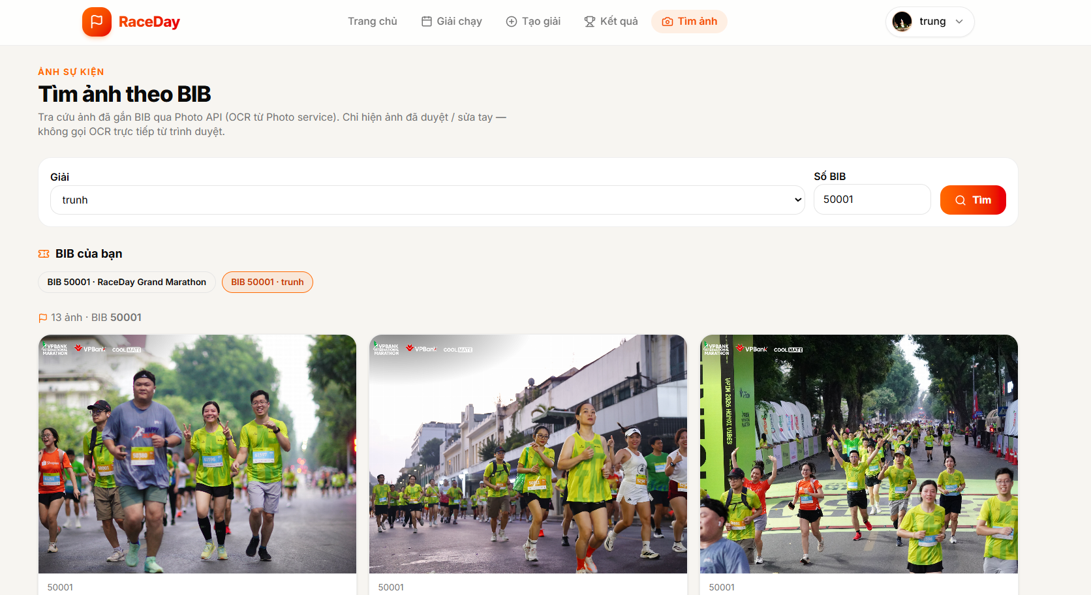
Figure 3.7.5.1 – Runner BIB Photo Search Page
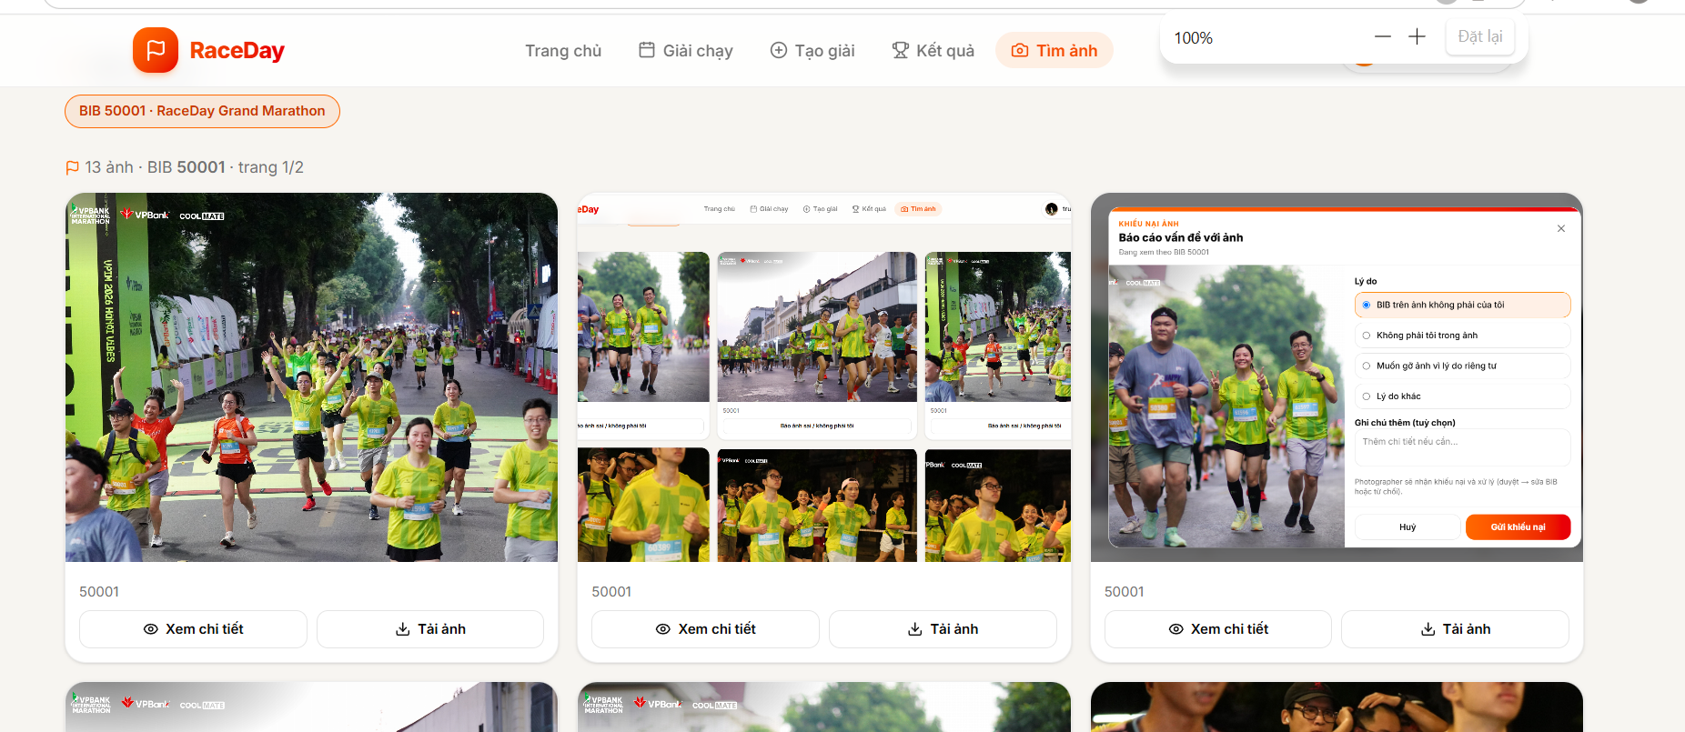
Figure 3.7.5.2 – Runner BIB Photo Search Page
Function Details:
Fields:
- Event Selection
- BIB Number
- Search Button
- Photo Gallery
- View detail button
- Download button
Data Processing:
- Require an authenticated session.
- Validate event and BIB input.
- Retrieve published photos for that event whose saved BIB tag matches the query.
- Display the gallery; open detail on request.
- Serve download through the system download endpoint (proxy), not by exposing storage credentials to the browser when proxy download is used.
- If no published matches exist, show an empty state.
Business Rules:
- Only published photos with matched or manually corrected status are searchable.
- Search requires authentication.
- Empty results must not expose unpublished or discarded photos.
- Download and detail access follow the same publication / eligibility rules as search.

3.7.6 Photo Detail and Dispute
Function Trigger:
Runner: from photo detail, selects “Báo ảnh sai / không phải tôi” and submits a reason.
Photographer: opens “Khiếu nại ảnh”, then approves or rejects an open dispute.
Function Description:
Allow Runners to report incorrect published photos, and allow Photographers to approve (send the photo back to BIB review) or reject the dispute with a note.
Screen Layout:
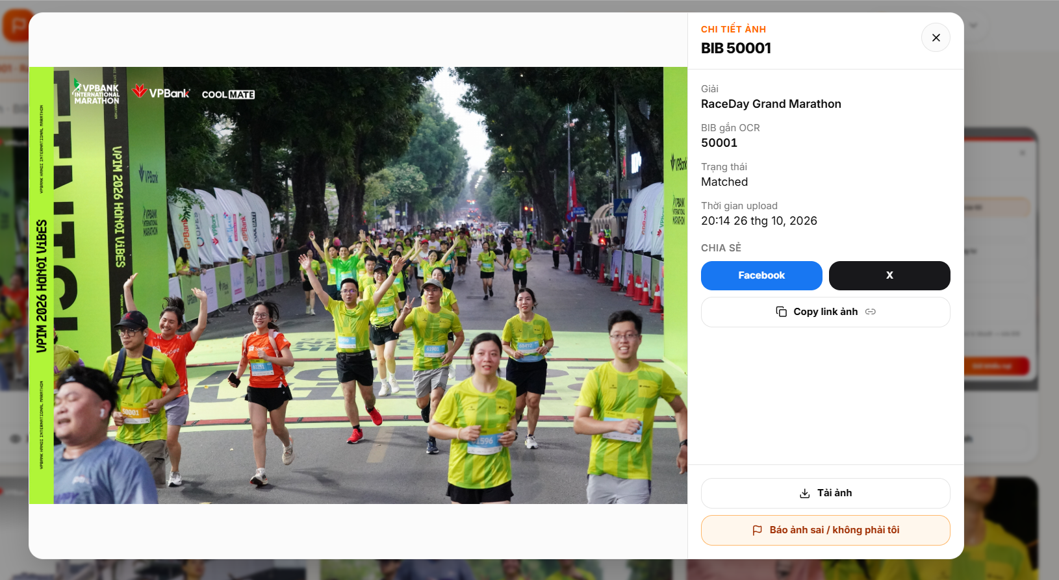
Figure 3.7.6.1 – Runner BIB Photo Detail Page
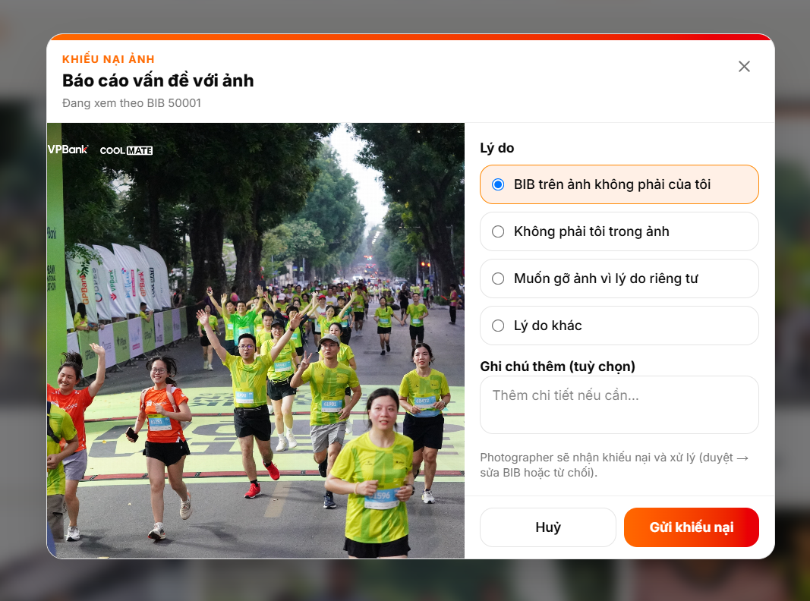
Figure 3.7.6.2 – Runner My Disputes Page
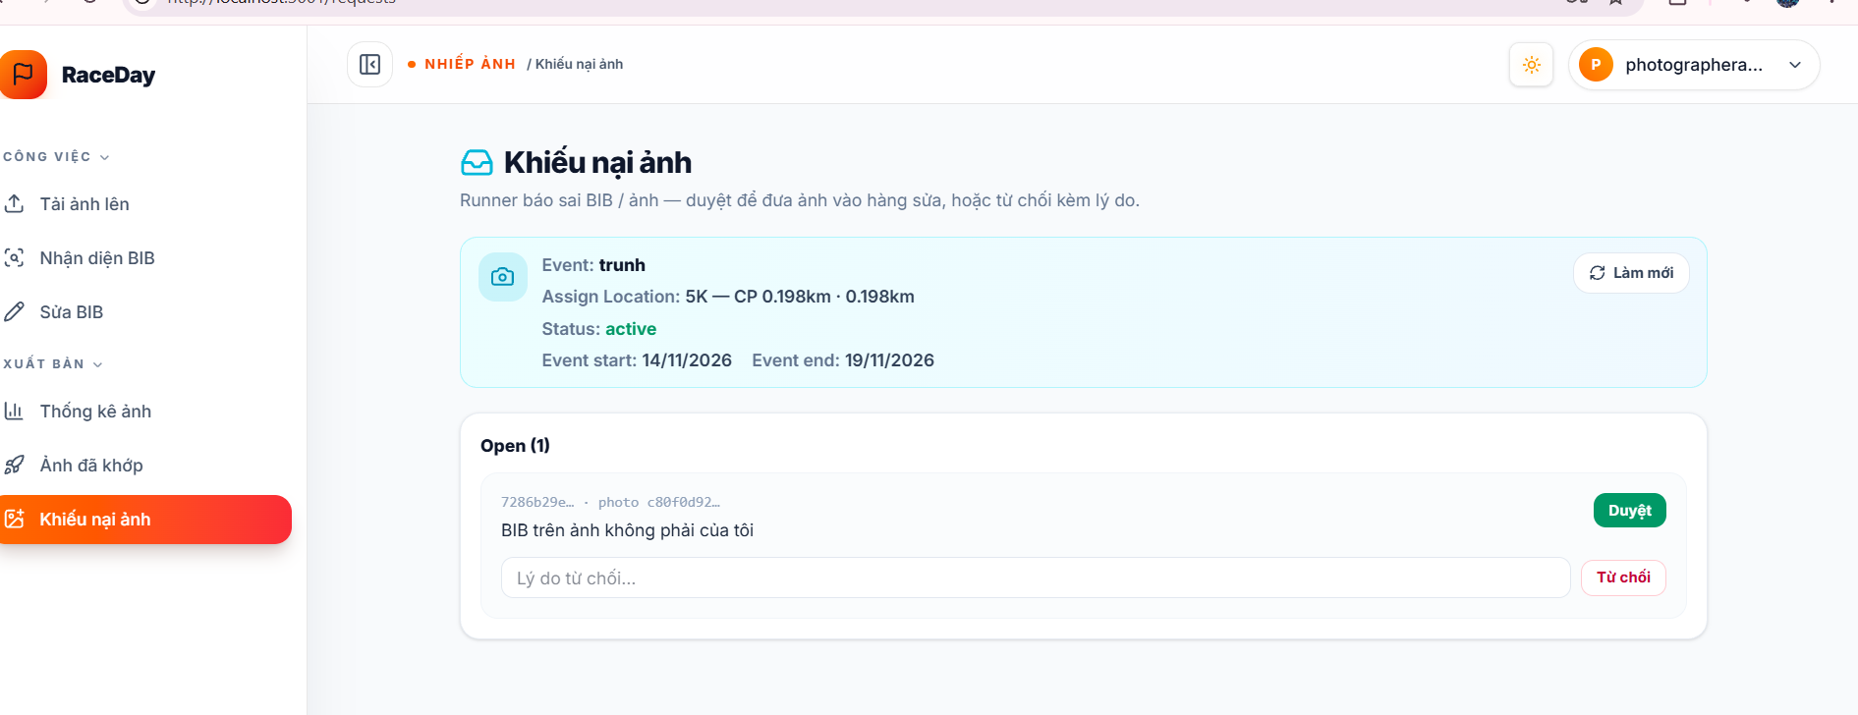
Figure 3.7.6.3 – Photographer Dispute Handling Page
Function Details:
Fields:
- BIB Number
- Search Button
- Photo Gallery
- Empty Result Message
Data Processing:
- Validate the selected event and BIB number.
- Search for photo records associated with the specified event and BIB tag.
- Retrieve photos eligible for public display.
- Display matching photos in the gallery.
- Display an appropriate message when no matching photos are found.
Business Rules:
- Search results must match both the selected event and the BIB number.
- Only photos eligible for public display may be returned.
- Invalid search input must be handled appropriately.
- The system must not claim that no photos exist solely because photo processing is incomplete.

3.8 User and Platform Administration
This feature allows authorized Administrators to manage user accounts, review platform content, and monitor system activity according to their permissions.

3.8.1 Manage User Accounts
Function Trigger:
An Administrator opens the User Management page and views user accounts.
Function Description:
Allow authorized Administrators to view account information and perform permitted account management actions.
Screen Layout:
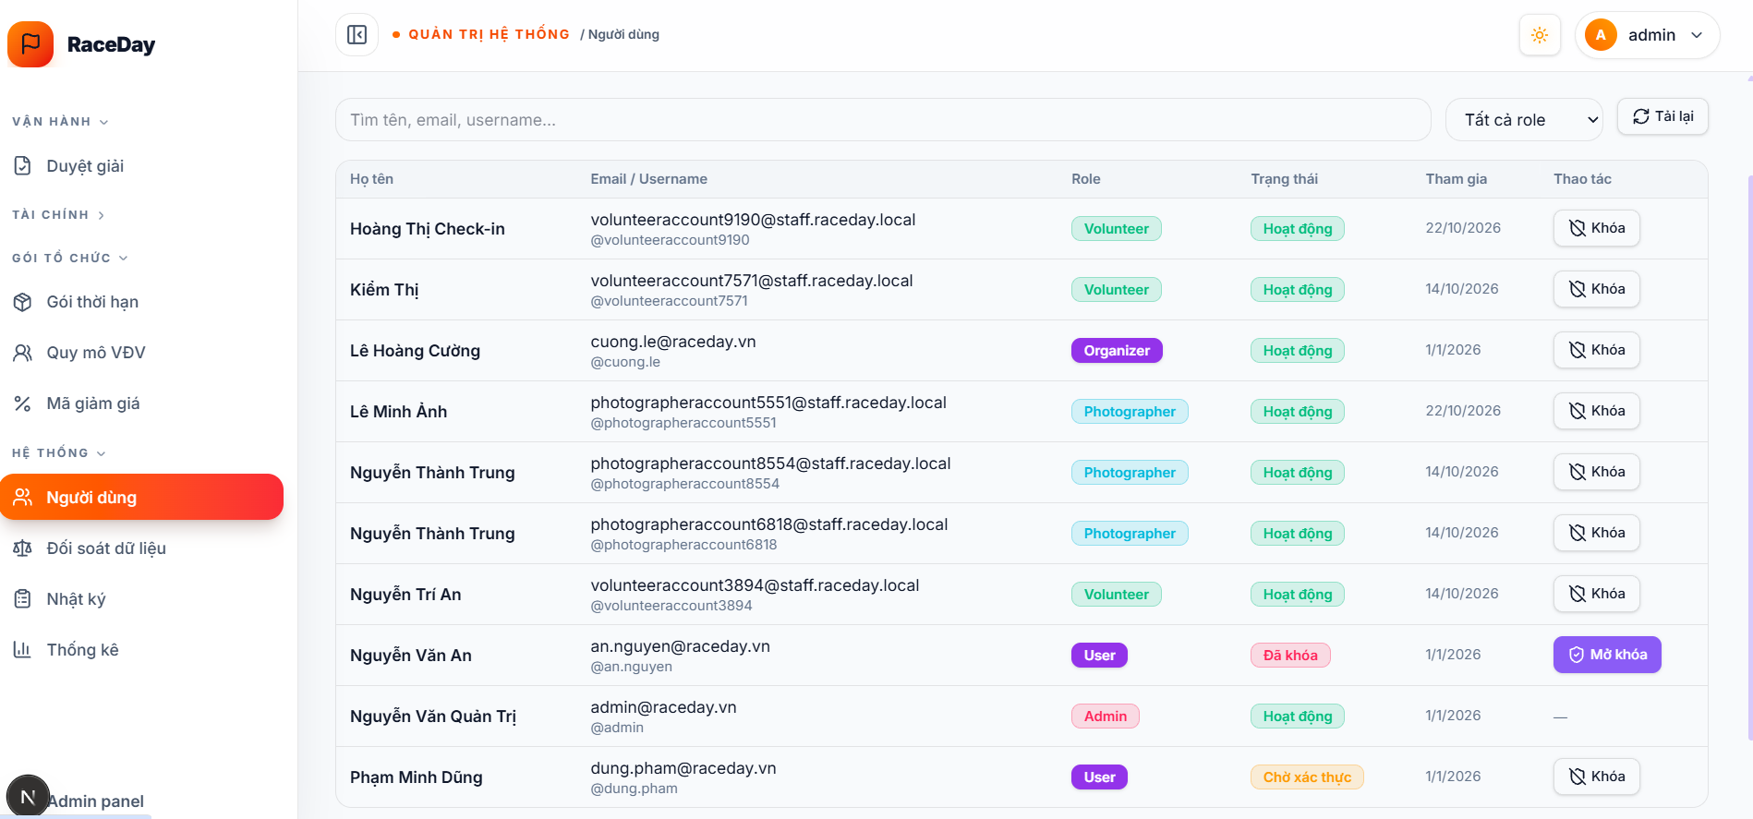
Figure 3.8.1.1 – User Management Page
Function Details:
- Retrieve user accounts according to the applied search or filter.
- Display account information and status.
- Validate permissions before applying changes.
- Update the account status or permitted account information.
- Record the action where audit logging is supported.
Business Rules:
- Only authorized Administrators may manage user accounts.
- Account management must follow role and permission rules.
- Administrative changes must not expose passwords or other authentication secrets.
- Actions affecting account access must follow the system's account status rules.

3.8.2 Configure Platform Audit
Function Trigger:
An authorized Administrator opens an Audit Logs page on their Administrator sidebar.
Function Description:
Allow authorized Administrators to check audit logs based on admin filter and search input.
Screen Layout:
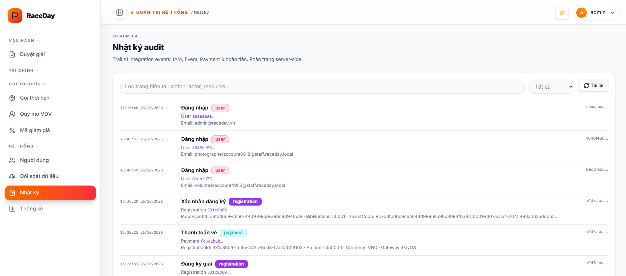
Figure 3.8.2.1
Function Details:
- Retrieve content requiring review.
- Display relevant content information and its current status.
- Allow the Administrator to review the content.
- Apply an authorized moderation action.
- Update the content status.
- Record the action when audit logging is supported.
Business Rules:
- Only authorized users may perform moderation actions.
- Moderation actions must follow the platform's content and privacy rules.
- Restricted content must not be made publicly available contrary to its status.

3.8.3 Manage User Accounts
Function Trigger:
An Administrator opens the User Management page and views user accounts.
Function Description:
Allow authorized Administrators to view account information and perform permitted account management actions.
Screen Layout:
Figure 3.8.1.1 – User Management Page
Function Details:
- Retrieve user accounts according to the applied search or filter.
- Display account information and status.
- Validate permissions before applying changes.
- Update the account status or permitted account information.
- Record the action where audit logging is supported.
Business Rules:
- Only authorized Administrators may manage user accounts.
- Account management must follow role and permission rules.
- Administrative changes must not expose passwords or other authentication secrets.
- Actions affecting account access must follow the system's account status rules.

4. Non-Functional Requirements

4.1 External Interfaces
RaceDay shall provide interfaces that enable communication between users and third-party software systems. These interfaces shall support the platform's core functions, including event registration, payment processing, race-day operations, result management, and BIB-based photo discovery.
- User Interfaces: The system shall provide a responsive web interface for runners, event organizers, photographers, and administrators. Mobile interfaces shall support race-day staff in performing check-in, checkpoint scanning, and emergency-related operations.
- Hardware Interfaces: The system shall support mobile device cameras for scanning QR codes, capturing BIB-related images, and assisting staff with participant identification. Manual BIB entry shall be available when camera scanning is unavailable or unsuccessful.
- Payment Interfaces: The system shall integrate with a supported domestic payment gateway through its provided API to initiate payments, receive payment status notifications, and update registration payment states. A sandbox environment shall be used for development and demonstration.
- Authentication Interfaces: The system shall provide authentication and authorization interfaces for account registration, login, password recovery, and role-based access control. Token-based authentication shall be used where appropriate for communication between clients and backend services.
- Photo Processing Interfaces: The system shall provide an interface for uploading race photos and integrating with OCR-based BIB recognition. Recognized BIB numbers and confidence information shall be used to associate photos with participants, subject to manual review when necessary.
- Backend API Interfaces: The system shall expose documented RESTful APIs for communication between the web application, mobile application, backend modules, and external services. API specifications shall be maintained using OpenAPI/Swagger.
- Data Storage and Messaging Interfaces: The backend shall communicate with its configured database, cache, and message broker to store application data, retrieve frequently accessed information, and process asynchronous tasks such as photo recognition and background event processing.

4.2 Quality Attributes

4.2.1 Usability
RaceDay shall provide a consistent and easy-to-understand user experience for users with different levels of technical knowledge, including first-time runners, event organizers, photographers, and race-day volunteers.
- The system shall allow runners to discover events, complete registration, make payments, and receive their BIB information and QR ticket without requiring formal training.
- The system shall provide clear navigation, readable text, sufficient color contrast, and consistent interface components across supported web and mobile devices.
- Race-day staff shall be able to perform participant check-in and checkpoint scanning with a minimal number of interactions. Manual BIB entry shall be available as an alternative when QR scanning or camera access fails.
- Organizer and administrator interfaces shall make frequently used functions, including event creation, registration monitoring, check-in management, result verification, and organizer approval, accessible without excessive navigation.
- The system shall display clear validation messages, error notifications, and empty-state guidance instead of exposing raw technical exceptions to users.
- The system shall provide understandable instructions and confirmation messages for important operations, including registration submission, payment completion, BIB assignment, and result publication.

4.2.2 Reliability
RaceDay shall maintain data consistency and support essential race-day operations. When a failure occurs, the system shall prioritize data integrity and traceability over silently accepting potentially incorrect information.
- Service Availability: Core services for participant check-in, checkpoint recording, registration status verification, and SOS handling shall remain operational during scheduled event periods, subject to the availability of the hosting infrastructure and external dependencies.
- Fault Isolation: Failures in non-critical functions, such as OCR processing, photo statistics, or background photo indexing, shall not unnecessarily interrupt registration, payment confirmation, or participant check-in.
- Offline Operation: Where supported by the mobile client, race-day staff shall be able to record scans locally during temporary network interruptions. Pending records shall be synchronized when connectivity is restored, with duplicate detection and conflict resolution applied.
- Duplicate Scan Handling: The system shall detect repeated scans of the same BIB within a configurable time interval. Suspected duplicates shall be flagged for review and shall not silently overwrite valid records.
- Photo Recognition Recovery: BIB recognition shall be treated as an assisted process rather than a guaranteed result. Low-confidence or unsuccessful detections shall be made available for manual review, and unrecognized photos shall remain available for later correction.
- Data Integrity: Registration records, payment states, scan logs, race results, and ranking records shall be stored and updated consistently. Raw scan records shall be retained separately from computed race times to support investigation and recalculation when necessary.
- Result Verification: Official rankings and certificates shall only be published after the required organizer verification. Changes resulting from disputes or result corrections shall be recorded with the relevant reason and audit information.
- Error Recovery: The system shall provide appropriate logging and recovery mechanisms to help administrators identify failures and restore interrupted background processing without unnecessarily duplicating completed operations.

4.2.3 Performance
RaceDay shall provide responsive interactions for community-scale running events. The following performance targets are initial project requirements and shall be evaluated through performance and load testing before the final demonstration.
- Photo Search Response Time: Under normal operating conditions, the first page of BIB-based photo search results shall be returned within 2 seconds for a typical event gallery.
- Concurrent Users: The system shall support at least 100 concurrent users performing common operations, including event browsing, registration, and check-in-related requests, without unacceptable response-time degradation.
- Asynchronous Photo Processing: OCR recognition and other time-consuming photo-processing tasks shall execute asynchronously so that bulk uploads do not block interactive APIs.
- Database Efficiency: Frequently accessed data, including event information, registration summaries, and BIB metadata, shall use appropriate indexing and query optimization. Pagination and image thumbnails shall be used where applicable to reduce unnecessary data transfer.
- Dashboard Responsiveness: Organizer dashboards shall provide timely updates on registration counts, participant check-in progress, and other operational statistics during race-day activities.
- Transaction Processing: Database operations for registration, capacity management, payment status updates, and check-in shall maintain data consistency under concurrent requests. Heavy reporting queries shall be designed to minimize interference with time-sensitive transactional operations.
- Performance Validation: The development team shall conduct load and performance tests to evaluate these targets, identify bottlenecks, and optimize the system before the final demonstration.

4.2.4 Security
RaceDay shall protect user accounts, personal information, payment-related data, event operations, and race photos against unauthorized access, modification, and disclosure.
- Authentication: The system shall use an appropriate token-based authentication mechanism, such as JWT, in accordance with the implemented technology stack. Passwords shall be stored using a secure password-hashing algorithm rather than plaintext.
- Authorization: Access to system functions shall be controlled according to user roles and event assignments. Runners, photographers, volunteers, organizers, and administrators shall only access functions and data permitted for their roles.
- Data Protection: Personal information, emergency contacts, medical information where collected, and other sensitive records shall only be accessible to authorized users with a legitimate operational need.
- Secure Communication: Communication between clients, backend services, and external integrations shall use HTTPS in deployed environments. Sensitive information shall not be exposed through URLs, client-side logs, or error messages.
- Payment Security: Payment processing shall use the supported payment gateway's approved integration mechanism. RaceDay shall not store full payment card numbers or card security codes. Payment callbacks shall be validated before the system updates payment status.
- Credential Management: API keys, database credentials, JWT signing keys, and other secrets shall be stored in environment-specific configuration or an appropriate secret-management mechanism. Production secrets shall not be committed to source control, and sandbox credentials shall remain separate from production credentials.
- Administrative Protection: Administrative and organizer-management endpoints shall require appropriate authentication and authorization. Administrative operations shall not be accessible to anonymous users.
- Audit Logging: Security-sensitive and audit-relevant operations, including role changes, result modifications, dispute decisions, and duplicate-scan resolutions, shall be logged with sufficient information for later investigation.
- Input Validation: The system shall validate user input, uploaded files, API requests, and external callback data to reduce the risk of malformed requests, unauthorized operations, and common application-level attacks.
- Session Management: The system shall enforce appropriate token expiration, logout, and password recovery procedures to reduce the risk of unauthorized account access.

4.2.5 Maintainability
RaceDay shall be designed and implemented to support future enhancements, testing, debugging, and maintenance throughout its development lifecycle.
- Modular Architecture: The system shall follow a modular monolith architecture with clear boundaries between major functional areas, such as identity and access management, event management, registration, payment, race results, and media processing.
- Code Quality: Developers shall follow agreed coding conventions, meaningful naming practices, and consistent project structure. Code changes shall undergo peer review before being merged into the main development branch.
- API Documentation: RESTful API contracts shall be documented and maintained using OpenAPI/Swagger. API changes shall be coordinated across dependent clients and backend modules to minimize integration issues.
- Configuration Management: Environment-specific settings for development, testing, and demonstration shall be externalized. Sensitive configuration values shall not be hardcoded into application source code.
- Automated Testing: Automated unit tests shall cover critical business rules, including BIB assignment, event capacity management, duplicate-scan handling, registration state transitions, and result calculation.
- Test Coverage: The project shall target at least 70% automated test coverage for critical backend business logic, measured using an agreed coverage tool. This target shall complement, rather than replace, meaningful assertions and integration testing.
- Logging and Diagnostics: The system shall provide structured logging and sufficient diagnostic information to help developers identify errors, monitor background processing, and troubleshoot integration failures without unnecessarily exposing sensitive data.
- Dependency Management: Third-party libraries and external integrations shall be managed through explicit dependencies. Updates and configuration changes shall be reviewed and tested to reduce compatibility and security risks.
- Technical Documentation: The project shall maintain documentation covering system architecture, database structure, API usage, environment setup, deployment procedures, and essential operational workflows to support future development and handover.

5. Requirement Appendix

5.1 Business Rules
ID | Rule Definition
BR-01 | Each account must have a unique identity according to the system's identification rule.
BR-02 | Users may access functions only available to them according to their assigned roles and permissions.
BR-03 | An Organizer may manage only events they own or have been authorized to manage.
BR-04 | Staff members(Photographer, Coordinator, Volunteer) may access only the events and functions assigned to them.
BR-05 | Locked accounts or accounts with revoked permission must not access restricted functions
BR-06 | Important account, permission, and data operations must be recorded in audit trails.
BR-07 | An Organizer must complete RaceDay's verification process before opening an event.
BR-08 | Each event must be associated with one primary responsible Organizer.
BR-09 | An event must contain all required information before it can be submitted for review.
BR-10 | Only events approved by an Admin or another authorized reviewer may be publicly listed and opened for registration.
BR-11 | Approval by RaceDay does not mean that an event has obtained all legally required permits or fulfilled every legal obligation.
BR-12 | Every event is required to provide three (3) mandatory documents:  - Event Organization Permit issued by a Government authority  - Fire Prevention & Firefight Plan, Rescue Plan  - Event's Official Rules & Regulations.  Additional documents may be required depending on the event
BR-13 | Important changes, including changes to date, time, locations, race distance, or event conditions, must follow the applicable update and approval process.
BR-14 | When an event is postponed or cancelled, the system must update its status, record the reason, and notify affected users.
BR-15 | The system must record who changed an event's status, when the change occurred, and the reason for the changes.
BR-16 | An Organizer must follow the event cancellation process and must not delete an event to erase registration or transaction history.
BR-17 | Each Runner must maintain a profile containing all personal information required for registration and participation in running events.
BR-18 | Each Runner must provide the medical information required by RaceDay and the relevant event before registering for an event that requires such informations
BR-19 | Runners are responsible for providing accurate, complete, and up-to-date personal and medical information.
BR-20 | Each event and race distance may define eligibility requirements, including minimum or maximum age, medical fitness criteria, and other participation conditions
BR-21 | Before accepting a registration, the system must validate the Runner's profile against the applicable event and distance eligibility requirements.
BR-22 | A Runner who does not satisfy the applicable eligibility requirements must not register for the affected event or race distance
BR-23 | Eligibility must be evaluated separately for each race distance. A Runner who is eligible for one distance is not automatically eligible for other distances or the same distance of another event.
BR-24 | Access to medical information must be restricted to authorized personnel and purposes. Medical information must not be exposed to users who do not need it for an authorized function.
BR-25 | When a Runner updates relevant profile or medical information, the system must re-evaluate eligibility for subsequent registrations according to the applicable rules.
BR-26 | The system must record the eligibility outcome and, where appropriate, the reason a registration was rejected, without unnecessarily exposing sensitive medical details.
BR-27 | Each registration must be associated with one Runner and one specific event
BR-28 | A Runner may register only when registration is open and the Runner meets the event's eligibility requirements.
BR-29 | Registration window must be closed 1-2 days before an even begin date.
BR-30 | The number of valid registrations must not exceed the capacity assigned to the event or race distance.
BR-31 | A paid registration may be confirmed only after successful payment according to the applicable payment policies.
BR-32 | A registration must not be recorded as successfully paid more than once.
BR-33 | Registration status and payment status must be managed separately.
BR-34 | Registration confirmation conditions must be clearly defined. In the paid MVP flow, a registration is confirmed after a valid simulated payment succeeds.
BR-35 | A refund request must be traceable to its original payment transaction and related history
BR-36 | Registration, transferring BIB, distance-change, and refund policies must be published before registration.
BR-37 | When an event is postponed or cancelled, the system must update registration states and initiate the corresponding financial workflow.
BR-38 | The system only simulates payment outcomes and does not execute any real financial transactions.
BR-39 | Each payment attempt must have a transaction record linked to the registration, including the amount, creation time, status, and simulated transactions ID.
BR-40 | Payment status must be managed separately, using states such as Pending, Success, Failed, and Refunded.
BR-41 | The server must validate the simulated payment result. A client-provided claim or redirect alone must not be trusted as proof of successful payment.
BR-42 | Repeated processing of the same payment request or transaction must not create multiple successful payment records.
BR-43 | The payment amount must match the amount due established for the transaction.
BR-44 | Payment status changes must be recorded in an audit trail.
BR-45 | The system may simulate the amount expected to be paid to an Organizer.
BR-46 | The simulated payout amount must be calculated from successful paid registrations minus configured fees
BR-47 | Simulated payouts must support the statuses Pending, UnderReview, Approved, Completed, and Rejected
BR-48 | Only an Admin or another authorized user may change a payout's approval status.
 | Payout changes must record the actor, timestamp, and reason.
BR-49 | Simulated balances, payouts, and refunds must not be represented as real money held by RaceDay or as a guarantee that real funds are available for refunds.
BR-50 | If an event is cancelled after successful paid registrations exist, the system must initiate the applicable financial workflow.
BR-51 | Refund eligibility, deadlines, and amounts must follow the published refund policy and applicable law.
BR-52 | The system must simulate refund requests, approvals, and outcomes without transferring real money.
BR-53 | Each refund must be linked to the original transaction and record its reason, amount, status, and processor..
BR-54 | The total successfully simulated refund amount must not exceed the successful payment amount of the original transaction, except for explicitly authorized and recorded adjustments.
BR-55 | Affected Runners must be notified of an event cancellation and informed of the applicable next steps.
BR-56 | Each BIB number must be unique within the defined event/race-distance scope
BR-57 | Each valid registration may have only one active BIB at a time.
BR-58 | Only Runners with eligible registrations may receive BIBs.
BR-59 | A check-in record must capture the Runner, check-in time, and staff member who performed the operation.
BR-60 | A QR code must be validated against the corresponding registration before check-in or BIB issuance is accepted.
BR-61 | Staff must verify the Runner's identity before assisting with a lost QR code or BIB.
BR-62 | BIB transfer and distance changes are permitted only when allowed by the event Rule & Regulations and RaceDay policy, approved by the Organizer, and completed at least seven days before the event start date.
BR-63 | Staff must not change registration or BIB ownership outside their authorized permissions.
BR-64 | When a replacement BIB is issued, the old BIB must be deactivated or otherwise handled to prevent two active BIBs for the same registration.
BR-65 | if a Runner and Organizer arrange a transfer or distance change outside RaceDay and the Organizer does not report or update it in the system, RaceDay will not process complaints about result or photo errors related to that unrecorded change
BR-66 | Race rules, timing methods, ranking criteria, and DNS/DNF/DQ conditions must be published.
BR-67 | GPS data must be associated with the relevant Runner or device, event, and timestamp.
BR-68 | The system must detect invalid or duplicate GPS data according to defined validation rules
BR-69 | A route-deviation alert is an indication requiring investigation and is not automatic proof of cheating.
BR-70 | Checkpoint records must be associated with relevant Runner, checkpoint, and event.
BR-71 | Official results must follow published race rules and appropriate timing/checkpoint date. GPS alone must not determine official rankings.
BR-72 | Only authorized users may modify official results. Each modification must include a reason and version history.
BR-73 | Result complaints must have a separate status to support tracking and resolution.
BR-74 | DNS (Did Not Start), DNF (Did Not Finish), and DQ (Disqualified) must be determined according to the published event rules.
BR-75 | Complaints concerning race timing, rankings, and results must be submitted within 30 days after the event ends, subject to the published complaint deadline and applicable requirements.
BR-76 | A Photographer may manage only photos associated with assigned events.
BR-77 | Each photo must have a unique identifier and required metadata, such as uploader, upload time, and event association.
BR-78 | An OCR photo-to-Runner match is only a suggestion and must be verified before being treated as official.
BR-79 | The system must provide a process for reporting incorrectly tagged photos and handling appropriate correction or removal requests. BR-75 applies to related errors caused by unreported off-platform changes.
BR-80 | If facial recognition is implemented, the system must assess its legal basis, privacy implications, and appropriate data-protection safeguards.
BR-81 | Weather alerts must be associated with relevant events, locations, and time.
BR-82 | A Weather API alert must not automatically cancel or postpone an event.
BR-83 | An authorized person must decide whether to Continue, Postpone, or Cancel an event and record the decision and reason.
BR-84 | The system must notify affected parties when event plans change.
BR-85 | Postponement or cancellation must trigger the corresponding registration and financial workflows.
BR-86 | Emergency-response procedures must be defined for the scope of the system and event operations.
BR-87 | The system must provide separate workflows for complaints about experienced problems and reports of suspicious content or entities.
BR-88 | Only authorized personnel may process complaints or reports and update their statuses.
BR-89 | Admins are responsible for platform moderation within RaceDay's scope and do not replace the Organizer's professional or event-organizing responsibilities.
BR-90 | Only users with a valid registration or verified participation may review an event or Organizer.
BR-91 | An event may be hidden or suspended only on valid grounds and by an authorized person. The decision must be recorded.
BR-92 | Complaints about an Organizer or event operations must be associated with a verifiable registration or participation. Result complaints follow BR-75.
BR-93 | Any user may report an Organizer or event suspected of being fake, spam, or otherwise suspicious. Registration is not required.
BR-94 | Reports must be reviewed. A high number of reports may trigger a review but does not prove a violation or automatically cancel an event.
BR-95 | Only users with appropriate permissions and scope may access data.
BR-96 | The purpose and legal basis for processing data must be defined according to the applicable policy and legal requirements.
BR-97 | GPS data, photos, and recognition data must be protected according to their risks and applicable requirements.
BR-98 | Data may be shared only with authorized parties and for permitted purposes.
BR-99 | Data retention, deletion, and anonymization must follow the applicable policies and legal requirements.
BR-100 | A risk alert alone does not prove that an Organizer has violated a rule or committed fraud.
BR-101 | Payout approvals, refunds, and other financial actions must be restricted according to assigned permissions.
BR-102 | Financial and other sensitive operations must be recorded in audit trails.
BR-103 | The system must track the status, timestamps, related parties, and outcomes of complaints and reports involving Organizers, events, payments, or cancellations.
BR-104 | A Coordinator shall only access and perform operations for events to which they have been assigned by an authorized Organizer.
BR-105 | A Coordinator shall be permitted to monitor runner progress, available GPS data, checkpoint records, route deviation alerts, and cut-off status for assigned events.
BR-106 | The Coordinator shall not be permitted to modify original GPS records or other source data without explicit authorization.
BR-107 | When an SOS alert is received, a Coordinator shall be permitted to acknowledge the alert, record its status, and coordinate notifications to the designated medical or emergency response team according to the event's emergency procedures.
BR-108 | Each SOS alert shall be associated with at most one Response record. If a Response record already exists for an SOS alert, the system shall prevent the creation of an additional Response record for that alert. Subsequent updates to the response status or handling progress shall be recorded in the existing Response record.
BR-109 | The system shall record relevant status changes and timestamps. An SOS alert or its acknowledgment shall not be treated as confirmation that emergency responders have received or resolved the request.
BR-110 | A Coordinator shall be permitted to monitor and record the status of supplies, available resources, and replenishment requests at assigned aid stations. Resource transfers and replenishment approvals shall be subject to the Coordinator's explicitly granted permissions and the event's operational procedures.
BR-111 | A Coordinator shall be permitted to record incidents, update operational information, and monitor contingency plans for assigned events. A Coordinator shall not have the authority to continue, postpone, or cancel an event by default. Such decisions shall be made by the Organizer or a person explicitly authorized to make them.
BR-112 | A Coordinator shall be permitted to record checkpoint passage and timestamp information for the Broom Wagon, where applicable. These records may support the identification of runners who may have withdrawn or require assistance. Broom Wagon records alone shall not automatically determine a runner's Did Not Finish (DNF) status unless the event's official rules explicitly permit such determination.
BR-113 | A Coordinator shall not modify, approve, or publish official race results unless the required permissions have been explicitly granted. Any authorized result modification shall follow the system's verification procedures and shall be recorded in the audit trail.
BR-114 | The system shall record significant operational actions performed by a Coordinator, including incident status updates, checkpoint records, and alert handling, where applicable. Audit records shall include the responsible user, timestamp, associated event, and relevant change details to support traceability and accountability.
BR-115 | A Coordinator shall only access personal data, location data, and medical information necessary to perform assigned operational duties. Access shall be restricted according to the user's permissions, the purpose of processing, and the system's data protection policies.
BR-116 | Only an Organizer or another explicitly authorized user shall be permitted to assign or revoke a Coordinator's event-specific permissions. When an assignment is revoked or the Coordinator's access to an event otherwise expires, the system shall prevent further access to functions and data restricted to that assignment.

5.2 Common Requirements
ID | Rule Definition
CR-01 | Each account must have a unique identity according to the system's identification rule.
CR-02 | Users may access functions only available to them according to their assigned roles and permissions.
CR-03 | An Organizer may manage only events they own or have been authorized to manage.
CR-03 | The system must validate user input before processing or storing data.
CR-03 | The system must maintain data consistency across event registrations, payments, BIB assignments, check-ins, and race results.
CR-03 | Each BIB number must be unique within its applicable event or race category, according to the event's configuration.
CR-03 | A registration must follow the event's registration rules, including registration period, capacity, and eligibility requirements.
CR-03 | Payment status must be updated according to the payment result. For demonstration purposes, payment processing may use a sandbox or simulated environment.
CR-03 | Only authorized users may perform check-in, record finish times, or modify race results.
CR-03 | Race results must be verified by an authorized Organizer or staff member before being officially published, where verification is required.
CR-03 | BIB Photo Finder results generated by OCR must be treated as suggestions and may require manual review or correction.
CR-03 | Personal information and other sensitive data must be accessible only to authorized users for legitimate system purposes.
CR-03 | Important system operations, such as changes to permissions, registrations, and race results, must be recorded when audit logging is supported.
CR-03 | The system must provide appropriate feedback when an operation succeeds, fails, or requires additional user action.
CR-03 | Failures of external services, such as payment processing or OCR, must be handled without unnecessarily affecting unrelated system functions.
CR-03 | System configuration and sensitive credentials must not be hardcoded in the source code.

5.3 Application Messages List
# | Message code | Message Type | Context | Content
1 | 200 | OK | The request is processed successfully and the server returns a response. | Request completed successfully.
2 | 201 | Created | A new resource is created successfully. | Resource created successfully.
3 | 204 | No Content | The request is processed successfully without returning a response body. | Operation completed successfully.
4 | 400 | Bad Request | The request contains invalid syntax, missing required data, or invalid input. | Invalid request. Please check your input and try again.
5 | 401 | Unauthorized | The request lacks valid authentication credentials | Authentication required. Please sign in and try again.
6 | 403 | Forbidden | The authenticated user does not have permission to perform the requested action. | You do not have permission to perform this action.
7 | 404 | Not Found | The requested resource or endpoint cannot be found. | The requested resource was not found.
8 | 405 | Method Not Allowed | The HTTP method is not supported by the requested endpoint. | This method is not allowed for the requested resource.
9 | 409 | Conflict | The request conflicts with the current state of a resource, such as duplicate registration. | A conflict occurred with existing data. Please review your request.
10 | 415 | Unsupported Media Type | The request uses a media type that the server does not support. | Unsupported media type. Please use a supported content type.
11 | 429 | Too Many Requests | The client has sent too many requests within a given period. | Too many requests. Please wait and try again later.
12 | 500 | Internal Server Error | An unexpected error occurs on the server while processing the request. | An unexpected server error occurred. Please try again later.
13 | 502 | Bad Gateway | The API Gateway receives an invalid response from an upstream server. | The server received an invalid response. Please try again later
14
15 | 503 | Service Unavailable | The server is temporarily unable to handle the request due to maintenance or overload. | The service is temporarily unavailable. Please try again later.
16 | 504 | Gateway Timeout | The API Gateway does not receive a timely response from an upstream server. | The server took too long to respond. Please try again later.

